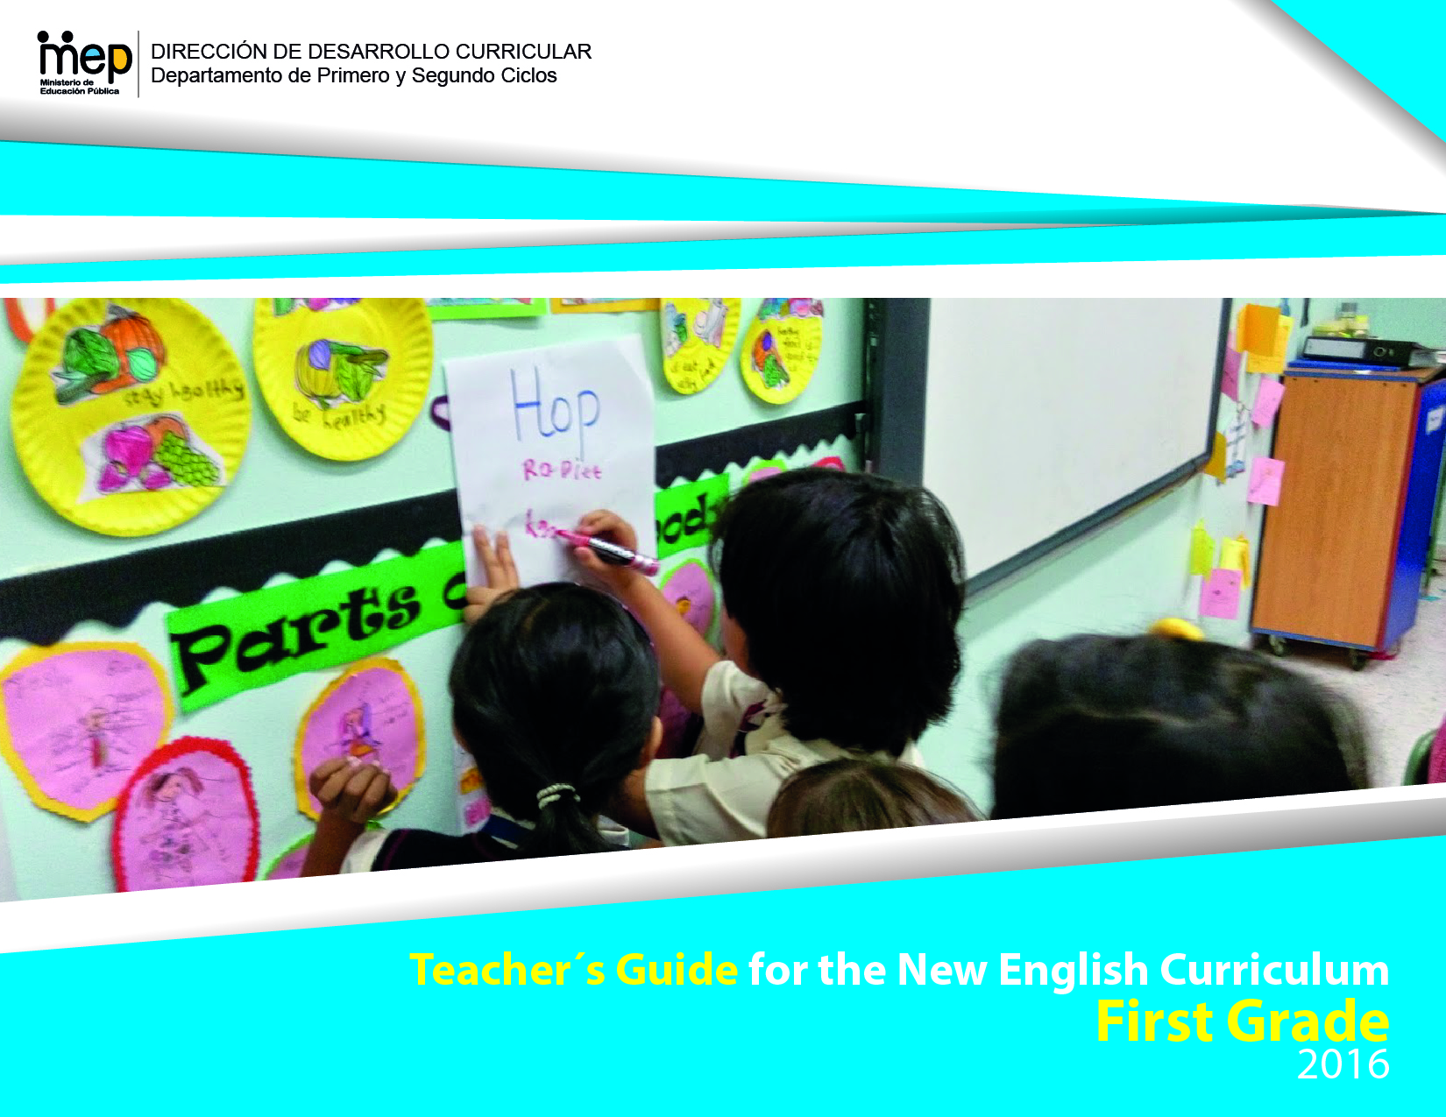

# Presentation

Dear teachers

This Teacher´s Guide has been developed to provide English teachers of first grade with the guidelines on how to effectively use various resources and pedagogical strategies with the intention of helping learners develop the knowledge, skills and habilities set in the new English syllabus for this level. As a result, learners can achieve an expected level of performance in the target language according to the CEFR. We believe that you know your students best and therefore we encourage you to freely adapt what you find here so that it responds to the needs and context of your learners.

This guide consists of six units. Each unit lesson plan comes along with the learner´s exit profile for the level, the scenarios and themes for the cycle and the scope and sequence of each unit within a timeline of six weeks. The scope and sequence provides a systematic scaffolding of the general and linguistic competences required for the development of the communicative competence.

The special features of this Teacher’s Guide are:

A. **Assessment Strategies and Evidences of Learning:** Each goal has a specific assessment indicator for each linguistic competence which requires the elaboration of assessment instruments.

B. **Goals:** Each lesson has specific and clear learning goals connected to a domain, scenario, theme and language function.

C. **Pedagogical Mediation/ Didactic Sequence:** subdivided in the following stages;

✓**Pre-Teaching:** (Warm-up, Activation of Prior Knowledge, Modeling, Clarifying)

✓**Pre-task:** Introductory activity for activation of students’ prior knowledge to carry out a specific task connected to a goal. It places emphasis on the linguistic, cognitive resources needed by the leaner.

✓**Task rehearsal:** Class work where students practice the language in a meaningful way for successful task completion.

✓**Task completion:**  A task that learners perform to demonstrate that the goal has been successfully achieved.

✓**Task assessment:** An activity for self and/or peer assessment and teacher feedback and/ or repair in relation to the achievement of a goal. Evaluation tools to evaluate performance tasks, of what students know and can do.

D. **Time:** Each phase of the didactic sequence includes a suggestion for the time that may be needed.

E. **Integrated Mini Project:** The project is a creative opportunity for students to integrate knowledge, abilities and skills**.**

F. **Reflective Teaching:** Suggestions for you to assess your own progress in teaching the material.

G. **Enduring Understanding Reflection**: Space to record how students grasped new undestandings and ideas in connection with the essential question of the unit.

We hope that this Teacher´s Guide will provide you as teachers with all you need to customize your teaching in an effective, creative, engaging, and interactive way in response to your students´needs. This guide will be up-dated and modified during the year to respond to the teachers´ needs.

Each unit offers a variety of activities for each phase of the lesson plan, the teacher selects those that are appropriate for achiving the learning goals, the context and learners needs, and also the numbers of lesson available for teaching English in the school.

Table of contents

Presentation 2

The Learner as a New Citizen 6

What are the legal underpinnings and how are they related to language teaching and learning? 8

Language Learning Considerations 9

Which pedagogical trends influence the teaching practices? 10

The Common European Framework of Reference (CEFR) 11

Costa Rican general descriptors according to CEFR English proficiency bands 12

The Action-Oriented Approach 14

General competences 16

Competence 16

Basic Principles of the Action-Oriented Approach 16

Communicative competence 18

Communication 19

Tasks 20

How are lessons planned? 21

Guidelines for the Pedagogic Mediation 24

First and Second Cycles 24

Summary for the Pedagogic Mediation for First and Second Cycles 26

How is learning assessed? 29

Integrated Mini-Project 30

Classroom Setting in the Action Oriented Approach 32

Learner Exit profiles for First Cycle 33

Scope and Sequence First Cycle 34

Unit 1 Scope and Sequence 35

Unit 1 All about me 40

Unit 2 Scope and Sequence 67

Unit 2 This is our Classroom 71

Unit 3 Scope and Sequence 101

Unit 3 We are all different 105

Unit 4 Scope and Sequence 129

Unit 4 Going to school, so cool! 133

Unit 5 Scope and Sequence 174

Unit 5 My Neighborhood 178

Unit 6 Scope and Sequence 206

Unit 6 Playtime 210

Teaching Resources 240

Resources Unit 1 240

Annexes 246

Annex 1 246

Fly Swatter Game 246

Annex 2 247

Hot Potato Game 247

Annex 3 248

Learning names game 248

Annex 4 249

Four corners Game 249

Annex 5 251

"Memory Game" 251

Resources Unit 2 252

Resources Unit 5 257

Resources Unit 6 291

# The Learner as a New Citizen

[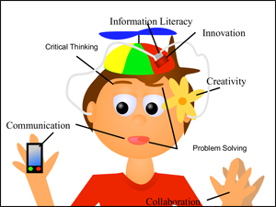](http://www.google.com/url?sa=i&rct=j&q=&esrc=s&source=images&cd=&cad=rja&uact=8&ved=0ahUKEwi5v9THj5nOAhUCqR4KHY65AgUQjRwIBw&url=http://web.tech4learning.com/blog-0/bid/45149/The-21st-century-classroom-where-the-3-R-s-meet-the-4-C-s&bvm=bv.128617741,d.dmo&psig=AFQjCNGYuLPA0bsB7OxZyCkRAtz3u23QIw&ust=1469897018703898)Education for a new citizenship reinforces the need of 21st century learners who integrate proactively in a globalized world while strengthening their national and global identity.

Source: <http://web.tech4learning.com/blog-0/bid/45149/The-21st-century-classroom-where-the-3-R-s-meet-the-4-C-s>

Education for a new citizenship envisions learners as active agents of change able to:

* Use knowledge, skills, and abilities beyond school contexts.
* Express their own points of view.
* Practice peaceful conflict resolution and search for democratic solutions.
* Harmonize social and economic development and environmental sustainability.
* Take action in favor of sustainability of local, national and global resources.
* Be aware of a global world where national borders have become more diffused.
* Use ICTs and access to knowledge networks as tools for communication, innovation, and proactive social service.
* Be compassionate national and global citizens.
* Practice democratic principles such as freedom of expression and religion, respect for plurality and cultural diversity (sexual, linguistic, and ethnic) as stated in the Costa Rican Constitution.
* Defend and protect Human Rights and be against all forms of discrimination.

As the chart below shows, the concept of New Citizenship is sustained by three main pillars:

Figure 2: Dimension for Educating for a New Citizenship

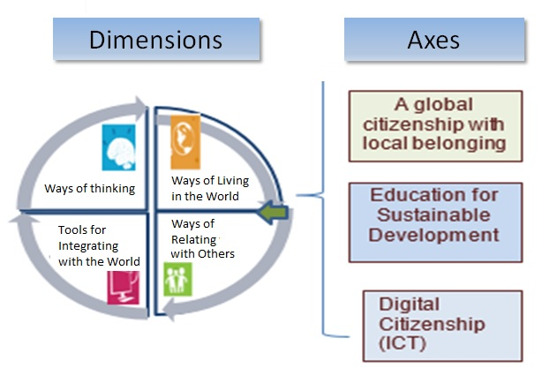

## What are the legal underpinnings and how are they related to language teaching and learning?

*Policy for the 21th Century* highlights three philosophical trends:

|  |  |  |  |
| --- | --- | --- | --- |
|  | Rationalism | Humanism | Constructivism |
| Understanding | Development of complex, challenging, creative and critical thinking skills, | Full realization of the human being, as a person with rights and responsibilities. | Construction and reconstruction of understandings and learnings |
| Implications for teaching | Cooperative learning and pedagogical scaffolding | Sensitiveness and awareness of learning styles and affective variables | Problem solving, inductive and deductive teaching and experiential learning |

The policy “*The School as the Core of the Quality of Costa Rican Education”* recognizes three dimensions of learning:

# Language Learning Considerations

|  |  |  |
| --- | --- | --- |
| **Considerations** | **Understanding** | **Implications for Language Learning** |
| **Philosophical** | It focuses on the learner as a social agent is active, independent, critical, reflective, creative, innovative, inquisitive, and respectful of human rights. | Learning environments and experiences should promote dialogue and creative responses to solve real-life problems. |
| **Psychological** | It seeks the whole development of the person and is associated with the person´s affective dispositions. | Pedagogic mediation is flexible, inclusive, and culturally relevant, respecting the individual differences. |
| **Neurological** | It is related to the brain’s architecture and how maturational processes influence language development. | Underscores the importance of starting the learning of foreign languages early in life. |
| **Socio-cognitive** | It is related to the brain’s architecture (attention, short-, working- and long-term memory) and how it functions to process information (metacognition) related to learning and communication. | Connects to the complexity and cognitive load of tasks presented to students. |
| **Socio-cultural** | It includes the notions of diversity, interdependence, and interconnection among others. | Addresses learning new behaviors, values, and social skills in line with a human rights approach and through democratic participation. |

## Which pedagogical trends influence the teaching practices?

## The Common European Framework of Reference (CEFR)

|  |  |
| --- | --- |
| **CEFR** describes proficiency levels based on accumulated evidence gathered over time from learner activities, tasks, or projects. | **Implications:**   * Standard Terminology * Track student progress * Descriptors – teaching, learning and assessment * Students monitor and take responsibility * Transferability across settings * Parent communication |
| D:\Users\yramirez\Documents\CEFR level of proficiency.jpg | |

### Costa Rican general descriptors according to CEFR English proficiency bands

|  |  |  |
| --- | --- | --- |
| **Basic User**  **Basic User** | A1 | * Can understand and use familiar everyday expressions and very basic phrases aimed at the satisfaction of needs of a concrete type. * Can introduce him/herself and others and can ask and answer questions about personal details such as where he/she lives, people he/she knows and things he/she has. * Can interact in a simple way provided the other person talks slowly and clearly and is prepared to help. * Can show limited ability to use simple grammatical structures and conventions such as punctuation, and capitalization.   **EXTENSION OF THE CEFR STANDARDS - INTEGRATION OF LANGUAGE ABILITIES**   * Can use A1 level, grade level and age appropriate linguistic (e.g. present verb forms), socio-cognitive (e.g., associating strategies) and socio-affective (e.g., cooperating or coping strategies) resources to integrate topical content from oral and written text to perform a goal-oriented product (mini-project) based on an integrated sequence of activities within a domain, scenario and theme. Linguistic resources include grammatical forms and meanings; socio-cognitive resources include a range of meta-cognitive strategies (planning) and cognitive strategies (revising); and socio-affective resources consist of strategies such as cooperating and coping. * Can use A1 level, grade level and age appropriate digital and telecommunication resources to research, plan, and implement the mini-project. * Can give, receive, and respond to feedback at critical stages of the creative process. * Can use level and age appropriate linguistic resources to integrate information from a reading or a listening or other inputs to perform from one skill modality to another (e.g., listening to speak, read to write) to achieve the goal of the scenario. * Can display awareness and development of non-cognitive dispositions (such as effort, perseverance, engagement, empathy, and focus). |
|
| A2  A2 | * Can understand sentences and frequently used expressions related to areas of most immediate relevance (e.g., very basic personal and family information, shopping, local geography, employment). * Can communicate in simple and routine tasks requiring a simple and direct exchange of information on familiar and routine matters. * Can describe in simple terms aspects of his/her background, immediate environment, and matters in areas of immediate need. * Can use some simple structures accurately but continues to systematically exhibit basic errors (such as verbs tenses, use of prepositions, articles).   **EXTENSION OF THE CEFR STANDARDS- INTEGRATION OF LANGUAGE ABILITIES**   * Can use A2 level, grade level and age appropriate linguistic (e.g. past verb forms), socio-cognitive (e.g., grouping strategies) and socio-affective (e.g., cooperating or questioning for clarification strategies) resources to integrate topical content from oral and written text to perform a goal-oriented product (mini-project) based on an integrated sequence of activities within a domain, scenario and theme. Linguistic resources include grammatical forms and meanings; socio-cognitive resources include a range of meta-cognitive strategies (monitoring) and cognitive strategies (resourcing); and socio-affective resources consist of strategies such as cooperating and coping. * Can use A2 level, grade level and age appropriate digital and telecommunication resources to research, plan, and implement the mini-project. * Can give, receive, and respond to feedback at critical stages of the creative process. * Can use level and age appropriate linguistic resources to integrate information from a reading or a listening input or other inputs to perform from one skill modality to another (e.g., listening to speak, read to write) to achieve the goal of the scenario. * Can display awareness and development of non-cognitive dispositions (such as effort, perseverance, engagement, empathy, and focus). |

## The Action-Oriented Approach

|  |  |
| --- | --- |
| **Learner**  [Resultado de imagen de learner images](https://www.google.com/imgres?imgurl=https://learnerview.ofsted.gov.uk/sites/default/files/learner-view-homepage-banner.jpg&imgrefurl=https://learnerview.ofsted.gov.uk/&docid=5PJQQILrnbOq6M&tbnid=ztgfT50v_lCz6M:&w=665&h=300&bih=691&biw=1455&ved=0ahUKEwi7x6L9xpnOAhWJ1R4KHQxmDAQQMwg8KBQwFA&iact=mrc&uact=8) | * An agent/performer with intercultural awareness skills. * Autonomous, works cooperatively, interacts with others, investigates and solves problems using the tools at his/her disposal (general and specific competences). * Develops metacognitive, reflective and critical thinking strategies for successful completion of the task. |
| **Teacher**  Resultado de imagen de teacher images working with learners | * Facilitator, coach, resource person, guide, advisor, and observer. * Helps the learner become autonomous and be successful in the completion of the task. * Provides effective feedback in the process of learning. * Shows expert role, but shares this responsibility with the learner. |
| **Learning Resources**  [Resultado de imagen de images of innovative classrooms](https://www.google.com/imgres?imgurl=http://cdn.patch.com/users/33150/2010/10/T600x450/123f96ec19a783aa3d14f7ec1a7c23fb.jpg&imgrefurl=http://patch.com/illinois/oaklawn/spartan-education-foundation-allows-teachers-to-creat6a888cc1c2&docid=p6ec_p7CxNZgTM&tbnid=mkpmu_Q8DdoEFM:&w=600&h=450&bih=691&biw=1455&ved=0ahUKEwjAtJfEy5nOAhWK1h4KHWS_A1o4ZBAzCFsoWDBY&iact=mrc&uact=8) | * Oral or written authentic texts: business cards, bus tickets, newspaper articles, book excerpts, wikis, bus schedules, city maps, bulletin boards, voice messages, and announcements. * Appropriate to the learner´s needs and competence level. * Intercultural perspective |
| **Aims of communicative activities/tasks**  D:\Users\acamposce\Pictures\roleplay.png | * Communicative activities become actions that the learner/social agent performs in order to build up general competences and communicative language competences. * The goal is successful action and accomplishment of tasks in a particular scenario and domain aligned to the learner’s life experience and personality. |
| **Learning Environment**  [Resultado de imagen de images of students having fun](https://www.google.com/imgres?imgurl=http://www.unr.edu/Images/student-services/cultural-diversity/API%204.jpg&imgrefurl=http://www.unr.edu/cultural-diversity/programs-and-services/programming&docid=Flvpi_I3n3uTnM&tbnid=7J00HYKKtlXtXM:&w=350&h=250&bih=691&biw=1455&ved=0ahUKEwif17PuzpnOAhXGox4KHbJxB0QQMwheKDowOg&iact=mrc&uact=8) | * Real-world contexts (personal, public, educational and vocational domain) collaborative, stimulating, mediated by ICTs. |
| **Assessment**  [Resultado de imagen de images of innovative teaching materials](https://www.google.com/imgres?imgurl=http://www.weareteachers.com/images/default-source/blog-images/close-reading.png?sfvrsn=0&imgrefurl=http://www.weareteachers.com/blogs/post/2015/05/27/10-super-innovative-teacher-ideas-for-close-reading&docid=xFbAhMl4I4vvIM&tbnid=SeRAeBryAMcSqM:&w=630&h=354&bih=691&biw=1455&ved=0ahUKEwiS57CcypnOAhVKWh4KHb_LBdoQMwhJKCUwJQ&iact=mrc&uact=8) | * Assessment is based on what the social agent is able to do in real-life situations or scenarios and the process he/she requires to develop the competences. Authentic assessment is favored. * The acquisition and refinement of general and communicative competences is a continuous process, both at school and in the world beyond the school. |

### General competences

Consist of knowledge, skills, and abilities to learn and existential competence that are not language-specific but learners use them when performing all kinds of actions including language activities.

### Competence

The CEFR defines competences as “the sum of knowledge, skills and characteristics that allow a person to perform actions in society.”

### Basic Principles of the Action-Oriented Approach

1. The students are social agents that use the target language to perform specific actions in real life contexts meaningfully.
2. Language performances, in oral or written form, respond to language functions and are carried out in specific scenarios.
3. Enabling and communicative activities are task-based and real-life.
4. Learners use authentic materials as comprehensible input, as much as possible.
5. The ICT become an important tool to create meaningful learning experiences.
6. A great degree of autonomy is placed on the learner; therefore, the teacher works in the development of learners’ meta-cognitive, meta-affective, and meta-social strategies.
7. Intercultural awareness plays an important role for getting meaning across and facilitating communication among cultures.
8. Vocabulary, syntax, cohesive forms, and phonology are taught with the purpose of facilitating communication

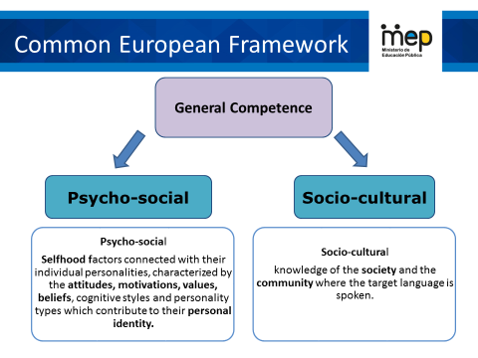

## Communicative competence

The communicative language competences involve knowledge, skills, and know-how for each of the following three components:

* **Linguistic Component:** Deals with the knowledge of phonology, morphology, lexicon and syntax.
* **Sociolinguistic Component:** Refers to the socio-cultural conditions of language use such as social group repertoires or politeness rules.
* **Pragmatic Component:** Covers, among others, speaker´s and receptor´s attitudes and beliefs, their understanding of the context of an utterance and the functional use of language; for example the use in specific scenarios of how to act in a given social event or how to participate in a job interview.

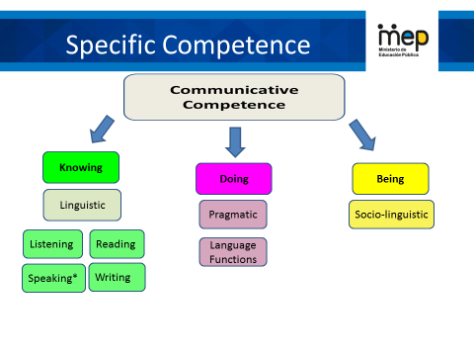

## Communication

The CEFR defines communication as a social act, where learners are social agents, developing a range of general and specific communicative language competences, moving from learning about the language to learning to communicate in the language in active, spontaneous, and authentic language interaction.

## Tasks

Defined as any purposeful action considered by an individual as necessary in order to achieve a given result in the context of a problem to be solved, an obligation to fulfill, or an objective to be achieved. This product may be a brochure for tourists, a blog entry, or a fund raising project for a humanitarian cause.

Task accomplishment by an individual involves the strategic activation of specific linguistic competences (linguistic, pragmatic and socio-linguistic) along with a range of socio-cognitive competences in order to carry out a set of purposeful actions in a particular domain (interpersonal, transactional, academic and professional) with a clearly defined goal and a specific outcome.

# How are lessons planned?

Lesson planning will be developed covering a complete unit which includes six weeks. This plan can be distributed weekly. Here is an example of how it can be done.

**Week 4**

Domain

Scenario

**Theme 4**

Language function 4

3-4 goals

Three learning pillars

3-4 assessment indicators

**Week 3**

Domain

Scenario

**Theme 3**

Language function 3

3-4 goals

Three learning pillars

3-4 assessment indicators

**Week 2**

Domain

Scenario

**Theme 2**

Language function 2

3-4 goals

Three learning pillars

3-4 assessment indicators

**Week 1**

Domain

Scenario

Enduring understanding Essential question

**Theme 1**

Language function 1

3-4 goals

Three learning pillars

3-4 assessment indicators

Integrated mini-project for assessment of unit goals

Feedback, Reinforcement and assessment

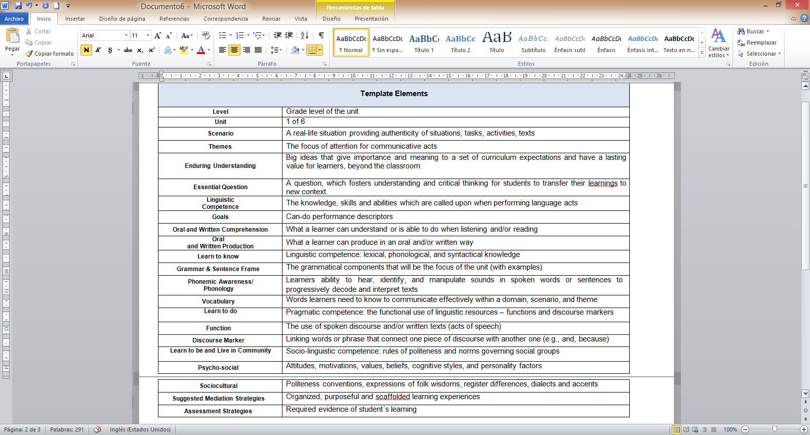

What is the teacher´s profile to implement this new curriculum?  
Teacher’s Profile

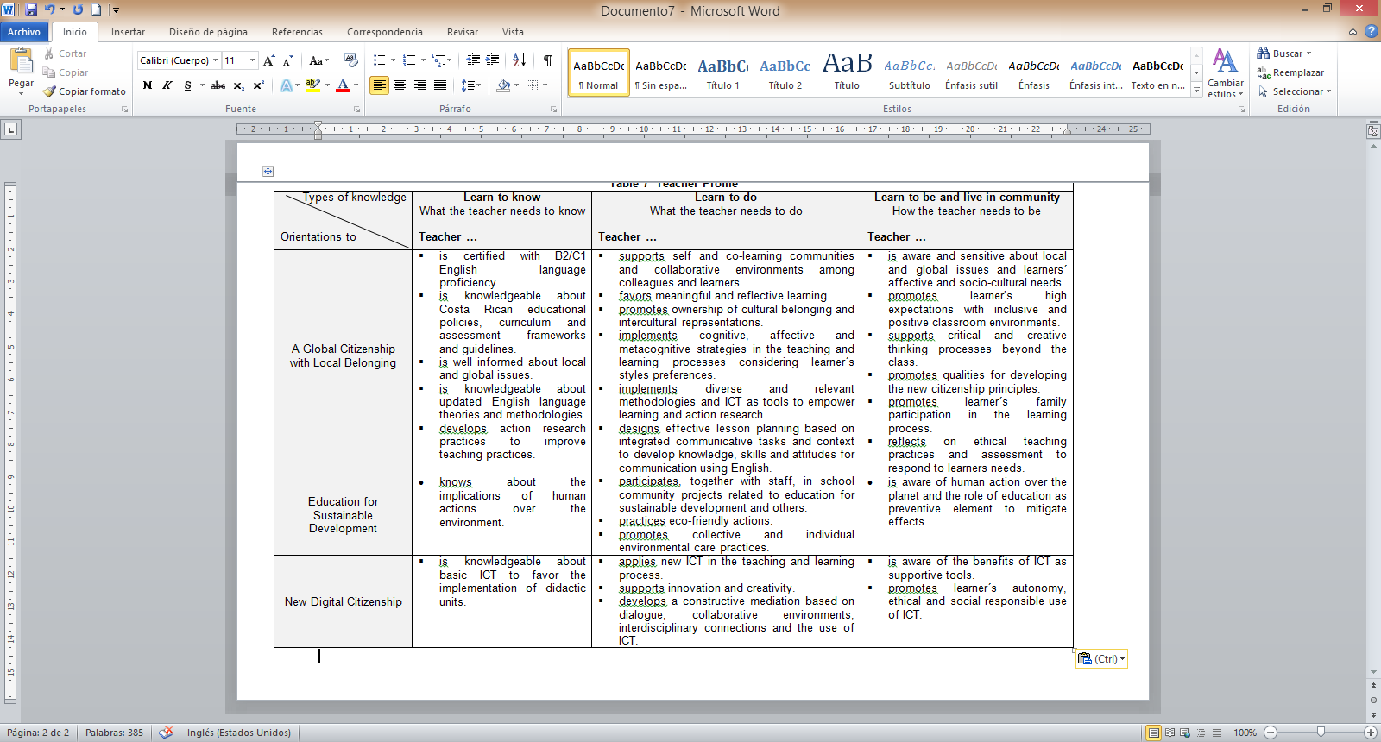

# Guidelines for the Pedagogic Mediation

## First and Second Cycles

* English language teaching first places priority on oral comprehension while simultaneously exposing students to oral production and concepts of print. **Reading and writing will be introduced progressively**.
* Lessons can follow a task-based sequence that will focus on linguistic and nonlinguistic items such as: phonemic awareness, language forms, vocabulary, oral or written comprehension and oral or written production, development of cognitive or socio-affective strategies, etc.
* Tasks follow a sequence: **pre-task, task planning/ rehearsal, task completion and task assessment.**
* During the Second Cycle, students are exposed to more complex tasks that gradually demand them to produce longer chunks of language in oral and written form within sentence frames until they begin to write more words and sentences on their own. They can also engage in the **writing process, revising, editing, and finally producing polished texts on their own.**
* Teachers can **select three or four goals per week from the units**. They can combine oral or written comprehension goals with oral and written production ones, depending on the stage of the lesson, so that an **integrated skills approach** is developed.
* Teachers can take **one lesson per week for phonemic awareness development** when it is possible.
* Teachers **start each theme and class with a warm-up activity**, which is part of the pre-teaching phase. After that, he/she introduces the **sentence frames, vocabulary, sounds or sociocultural aspects of the unit, which are the focus of the lesson**. Then, **teachers share the learning goals and essential question** with the students for that day or week.
* The enduring understanding and essential question are central to articulate the three learnings: learn to know, learn to do and learn to be and live in community.
* **The enduring understanding is shared by the teacher at the beginning of each unit** to connect students with the core ideas that have lasting value beyond the classroom.
* Teachers facilitate **pre-task activities** for activation of students’ prior knowledge to carry out a specific task, placing emphasis on the forms, sounds and vocabulary words needed by repeating, rephrasing, writing on the board or drawing.
* Pre-task activities in listening, reading, speaking and writing are developed to help students recall, internalize and pronounce useful words and phrases demanded by the task that they will perform. In first grade, tasks can be very simple to let children adjust linguistically, socially, and cognitively to the target language, but they can become more complex progressively and include **pre-task activities, task planning, reporting, and assessment.**
* During the pre-task phase, the teacher introduces the task goal and outcome. Teacher activates students’ background knowledge to perform the task. The language and sentence frames needed are reviewed or introduced as well as phonological elements.
* As communicative competence develops, controlled scaffolded activities in listening, reading, speaking and writing are developed to help students recall, internalize and pronounce useful words and phrases demanded by the task that they will perform.
* Assigning learners meaningful tasks that resemble real language use where reading and writing or listening and speaking are integrated is recommended.
* **Presenting and explaining learning objectives and expected outcomes of the task and assuring that learners understand task instructions is important.**
* It is advisable to provide learners with enough time for task preparation and clarification.
* The students will move from dependency on the teacher when solving a task to more autonomous work.
* It is important to support, monitor, and encourage the students while solving a task
* **Learners will have at their disposal useful words, phrases and idioms that they need to perform the task**. It could be an audio recording with the instructions and the pronunciation of the words and phrases needed.
* The students solve the task together using all resources they have. They rehearse their presentation or revise their written report. Then, they present their spoken reports or display their written reports.
* **Provide rubrics for assessing students’ task performance** and move progressively to self- assessment and peer assessment.
* Provide feedback and further practice on areas that need more work, listening, and writing, speaking, reading, vocabulary work, phonemic awareness, and the like.
* **At the end of each unit, the students elaborate a mini- project to demonstrate achievement of unit goals within a domain, scenario and theme**.
* The mini-project is an opportunity for students to integrate these three learnings and linguistic skills in a single task. For example, writing a class book based on a story with each student producing one page of the book with drawings and sentence frames. Students` products can begin with a simple drawing and a label written by the teacher.
* As proficiency develops, provide learners with more complex tasks, which involve the use of words, phrases and later sentences on a more elaborate level.
* Teach English in English and make learners be socially and cognitively engaged.

# Summary for the Pedagogic Mediation for First and Second Cycles

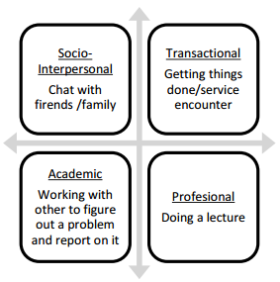

**Domain:**

There are four domains of language use. We are going to work with the socio Interpersonal domain in

First Cycle and the transactional domain in Second Cycle.

**Scenario:**

A real-life situation providing authenticity of situations to tasks, activities and texts. There are 6 scenarios in each grade level, one per unit.

**Theme:**  There are FOUR themes per unit. Use ONE theme per week.

**Enduring Understanding**

It is introduced at the beginning of each unit and it is reviewed at the end of the unit as part of the integrated mini-project assessment.

**Essential Question:**

It is introduced at the beginning of each unit.

**Learn to Know: Grammar & Sentence Frame 🡪Vocabulary 🡪 Phonemic Awareness**

The scope and sequence provided for lesson planning correlates this element of the curriculum with each of the goals and themes per week.

**Learn to Do: Function🡪 Discourse Markers**

Take them from the syllabus. There is one function per theme.

**Learn to Be and Live in Community: Psycho-social 🡪Sociocultural**It is taken from the curriculum and it is integrated in the pedagogical mediation.

**Assessment Strategies & Instruments:**

Use indicators from the syllabus. There is one assessment indicator for each goal.

There is going to be a guide for classroom assessment.

**Learner can**

Select three or four goals per week for each unit theme.

**Pedagogic Mediation**

**Pre-teaching:** It prepares learners for the achievement of weekly goals within a specific theme and scenario.

**Warm up:**

Fun activity to motivate learners. It can be connected to the theme and goal of the lesson.

**Activation of prior knowledge includes:**

* Goal of the unit ( Listening, reading, spoken production, spoken interaction, writing)
* Enduring Understanding
* Essential Question
* Connection of new language and sentences frames to students ‘back ground knowledge.

**Modeling**

Teacher centered. Teacher models pronunciation and meanings of the new sounds-vocabulary- sentence frames of a specific theme connected to a scenario.

**Clarification**

Teacher asks questions to leaners to get feedback from them and clarifies meanings, forms or pronunciation if it is need it.

**The task cycle:** it provides learners with the scaffolding needed to reach a goal within a theme and scenario.

**Pre-task**

Activation of students’ prior knowledge to carry out a specific task and to reach a specific goal (listening, reading, spoken production, spoken interaction, writing) placing emphasis on the forms, sounds and vocabulary words within a theme and scenario.

**Task-rehearsal**

An activity that provides students with language practice for successful task completion. It is student-centered. Students practice with Teacher´s help.

**Task completion**

Learners perform in oral, written comprehension, oral or in written production tasks. The purpose of this task is for students to demonstrate if they have reached the goal.

**Task Assessment**

Teacher´s assessment of the task, self and peer assessment for feedback on task performance.

It could require repair and reinforcement by a supplementary task if the goal has not been reached by most of the students.

**Post-Task**

A task connected to the main task for skill integration.

Note: There is a lesson of phonemic awareness each week. The phonemic awareness lesson follows all the stages: Pre-teaching, pre-task- task rehearsal, task completion and task assessment.

The **pre-teaching phase** is developed at the beginning of each theme, each week, and during the phonemic awareness lesson.

# How is learning assessed?

Assessment is a purposeful, continuous, contextualized, authentic, reflective, investigative, systematic and multi-phase process, which responds to these four fundamental questions: Why assessing learning? What to assess? How to assess it? Which are the pedagogical implications?

The purpose of assessment is to serve each learner’s learning and growth. To prevent student’s failure and allow timely intervention, assessment allows teachers to detect learning gaps, so that learners can receive the support needed to be successful. The “what” of assessment involves having clarity about the knowledge, skills, abilities, and attitudes (learn to know, learn to do, learn to be and live in community) that learners have to develop as established in the curriculum goals or “can do performance descriptors”. This implies that assessment will mainly be performance-based. Learners are required to demonstrate through integrated-skills tasks within a domain, scenario and theme, specified knowledge, skills and abilities using the target language. Assessment can also be a discrete point, which means the use of selected response tasks to isolate and measure discrete units of grammatical knowledge, which encompasses grammatical, semantic and pragmatic knowledge -- form, meaning and use (Purpura, 2014, p 9). Assessment will also be authentic which means that the assessment task will simulate real-life situations within domains and scenarios beyond the classroom setting, and the socio-cognitive, socio-affective, socio-cultural and linguistic demands upon the learner will be similar to the one of a speaker in a target language setting.

Classroom assessment mirrors the learning goals, content of instruction and instructional practices, therefore, curriculum, teaching, and assessment must be coherent for learning goals to be achieved and learners’ communicative competence to be developed.

Task design, task performance, and assessment become a fundamental unit of instructed learning; tools such as analytic and/or holistic scales, rubrics, progress indicators and checklists play an important role for obtaining valid and reliable qualitative and quantitative data about students´ learning and performance.

# Integrated Mini-Project

A more complex “learn to do” classroom task for each unit.

* Learners (as social agents) integrate knowledge, skills and abilities (KSA), within the domain, scenario, themes, the enduring understanding and essential questions of the unit.
* Proactive (not reactive)
* Interconnected with classroom activities
* Formative, skill-integrated performance
* Collective actions (social dimension)
* Promotes the democratic citizenship. (CEFR p.12)

Integrates skills and unit’s goals and leads to a final product.

**AOA Task Oriented to a ProductKeep the end in mind!**



**Phases of the Integrated-Mini-Project**

Phase 1: **Planning**: In the first grade, different alternatives are offered for the integrated mini-project in the syllabus. Teachers and students can propose others based on the interests and linguistic resources. As they develop more independence autonomy and become more proficient, the learner takes an active role deciding what and how of the project.

Phase 2. **Creating collaborative**: Students activate their prior knowledge, do research, share, negotiate, search for materials and collaboratively elaborate the integrated- mini project applying the knowledge skills, skills and attitudes developed in the unit.

Phase 3. **Preparation**: Once the integrated mini-project is completed, the students will rehearse, evaluate and adjust their integrated mini-project.

Phase 4: **Participation**: Students depending on the nature of the integrated mini-project, present their integrated mini-project individually, in pairs or groups to the class, parents or school community. They can answer questions, participate in self-assessment, and peer assessment experiences. The teacher also assesses the integrated mini-project and provide feedback to learners.

# Classroom Setting in the Action Oriented Approach

When implementing the action oriented lessons in your English class; remember to:

a) Consider learners interets and needs.

b) Offer opportunities to work in pairs, in small groups, and as a whole class.

c) Create a context for learning and reflecting.

d) Provide multiple opportunities to develop communicative competence.

e) Use different classroom layouts: the horseshoe, chairs in a circle, traditional rows and nested tables in groups.

# Learner Exit profiles for First Cycle

|  |  |  |  |
| --- | --- | --- | --- |
| Types of knowledge  Orientations to | **Learn to know**  What the learner needs to know  **Learner …** | **Learn to do**  What the learner needs to do  **Learner…** | **Learn to be and live in community**  How the learner needs to be  **Learner…** |
| A Global Citizenship with Local Belonging | * extracts explicit information from visual and simple texts. * uses oral and written codes for communicating simple and familiar ideas. * identifies time and space data in sequential order by using visuals. * Understands the purpose of given instructions . * recognizes meaningful information gradually. | * recognizes gradually different styles when working in groups according to skills and motivations. * practices assertive communications skills. * Recognizes gradually own abilities for team work gradually. | * recognizes his/her own rights and responsibilities and the ones of others gradually. * values positively diversity in his/her family, school, society and context. * judges positively daily actions that contribute for wellbeing. * participates in peaceful conflict solving. |
| Education for Sustainable Development | * recognizes gradually different social and environmental risks affecting life. | * initiates valuing the implication of efforts over the achievement of goals. | * initiates differentiating beliefs, attitudes, actions over sustainable development. |

# Scope and Sequence First Cycle

|  |  |  |  |  |  |  |
| --- | --- | --- | --- | --- | --- | --- |
| **Scope and Sequence First Cycle** | | | | | | |
| **Level** | **Unit 1** | **Unit 2** | **Unit 3** | **Unit 4** | **Unit 5** | **Unit 6** |
| **First Grade** | **Scenario: All About Me!**  **Themes:**   * Saying hello! Saying Good Bye! * Introducing Myself * The Way I Look and Feel * Making New Friends | **Scenario: This is our Classroom!**  **Themes:**   * Stand up! Sit down! * Things in My Classroom * My School Supplies * Where is my Pencil? | **Scenario: We Are All Different!**  **Themes:**   * Meet my Family * What my Family Looks Like * Different Things my Family Likes to Do * I Like… | **Scenario: Going to School, so Cool!**  **Themes:**   * This Is my School. * Helpers at my School. * Going around School. * A Week at my School | **Scenario: My Neighborhood.**  **Themes:**   * This Is my Neighborhood * Where is the School? * How can I Get to the Supermarket? * Community Helpers | **Scenario: Playtime**  **Themes:**   * Fun Games and Activities * I need a Rope to Play * My Favorite Game and Activities * Show me How to Play |
| **Second Grade** | **Scenario: Learning Is Fun**  **Themes:**   * Hi! How are you today? * My Learning Environment * What Do I do at School? * What I Like about School? | **Scenario: Healthy Habits**  **Themes:**   * I Love my Body! * Healthy Habits make me Feel Great! * Yummy and Good for my Tummy * I Can Be Healthy and Happy | **Scenario: Home Sweet Home**  **Themes:**   * A Visit from my Cousins * A Home Tour * What We Do around the House * Cleaning the House | **Scenario: Loving and Caring Animals**  **Themes:**   * Barn or House? * Moo, Meow, and Cock-a-Doodle-Do * Living with Animals and Pets around me * Walk the Dog...and Other Ways to Care for Animals | **Scenario: Fabulous Flora and Fauna**  **Themes:**   * A Nature Walk * Animals A to Z * Green Kingdom * Protecting Nature | **Scenario: A change of Scenery**  **Themes:**   * Rain, Rain Go Away * Try This on * May I Have a Bite? * Please Tell me What´s Fun |
| **Third Grade** | **Scenario: Our Family “to Do” List**  **Themes:**   * Family Chores * Things I Like to Do to Help my Family * Can you help me? * Where is the Broom? | **Scenario: Families Celebrate Together!**  **Themes:**   * What isthere to Celebrate? * My Family`s Special Dates * When is your Birthday? * Sharing Family Celebrations! | **Scenario: May I Help You?**  **Themes:**   * Is This the Cashier or the Clerk? * Going to a Store! * Where do I Get some Fresh Vegetables? * How Much does it Cost? | **Scenario: Getting around Town!**  **Themes:**   * A Day in my Community * Help! I Need a Pair of Shoes. * Walk this Way * Step by step Directions | **Scenario: Fun Places and Spaces**  **Themes:**   * Let´s Go Outside * Indoor fun on a rainy day * Come on! Make-up your Mind. * Are you ready to Have Fun? | **Scenario: Welcome to Costa Rica**  **Themes:**   * Costa Rica: a Diverse Country * Where Can I Go? * How will I Get There? * Exploring Costa Rica: no Better Place to Be |

|  |  |  |  |  |
| --- | --- | --- | --- | --- |
| Unit 1 Scope and Sequence | | | | |
| **Scenario:** All about me | | | | |
| **Enduring Understanding** | Our names, the way we look, and the way we feel make us special. | | | |
| **Essential  Question** | What makes us special? | | | |
| |  | | --- | | **Dimensions** | | **1.** **Ways of thinking ( x )** | | **2. Ways of living in the world ( x )** | | **3. Ways of relating with others ( x )** | | **4. Tools for integrating with the world ( x )** | | | | | |
| **Assessment and Goals** | | | | |
| **Week 1** | **Week 2** | **Week 3** | **Week 4** | **Week 5** |
| **Theme**  1. Saying Hello! Saying Good-bye! | **Theme**   1. Introducing Myself | **Theme**   1. The Way I Look and Feel | **Theme**   1. Making New Friends |  |
| **Assessment:**  **L.4.**Recognizes one or two forms of greetings farewells (Hello, Good-bye) expressions of politeness and personal feelings expressed slowly and clearly.  **R.1.** Participates in choral reading to identify greetings and leave-takings.  **R.PA2.** Identify the initial phoneme of a spoken word.  **SP.1.** Recognizes how he/she or other person is feeling using simple, standard expressions.  **Goals:**  **L.4.** understand basic greetings, farewells, expressions of politeness and feelings (e.g., hello, good-bye, sorry, pardon?).  **R.1.**Participates in choral reading (clapping and chanting) in response to the rhyme and rhythm of a predictable patterned song or picture story that is read aloud. Can repeat key words after the teacher.  **R.PA2.** identify sounds of letters **/m/ /e/** of the alphabet in order with a concrete item or picture representing the sound.  **SP.1.** Express how I look and feel using simple, standard expressions. | **Assessment:**  **L.3.** Recognizes simple questions, which directly concern them such as their name and where they are from.  **R.PA2.** Identify the initial phoneme of a spoken word.  **SI.1.**Asks for something when pointing or gesturing to support the request.  **SP.1.** Describes personal appearance and feelings with simple words.  **Goals:**  **L.3.** understand simple questions, which directly concern them such as their name and where they are from.  **R.PA.2.** identify sounds of letters **/s/ /a/** of the alphabet in order with a concrete item or picture representing the sound.  **SI.1.** ask for something when pointing or gesturing to support the request. | **Assessment:**  **L.2.**Recognizes simple personal information (e.g.**name, age, country of origin, personal traits**)  **R.PA2.** Identify the initial phoneme of a spoken word.  **SI.2.** Uses one or two forms of greetings and farewells (Hello, Good- bye).  **SI.3.**Expresses a lack of understanding.  **W.1.** Says words for the teacher to write.  **Goals**  **L.2.** recognize often spoken words similar to the languages with which they are familiar (e.g., Pay attention, silence, excellent).  **R.PA.2.** identify sounds of letters **/t//e/** of the alphabet in order with a concrete item or picture representing the sound.  **SI.2.** use one or two learned expressions of greeting, farewell, and politeness (e.g., hello, good-bye, please, you are welcome and thank you).  **SI.3.** express a lack of understanding.  **W.1.** dictate words for the teacher to write. | **Assessment:**  **L.1.**Recognizes simple personal information (e.g.**name, age, country of origin, personal traits**)  **R.PA2.** Identify the initial phoneme of a spoken word.  **SI.4.**Responds in a predictable pattern to simple questions about familiar things.  **W.2.** Represents an event or character from a picture story or one main idea.  **Goals:**  **L.1.** Recognize simple information such as name, age, and perhaps country of origin when that information is given slowly and clearly.  **R.PA.2.** identify sounds of letters **/l//a/** of the alphabet in order with a concrete item or picture representing the sound.  **SI.4.** understand and respond in a predictable pattern to simple questions about familiar things and if the other person speaks slowly and clearly.  **W.2.** draw pictures of an event or character from a picture story or one main idea. | **Assessment**  **Instruments for Process/Product**   * Sticky notes * anecdotal note cards * Checklists * Inside and outside circle   **Week 6**  **Suggested Integrated Mini project**   * a poster, * a mobile, * magic box or * booklet using cardboard or technology for introducing oneself |
| **Function**   * Greeting and saying good bye in proper contexts | **Function**   * Introducing myself | **Function**   * Identifying personal traits and feelings | **Function**   * Getting to know others |
| **Discourse Markers**   * and | **Discourse Markers**   * and | **Discourse Markers**   * and | **Discourse Markers**   * and |
| **Grammar & Sentence Frames**  Personal and Possessive pronouns – I, my   * I am Amanda. * Mynameis Juan.   Question/Answerswith BE   * What is your name? My… * How are you? Fine. * Howold are you? 6 | **Grammar &Sentence Frames**  Personal and Possessive pronouns – I, my   * I am Amanda. * My name is Juan.   Question/Answers with BE   * What is your name? My… * How are you? Fine. * How old are you? 6 | **Grammar & Sentence Frames**  Yes/No Questions   * Are you a student? Yes * Are you in first grade? Yes * Are you tall? Yes/No (use appropriate)   (S-V-C) sentences   * I am______ (name, age, country, physical description) * I feel _____ (happy/sad). | **Grammar & Sentence Frames**  Wh- questions in Simple Present   * Where do you live? * Where are you from?   Clarifying Questions   * Pardon? * What? * Repeat, please. |
| **Phonemic Awareness**  /**m/ /e/ (me, meet; eight, egg)** | **Phonemic Awareness**  /**s/ /a/ (sad, sound, are, am )** | **Phonemic Awareness**  /**t/ /e/ (ten, tall, egg, elephant)** | **Phonemic Awareness**  /**l/ /a/ (love, live, am, ant)** |
| **Vocabulary**  1. Saying Hello! Saying good bye!  Greetings   * Hi! Hello! Good morning, Good afternoon, Good evening, How are you?   Leave-takings   * Good-bye, bye, see you, see you later. | **Vocabulary**  2.Introducing myself   * My name is… * I am from… / 7 years old. * ‘I live in…   Expressions of Politeness   * Excuse me, pardon, thank you, you are welcome, * Nice to meet you.   Cardinal Numbers   * 1-10   Nationalities   * Costa Rica, Nicaragua… | **Vocabulary**  3.The way I look and I feel  Physical Appearance   * short, tall, handsome, pretty   Colors  red, blue, green,yellow | **Vocabulary**  4.Making new friends  Information questions   * What´s your name? Where are you from? * How old are you? * Nice to meet you/too. |
| **Psycho-social**   * Showing self-esteem, self-confidence   **Socio-cultural**  **idioms/ phrases**   * Greeting people (handshaking, kissing and some others depending on the community or context). | **Psycho-social**   * Showing self-esteem, self-confidence   **Sociocultural**  **Idioms/phrases**  Hey!  Bye-bye  See ya | **Psycho-social**   * Showing self-awareness by describing self   **Sociocultural**  **Idioms/phrases**  See you later alligator! | **Psycho-social**   * Stimulating creativity through the arts (drawing, acting, body language)   **Sociocultural**  **Idioms/phrases**  After a while crocodile! |  |

# Unit 1 All about me

|  |  |  |  |  |  |  |  |  |  |
| --- | --- | --- | --- | --- | --- | --- | --- | --- | --- |
| **Term: 1** | | **Level: First** | | | **Unit: 1** | | | **Week: 1** | |
| **Domain:**  Socio-Interpersonal | | | | **Scenario:** All about me | | **Theme:**  Saying Hello! Saying Good-bye! | | | |
| **Enduring Understanding**: Our names, the way we look, and the way we feel make us special. | | | | | | | | | |
| **Essential Question:**  What makes us special? | | | | | | | | | |
| |  | | --- | | **Dimensions** | | **1.** **Ways of thinking ( )** | | **2. Ways of living in the world ( )** | | **3. Ways of relating with others ( x )** | | **4. Tools for integrating with the world ( x )** | | | | | | | | | | |
| **Learn to Know** | | | | **Learn to Do** | | **Learn to Be and Live in Community** | | | |
| **Grammar & Sentence Frames**  Personal and Possessive pronouns – I, my   * I am Amanda. * My name is Juan.   Question/Answers with BE   * What is your name? My… * How are you? Fine. * How old are you? 6   **Vocabulary**  1. Saying Hello! Saying good bye!  Greetings   * Hi! Hello! Good morning, Good afternoon, Good evening, How are you?   Leave-takings   * Good-bye, bye, see you, see you later.   **Phonemic Awareness**  /**m/ /e/ (me, meet; end, egg** | | | | **Function**  Greeting and saying good bye in proper contexts  **Discourse Markers**  And  Hello **and** goodbye! | | **Psycho-social**   * Showing self-esteem, self-confidence   **Socio-cultural**  **idioms/ phrases**  Greeting people (handshaking, kissing and some others depending on the community or context). | | | |
| **Assessment Strategies & Evidences of learning**  (Diagnostic, formative, summative) | **Goals** | | | **Pedagogical Mediation/ Didactic Sequence** | | | | | **Time** |
| Learner…  **L.4.**Recognizes one or two forms of greetings farewells (Hello, Good-bye) expressions of politeness and personal feelings expressed slowly and clearly.  **R.1.** Participates in choral reading to identify greetings and leave-takings.  **R.PA2.** Identify the initial phoneme of a spoken word.  **SI.2.** Uses one or two forms of greetings and farewells (Hello, Good- bye). | Learner can  **L.4.** understand basic greetings, farewells, expressions of politeness and feelings (e.g., hello, good-bye, sorry, pardon?).  **R.1.**Participates in choral reading (clapping and chanting) in response to the rhyme and rhythm of a predictable patterned song or picture story that is read aloud. Can repeat key words after the teacher.  **R.PA2.** identify sounds of letters **/m/ /e/** of the alphabet in order with a concrete item or picture representing the sound.  **SI.2.** use one or two learned expressions of greeting, farewell, and politeness (e.g., hello, good-bye, please, you are welcome and thank you). | | | * Teacher greets students and introduces Essential Question and goals for the day.   **Pre-teaching**  **Warm up**   * Listening to a song, “Hello, Hello! Kids Song ”   **Activation of Prior Knowledge**   * Teacher introduces greetings and leave-takings, vocabulary and sentence frames using a power point presentation/puppets.   **Modeling**   * Teacher uses flashcards to model pronunciation of greetings and leave-takings and students participate in choral repetition.   **Clarifying**   * Teacher clarifies vocabulary and expressions by asking questions.   **Oral Comprehension (Listening)**  **Pre-task: Identification of personal information**   * Teacher introduces the goal for the lesson. * Students repeat words and sentence frames related to greetings and leave-takings after modeling by the teacher chorally and individually using visual aids (power point) or puppets.   **Task rehearsal**   * Learners act out greetings and leave-takings as they are heard. * Learners identify the greetings and leave-takings in pictures shown by the teacher.   **Task completion**   * Students identify greetings and leave-takings from pictures by pointing, drawing, circling, matching or using body language after a slow and clear oral conversation.   **Task assessment**   * Students play the flyswatter game (Annex 1) to correct students´ work. * The teacher provides feedback and/or repair. Whole group assesses their performance.   **Goal: Approaching Good Excellent**  **Participation in choral Reading**  **Pre-task**   * Teacher introduces the goal for the lesson. * Students listen to the song, “Hello” as they watch the video at <https://www.youtube.com/watch?v=tVlcKp3bWH8>. * Teacher can also create a short conversation using pictures of greetings and leave-takings for students to read. * Students read chorally the song´s lyrics and/or a short conversation after the teacher as they are written and/or projected on the board.   **Task-rehearsal**   * Studentsclap and chant the song and/or short conversation as it is read aloud by the teacher. * Students perform the actions expressed in the song/ short conversation related to greetings/ leave-takings and/or personal introductions as they are heard.   **Task- completion**   * Learners read chorally short phrases and key words related to greetings, leave takings and short personal introductions while listening to a song and/ or short conversation using body language and after observing visual stimuli.   Example: Hello!, I am Anna. What´s your name.  Hello! My name is Mark.  Good- bye  Good. Bye    **Task Assessment**     * Teacher asks individuals to say key words of the chant as he/she stops the video or shows a picture. * Whole group assesses achievement of the goal.   **Goal: Approaching Good Excellent**  **Phonemic Awareness**  **Pre-task: Identification of sounds**   * Teacher introduces the goal for the lesson. * Teacher introduces sounds of nature to activate students ‘prior knowledge (drops of rain, the ocean, a river, a bird). * Teacher shows pictures that express meanings with the target sounds. * Teacher models the initial sound of three words beginning with /m/ and /e/ and shows the pictures. * Teacher exaggerates the sounds. * At this point, it is not recommended to print the words on the pictures. The goal is to make the students hear, notice and distinguish the initial sounds of the words when they are heard. * Teacher clarifies understanding by showing pictures of words with the two sounds to see if they recognize the difference between them. * As a complement, learners can listen to the videos ¨**Letter M Phonics Song** by Little Fox¨ and ¨**Letter E Phonics Song**¨ with sounds /m/ and /e/ with exaggerated gestures and pictures associated with the sounds.   **Task rehearsal**   * Learners hear, notice and repeat the sound /m/ and /e/ with words that contain the sound at the beginning of the word.   **Task completion**   * Learners sing and chant words and phrases that contain the target sound using pictures and/or the video ¨**Phonics Letter M song**¨ and ¨**Phonics Letter E song**¨. * Students match each of the sounds with correct pictures while listening to the teacher saying the sound and the word three times.   **Task assessment**   * Learners identify the initial phoneme /m/ /e/ of familiar words by reacting with body language after aural stimuli. When students listen to words beginning with the sound /m/ they stand up and as they listen to a word beginning with sound /e/ they sit down. * Learners recognize the sound heard /m/ /e**/** by playing ¨Hot potato game¨ (Annex 2). * Whole group assesses their performance.   **Goal: Approaching Good Excellent**  **Oral Production**  **Pre-task: Interaction using greetings and leave-takings**   * Teacher introduces the goal for the lesson. * Students repeat words and sentence frames related to greetings and leave-takings using pictures, puppets or a power-point presentation ( see <https://www.youtube.com/watch?v=gVIFEVLzP4o>). * Students listen to the teacher while shows flashcards with greetings and leave-takings.   **Task rehearsal**   * Students use puppets to greet/say good-bye to each other. * Students sing the song, “Good morning” (<https://www.youtube.com/watch?v=gVIFEVLzP4o>) and greet their classmates.   **Task–Completion**   * Students role-play greetings and leave-takings using finger puppets or a toy. * Students use the appropriate greeting or leave taking with their partner as they see the picture of the greeting or leave-taking shown by the teacher or another classmate.   **Task assessment**   * Students role-play short conversations in pairs by using mini flashcards with greetings, leave-takings. * The teacher provides feedback or repair. Whole group assesses their performance.   **Goal: Approaching Good Excellent** | | | | | 15 minutes  25 minutes  35 minutes  40 minutes  40 minutes |
| **Integrated Mini-Project** | | | | | | | | | **Time** |
| Phase: _______ | | | | | | | | |  |
| **Reflective Teaching** | | | | | | | | | |
| What worked well | | | What didn’t work well | | | | How to improve | | |
| **Enduring Understanding Reflection** | | | | | | | | | |
|  | | | | | | | | | |

|  |  |  |  |  |  |  |  |  |  |
| --- | --- | --- | --- | --- | --- | --- | --- | --- | --- |
| **Term: 1** | | **Level: First** | | | **Unit: 1** | | | **Week: 2** | |
| **Domain:**  Socio-Interpersonal | | | | **Scenario:** All about me | | **Theme:** Introducing Myself | | | |
| **Enduring Understanding**: Our names, the way we look, and the way we feel make us special. | | | | | | | | | |
| **Essential Question:**  What makes us special? | | | | | | | | | |
| |  | | --- | | **Dimensions** | | **1.** **Ways of thinking ( )** | | **2. Ways of living in the world ( )** | | **3. Ways of relating with others ( x )** | | **4. Tools for integrating with the world ( x )** | | | | | | | | | | |
| **Learn to Know** | | | | **Learn to Do** | | **Learn to Be and Live in Community** | | | |
| **Grammar & Sentence Frames**  Personal and Possessive pronouns – I, my   * I am Amanda. * My name is Juan.   Question/Answers with BE   * What is your name? My… * How are you? Fine. * How old are you? 6   **Vocabulary**  2.Introducing myself   * My name is… * I am from… / 7 years old. * ‘I live in…   Expressions of Politeness   * Excuse me, pardon, thank you, you are welcome, * Nice to meet you.   Cardinal Numbers   * 1-10   Nationalities  Costa Rica, Nicaragua…  **Phonemic Awareness**  /**s/ /a/ (sad, sound, are, am)** | | | | **Function**   * Introducing myself   **Discourse Markers**  And  My name is …. **and** I live in Costa Rica. | | **Psycho-social**   * Showing self-esteem, self-confidence   **Socio-cultural**  **idioms/ phrases**  Hey!  Bye-bye  See ya | | | |
| **Assessment Strategies & Evidences of learning**  (Diagnostic, formative, summative) | **Goals** | | | **Pedagogical Mediation/ Didactic Sequence** | | | | | **Time** |
| Learner…  **L.3.** Recognizes simple questions, which directly concern them such as their name and where they are from.  **R.PA2.** Identify the initial phoneme of a spoken word.  **SI.1.** Asks for something when pointing or gesturing to support the request. | Learner can  **L.3.** understand simple questions, which directly concern them such as their name and where they are from.  **R.PA.2.** identify sounds of letters **/s/ /a/** of the alphabet in order with a concrete item or picture representing the sound.  **SI.1.** ask for something when pointing or gesturing to support the request. | | | * Teacher greets students and introduces Essential Question and goals for the day.   **Pre-teaching**  **Warm up**   * Teacher uses the video, “Counting from 1 to 10“ https://www.youtube.com/watch?v=85M1yxIcHpw”   **Activation of Prior Knowledge**   * Teacher uses video “My name ´s Gogo. What´s your name?”   **Modeling**   * Teacher uses the video and finger puppets to introduce vocabulary and sentence frames. * Students participate in choral repetition and use body language.   **Clarifying**   * Teacher asks questions to students to clarify the new meanings and phrases using flashcards.   **Oral Comprehension**  **Pre-task: Recognition of questions and basic personal information**   * Teacher… * Introduces the goal for the lesson and reviews words and sentence frames using visual aids (power point) or/and puppets and video.   **Task Rehearsal**   * Learners listen to the video ¨What's your name, Self-introduction Lesson¨, * Learners make pairs and practice in a rotating circle the vocabulary and the sentence frames related to name and nationality. * Students play “Learning names game” ( See Annex 3)   **Task Completion**   * Learners respond to personal information questions saying their name and nationality as the teacher asks the questions to them by throwing a ball..   **Task assessment**   * Teacher provides feedback to students´ answer using puppets or realia. * Whole group assesses their performance.   **Goal: Approaching Good Excellent**  **Post Task**  Students ask and answer questions related with name and nationality to each other within a circle using a toy. As they pass the toy to the elbow partner, they ask the question and the elbow partner answers and continues the chain.  **Phonemic Awareness**  **Pre-task: Identification of sounds**   * Teacher introduces the goal for the lesson. * Warm-up ”Numbers´ song” with clapping and chanting * Teacher introduces sounds of nature to activate students ‘prior knowledge (the wind, a bird, a bell, an animal). * Teacher shows pictures and models the initial sound of three words beginning with /s/ and /a/. Teacher exaggerates the sounds. At this point, it is not recommended to print the words on the pictures. The goal is to make the students hear, notice and distinguish the initial sounds of the words when they are heard. * To reinforce the sounds, teacher can show the videos ¨**Letter S Phonics Song** by Little Fox¨ and ¨**Letter A Phonics Song**¨ with sounds /s/ and /a/ with exaggerated gestures and pictures associated with the sounds. * Teacher asks questions to students for clarification of understandings.   **Task rehearsal**   * Learners repeat the sound /s/ and /a/ with words that contain the sound at the beginning of the word using flascards. * Learners sing and chant words and phrases that contain the target sound using the video ¨**Phonics Letter S song**¨ and ¨**Phonics Letter A song**¨.   **Task completion**   * Students match the target sounds with the correct picture while listening to the teacher as she/he says the words three times.   **Task assessment**   * Identifying the initial phoneme /s/ /a/of familiar words by circling the picture of the word they hear that contains the sound heard. * Recognizing the sound heard /s/ /a**/** by playing ¨Four corners game¨ (Annex 4). * For feedback, the teacher pastes the three pictures on the board and as teachers says the words, the students point to the picture of the word heard. Whole group assesses their performance.   **Goal: Approaching Good Excellent**  **Oral Production**  **Pre-task: Asking for basic information**   * Teacher shares goal with the students. * Teacher uses video to introduce basic forms of greetings in context (see<https://www.youtube.com/watch?v=Tz4R2lyv6sE&list=PLQMdP883acCS1tRW46LSz8ydMEXbOTEj9>). Some short sections of this video can be used to introduce personal information questions in context. ( see <https://www.youtube.com/watch?v=m1McPCnixOY>) * Students listen to the video. * Students repeat the dialogue with the teacher.   **Task rehearsal**   * Students clap and chant the conversations within a whole group with the teacher modeling. * Students interact in oral form with a partner using greetings and 2 information questions in a rotating circle.   **Task–completion**   * Students in pairs and with the teacher´s help, role play the situation of meeting a new friend at the playground. They greet, introduce themselves and ask for their friend´s name.   **Task assessment**   * Self and peer assessment. Whole class assesses their achievement of the goal.   **Goal: Approaching Met Excelled**   * Teacher provides feedback by chanting the short conversations as a whole group. * Teacher works on repair if necessary. | | | | | 15 minutes  25 minutes  40 minutes  40 minutes |
| **Integrated Mini-Project** | | | | | | | | | **Time** |
| Phase: _______ | | | | | | | | |  |
| **Reflective Teaching** | | | | | | | | | |
| What worked well | | | What didn’t work well | | | | How to improve | | |
| **Enduring Understanding Reflection** | | | | | | | | | |
|  | | | | | | | | | |

|  |  |  |  |  |  |  |  |  |  |
| --- | --- | --- | --- | --- | --- | --- | --- | --- | --- |
| **Term: 1** | | **Level: First** | | | **Unit: 1** | | | **Week: 3** | |
| **Domain:** Socio-Interpersonal | | | | **Scenario:** All about me | | **Theme:** The Way I Look and Feel | | | |
| **Enduring Understanding**: Our names, the way we look, and the way we feel make us special. | | | | | | | | | |
| **Essential Question:**  What makes us special? | | | | | | | | | |
| |  | | --- | | **Dimensions** | | **1.** **Ways of thinking ( x )** | | **2. Ways of living in the world ( x )** | | **3. Ways of relating with others ( x )** | | **4. Tools for integrating with the world ( x )** | | | | | | | | | | |
| **Learn to Know** | | | | **Learn to Do** | | **Learn to Be and Live in Community** | | | |
| **Grammar & Sentence Frames**  Yes/No Questions   * Are you a student? Yes * Are you in first grade? Yes * Are you tall? Yes/No (use appropriate)   (S-V-C) sentences   * I am______ (name, age, country, physical description) * I feel _____ (happy/sad).   **Vocabulary**  3.The way I look and I feel  Physical Appearance   * short, tall, handsome, pretty   Colors  red, blue, green, yellow  **Phonemic Awareness**  /**t/ /e/ (ten, tall,egg, elephant)** | | | | **Function**   * Identifying personal traits and feelings   **Discourse Markers**  I feel happy **and** you. | | **Psycho-social**   * Showing self-awareness by describing self   **Socio-cultural**  **idioms/ phrases**  See you later alligator! | | | |
| **Assessment Strategies & Evidences of learning**  (Diagnostic, formative, summative) | **Goals** | | | **Pedagogical Mediation/ Didactic Sequence** | | | | | **Time** |
| Learner…  **L.2.**Recognizes simple personal information (e.g.**name, age, country of origin, personal traits**)  **R.PA2.** Identify the initial phoneme of a spoken word.  **SP.1.** Recognizes how he/she or other person is feeling using simple, standard expressions.  **SI.3.**Expresses a lack of understanding.  **W.1.** Says words for the teacher to write. | Learner can  **L.2.** recognize often spoken words similar to the languages with which they are familiar  **R.PA.2.** identify sounds of letters **/t/ /e/** of the alphabet in order with a concrete item or picture representing the sound.  **SP.1.** Express how I look and feel using simple, standard expressions.  **SI.3.** express a lack of understanding.  **W.1.** dictate words for the teacher to write. | | | * Teacher greets students and introduces Essential Question and goals for the day.   **Pre-teaching**  **Warm up**   * Teacher uses the video, “Counting from 1 to 10“ https://www.youtube.com/watch?v=85M1yxIcHpw”   **Activation of Prior Knowledge**   * Teacher activates students ‘prior knowledge about colors using the video, “The Rainbow Colors Song”   **Modeling**   * Teacher uses puppets to introduce vocabulary and sentence frames. * Students participate in choral repetition.   **Clarifying**   * Teacher asks questions to students to clarify the new meanings and phrases using flashcards.   **Oral Comprehension**  **Pre-task: Identification of personal information**   * Teacher introduces the goal of the lesson. * Teacher introduces to learners toys and puppets including name, age, country of origin and personal traits. ( see  **https://www.youtube.com/watch?v=KCZAtgacc7I)** * Teacher models and learners listen and repeat. * Teacher asks questions to learners about the characters to check comprehension and understanding.   **Task rehearsal**   * Students listen to people introducing themselves and identify each person by pointing or circling. * **Task completion** * Students listen to personal information related to their classmates or imaginary people and point to the person being described. (Example: She is tall. She is seven years old. She´s from the Costa Rica. She is Lucia).   **Task assessment**   * Students do a matching game with Learn Colors Preschool Chant Colors Song for Preschool by ELF Learning ELF Kids Videos * Teacher provides feedback to students´ answer using puppets or realia. * Whole group assesses their performance.   **Goal: Approaching Good Excellent**  **Phonemic Awareness**  **Pre-task: Identification of sounds**   * Teacher introduces the goal for the lesson. * Teachers uses brain gym as a warm-up activity. * Teacher activates students ‘prior knowledge by reviewing past lesson sounds using pictures. * Teacher introduces the new sounds using the videos ¨**Letter T Phonics Song** by Little Fox¨ and ¨**Letter E Phonics Song**¨ with sounds /t/ and /e/ with exaggerated gestures and pictures associated with the sounds. * Teacher models the pronunciation of the sounds. * Teacher exaggerates the sounds. * At this point, it is not recommended to print the words on the pictures shown. The goal is to make the students hear, notice and distinguish the initial sounds of the words when they are heard. * Teacher asks questions to students using pictures to confirm understanding.   **Task rehearsal**   * Learners repeat the sound /t/ and /e/ with three words that contain each of the sounds in initial position. * Learners play hot potato. The learner who gets the pototo has to identify the word in the picture and identify the initial sound. * Learners sing and chant words and phrases that contain the target sound using flashcards.   **Task completion**   * Students match each sound with correct picture while listening to the teacher saying the word and emphasizing the sound three times.   **Task assessment**   * Identifying the initial phoneme /t/ /e/of familiar words by listening and circling the sound you hear. * Recognizing the sound heard by playing ¨Memory game¨ (Annex 5) going with the sound heard /t/ /e**/.** * For feedback, the teacher pastes the three pictures on the board and as teachers says the words, the students point to the picture of the word heard. Whole group assesses their performance.   **Goal: Approaching Good Excellent**  **Oral Production**  **Responding to personal information, descriptions and feelings**  **Pre-task**   * Teacher shares goal with the learner. * Students repeat learned expressions by teacher modeling supported with pictures * Students watch videos related with feelings and physical appearance. (see https://www.youtube.com/watch?v=zEk48QQSPo4&t=41s) (<https://www.youtube.com/watch?v=Eu-Ztd0XMUo&t=76s>) (<https://www.youtube.com/watch?v=oxsWI8C30TE>) * Students listen and repeat using gestures.   **Task rehearsal**   * Students practice in small groups expressing feelings using flashcards and saying, today I feel… (happy/sad) or I am… (happy / sad) as a response to the question: how do you feel today? * Students practice the lyrics of the “ELS Song, She is Tall”, with the help of the teacher.   **Task completion**   * Students draw themselves or take a selfie. They describe themselves using two adjectives. One is for feelings and the other for physical appearance. * Learners describe their feelings and physical appearance to their partner using a visual aid or gestures with short sentences.   **Task assessment**   * Teacher observes students ‘performance to provide feedback or repair. * Self-assessment. Whole group assesses achievement of the goal.   **Goal: Approaching Good Excellent**  **Pre-task**   * Teacher shares the goal with students. * Teacher shows pictures of two feelings for students to identify them. Teacher includes two feelings students do not know and wait for their reaction…. * Teacher explains that when this happens, students can say. “I don´t understand”. Teacher shows a picture or draws on the wall the symbol /?/ and then repeat… I don´t understand…. * Students repeat after the teacher… I don´t understand… * Teacher says two questions related with feelings that students do not know for them to answer, yes or no (example, Are you mad?, then, teacher says a new one… wait… and say with the students … I don´t understand and shows the symbol /?/. * Teacher introduces two questions like: Are you hungry? Yes/No, and Are you tall? Yes/No. Students can answer… “what… I don´t understand”   **Task Rehearsal**  Students practice with their partner the question drill and the answer, Yes/ No or I don´t understand. They take turns.  **Task completion**  Teacher distributes a ? to all students. When they do not understand a question said by the teacher, they hold up the sign and say, “I do not understand.” They perform asking questions in pairs and responding… I don´t understand.  **Task assessment**   * Whole class assesses their achievement of the goal.   **Goal: Approaching Good Excellent**  **Pre-task: Expression of ideas through pre-writing**   * Teacher shares goal with students. * Teacher review greetings, leave-takings and sentence frames with students using flashcards or a guessing game. * Teacher shows students the way some vocabulary words are written in English.   **Task rehearsal**   * New elbow partners are formed. * Elbow partners identify colors, numbers, feelings, and adjectives for physical traits, then select two. They prepare to dictate to the Teacher.   **Task completion**   * Students dictate words using native language for the teacher to repeat and write in English. * Option: Play “I Spy” as a way to do dictation. Students say I spy something (age, size, etc.) and other students guess who the person is. Teacher then writes the two descriptive words on the board as all say aloud in English.   **Task assessment**   * Students draw three pictures related to themselves in their notebooks and write the words following the model given by the teacher on the board. * Teacher observes students ‘performance to provide feedback or repair. * Self-assessment. Whole group assesses achievement of the goal.   **Goal: Approaching Good Excellent** | | | | | 15 minutes  20/25 minutes  30/40 minutes  25/40 minutes  25/40 minutes  20/40 minutes |
| **Integrated Mini-Project** | | | | | | | | | **Time** |
| Phase: _______ | | | | | | | | |  |
| **Reflective Teaching** | | | | | | | | | |
| What worked well | | | What didn’t work well | | | | How to improve | | |
| **Enduring Understanding Reflection** | | | | | | | | | |
|  | | | | | | | | | |

|  |  |  |  |  |  |  |  |  |  |
| --- | --- | --- | --- | --- | --- | --- | --- | --- | --- |
| **Term: 1** | | **Level: First** | | | **Unit: 1** | | | **Week: 4** | |
| **Domain:**  Socio-Interpersonal | | | | **Scenario:** All about me | | **Theme:** Making New Friends | | | |
| **Enduring Understanding**: Our names, the way we look, and the way we feel make us special. | | | | | | | | | |
| **Essential Question:**  What makes us special? | | | | | | | | | |
| |  | | --- | | **Dimensions** | | **1.** **Ways of thinking ( )** | | **2. Ways of living in the world ( x )** | | **3. Ways of relating with others ( x )** | | **4. Tools for integrating with the world ( x )** | | | | | | | | | | |
| **Learn to Know** | | | | **Learn to Do** | | **Learn to Be and Live in Community** | | | |
| **Grammar & Sentence Frames**  Wh- questions in Simple Present   * Where do you live? * Where are you from?   Clarifying Questions   * Pardon? * What? * Repeat, please.   **Vocabulary**  4.Making new friends  Information questions   * What´s your name? Where are you from? * How old are you? * Nice to meet you/too.   **Phonemic Awareness**  /**l/ /a/ (love, live, am, ant)** | | | | **Function**   * Getting to know others   **Discourse Markers**  And  Amanda **and** Nicole are friends. | | **Psycho-social**   * Stimulating creativity through the arts (drawing, acting, body language)   **Socio-cultural**  **idioms/ phrases**   * After a while crocodile! | | | |
| **Assessment Strategies & Evidences of learning**  (Diagnostic, formative, summative) | **Goals** | | | **Pedagogical Mediation/ Didactic Sequence** | | | | | **Time** |
| Learner…  **L.1.**Recognizes simple personal information (e.g.**name, age, country of origin, personal traits**)  **R.PA2.** Identify the initial phoneme of a spoken word.  **SI.4.**Responds in a predictable pattern to simple questions about familiar things.  **W.2.** Represents an event or character from a picture story or one main idea. | Learner can  **L.1.** Recognize simple information such as name, age, and perhaps country of origin when that information is given slowly and clearly.  **R.PA.2.** identify sounds of letters **/l/ /a/** of the alphabet in order with a concrete item or picture representing the sound.  **SI.4.** understand and respond in a predictable pattern to simple questions about familiar things and if the other person speaks slowly and clearly.  **W.2.** draw pictures of an event or character from a picture story or one main idea. | | | * Teacher greets students and introduces Essential Question and goals for the day.   **Pre-teaching**  **Warm up**   * Teacher uses the video, “Counting from 1 to 10“ https://www.youtube.com/watch?v=85M1yxIcHpw”   **Activation of Prior Knowledge**   * Teacher reviews with students simple information such as name, age, country, greetings and leave-takings, vocabulary and sentence frames using puppets.   **Modeling**   * Teacher uses flashcards to model pronunciation of vocabulary.   **Clarifying**   * Students participate in choral repetition to review vocabulary.   **Oral Comprehension**  **Pre-task: Identification of personal information**   * Teacher introduces the goal for the lesson. * Students repeat words and sentence frames related to name, age, country and personal traits using visual aids (power point) or puppets.   **Task rehearsal**   * Students listen to short personal introductions using puppets, videos or pictures and students identify main details in oral form by responding to teacher´s questions (name, age, nationality).   **Task completion**   * Students listen to short conversations of personal introductions and identify people´s personal details by circling or matching pictures with numbers.   **Task assessment**   * Teacher observes students ‘performance to provide feedback or repair. * Self-assessment. Whole group assesses achievement of the goal.   **Goal: Approaching Good Excellent**  **Post task**   * Students role-play short conversations and basic personal information exchanges with the help of the teacher.   **Phonemic Awareness**  **Pre-task: Identification of sounds**   * Teacher introduces the goal for the lesson. * Teacher uses brain gym as a warm-up activity. * Teacher activates students ‘prior knowledge by reviewing past lesson sounds using pictures. * Learners listen to the videos ¨**Letter L Phonics Song** by Little Fox¨ and “**Letter A Phonics Song**” with sounds /l/ and /a/ with exaggerated gestures and pictures associated with the sounds. * Teacher introduces the new sounds using the videos “**Letter A Phonics Song”** by Little Fox¨ and “**Letter l Phonics Song**” with sounds /l/ and /a/ with exaggerated gestures and pictures associated with the sounds. * Teacher models the pronunciation of the sounds. * Teacher exaggerates the sounds. * At this point, it is not recommended to print the words on the pictures. The goal is to make the students hear, notice and distinguish the initial sounds of the words when they are heard. * Teacher asks questions to students using pictures to confirm understanding.   **Task rehearsal**   * Learners repeat the sound /l/ and /a/ with words that contain the sound at the beginning of the word. * Learners sing and chant words and phrases that contain the target sound using the video ¨**Phonics Letter L song**¨ and ¨**Phonics Letter A song**¨.   **Task completion**   * Students match sounds with correct picture while listening to the teacher saying the word and emphasizing initial sounds three times.   **Task assessment**   * Learners identify the initial phoneme /l /a/of familiar words by listening and circling the sound they hear. * Recognizing the sound heard by playing ¨Memory game¨ (Annex 5) going with the sound heard /l/ /a**/.**   **Oral Production**  **Pre-task: Responding to simple questions**   * Teacher shares goal with the learners. * Teachers uses the video: If you are happy and you know it, clap your hands song * Students repeat key phrases like; where are you from? Where do you live? and respond to the drill with the teacher´s help.   **Task rehearsal**   * With study buddies, studentsrepeat personal information questions in a chain drill modeled by the teacher with slow and clear pronunciation in a rotating circle.   **Task completion**   * Students ask and answer personal information questions as they stand in circle. Turns are taken by tossing a lightweight classroom object like an eraser to the student who must ask the question and the entire circle responds.   **Task assessment**   * Once activity begins, Teacher can note areas that need to be clarified or corrected in his or her notes. * Teacher observes students ‘performance to provide feedback or repair. * Self-assessment. Whole group assesses achievement of the goal.   **Goal: Approaching Good Excellent**  **Pre-Task: Expression of ideas through pre-writing**   * Teacher shares the goal with the student. * Teacher describes two people in the form of a story. * Students listen to the story as they look at the pictures.   **Task rehearsal**   * Teacher writes and **students copy** one or two words related to people´s feelings and descriptions.   **Task completion**   * Students **create** a drawing that represents one main idea from the story. * Teacher writes and **students copy** one or two words for describing people and expressing feelings.   **Task assessment**   * Students share their drawing as they exit the classroom. * Teacher observes students ‘performance to provide feedback or repair. * Self-assessment. Whole group assesses achievement of the goal.   **Goal: Approaching Good Excellent** | | | | | 15 minutes  20/40 minutes  20/40 minutes  25/40 minutes  20/40 minutes |
| **Integrated Mini-Project** | | | | | | | | | **Time** |
| * **Students plan and create collaborative** a (poster, a mobile, magic box or mini-book) using cardboard or technology for introducing oneself (age, birthday, and physical appearance and feelings). * **Students rehearse and briefly describe** her/his self-using theposter, a mobile, magic box or mini-book to their partners in a rotating circle. * **Students participate** in individual or groupassessment. | | | | | | | | | 120/200 minutes |
| **Reflective Teaching** | | | | | | | | | |
| What worked well | | | What didn’t work well | | | | How to improve | | |
| **Enduring Understanding Reflection** | | | | | | | | | |
|  | | | | | | | | | |

|  |  |  |  |  |
| --- | --- | --- | --- | --- |
| Unit 2 Scope and Sequence | | | | |
| **Scenario: This is our Classroom** | | | | |
| **Enduring Understanding** | The things in our classroom help make learning easier. | | | |
| **Essential  Question** | What makes our classroom special? | | | |
| |  | | --- | | **Dimensions** | | **1.** **Ways of thinking ( )** | | **2. Ways of living in the world ( )** | | **3. Ways of relating with others ( x )** | | **4. Tools for integrating with the world ( x )** | |  | | | | | |
| **Assessment and Goals** | | | | |
| **Week 1** | **Week 2** | **Week 3** | **Week 4** | **Week 5** |
| **Theme**   1. Stand up! Sit Down! | **Theme**   1. Things in my Classroom | **Theme**   1. My School Supplies | **Theme**   1. Where is my Pencil? |  |
| **Assessment:**  **L.1.** Recognizes simple classroom instructions, when expressed slowly and clearly.  **R.1.** Identifies one or two-step directions.  **R.PA.3.** Identifies the initial phoneme in spoken word.  **SI.2.** Expresses a lack of understanding.  **Goals:**  **L.1.** understand simple classroom instructions, such as «Stand up, please», «Come here», or «Close the door, please» when expressed slowly and clearly, possibly with accompanying gestures and pictures.  **R.1.** follow one or two-step directions accompanied by demonstrations to complete classroom routines.  **R.PA.3.** identify the initial phoneme **/o/** in spoken word if attached to a picture.  **SI.2.** express a lack of understanding. | **Assessment:**  **L.3**.Recognizes spoken words similar to the native language.  **R.PA.3.** Identifies the initial phoneme in spoken word.  **S.P.1.** Names some common objects in familiar environments  **W.1.** Says words for teacher to write.  **Goals:**  **L.3.** understand simple information about an object (for example, the size and color of a book, and where it is) if the person speaks slowly and clearly, possibly with accompanying gestures.  **R.PA.3.** identify the initial phoneme of /**g/, /b/, /** in spoken word if attached to a picture.  **S.P.1.** name some common objects in familiar environments, for example (e.g., It is a ruler. It is a book.)  **W.1.** dictate words for teacher to write. | **Assessment:**  **L.2.** Identifies simple information about an object.  **R.PA.3.** Identifies the initial phoneme in spoken word.  **SI.1.** Asks what the object is.  **W.2.** Identifies one main idea from an event or character in a picture story.  **Goals**  **L.2.** recognize spoken words similar to the languages with which they are familiar (e.g., class, map, repeat).  **R.PA.3.** identify the initial phoneme of / **/n/, /h/** in spoken word if attached to a picture.  **SI.1.** ask what the object is using learned expressions of language by pointing to it.  **W.2.** draw pictures of an event or character from a picture story or one main idea. | **Assessment:**  **R.2** Participates in choral reading.  **R.PA.3.** Identifies the initial phoneme in spoken word.  **SI.3.** Responds in a predictable pattern to simple questions.  **W.3.** Classifies drawings or pictures within a graphic organizer.  **Goals:**  **R.2.** participate in choral reading (clapping and chanting) in response to the rhyme and rhythm of a predictably patterned song or picture story that is read aloud  **R.PA.3.** identify the initial phoneme of **/ /r/** in spoken word if attached to a picture.  **SI.3.** understand and respond in a predictable pattern to simple questions about familiar things if the other person speaks slowly and clearly  **W.3.** organize drawings or pictures within a graphic organizer (sequence). | **Assessment**  **Instruments for Process/Product**   * Sticky notes * anecdotal note cards * Checklists * Inside and outside circle   **Week 6**  **Suggested Integrated Mini project**   * Mistery box, * poster, * pictionary |
| **Function**   * Giving and following directions | **Function**   * Identifying classroom objects | **Function**   * Identifying school supplies | **Function**   * Locating classroom objects and people |
| **Discourse Markers**   * and | **Discourse Markers**   * and | **Discourse Markers**   * and | **Discourse Markers**   * and |
| **Grammar & Sentence Frames**  Imperative sentences   * Stand up. * Sit down. * Look at me. | **Grammar &Sentence Frames**  (S-V-C) sentences with BE   * This is my classroom. * This is a table.   This is a book.  Adjectives (quantity/ size/color) with nouns   * This table is brown. * The book is red. * The two desks are small. | **Grammar & Sentence Frames**  Single word questions   * Pencil? * Book? * Can I borrow your pen?   Singular personal possessive pronoun  I, my   * I love my classroom. * This is my classroom. * This is my book. | **Grammar & Sentence Frames**  Prepositions of location   * I see a book on the table. * The pencil is in the desk. * The ruler is under the chair.   Yes/No question using verb “to be”   * Is this a pen? * Is this a desk? * Is this my pen? |
| **Phonemic Awareness**  /**o/ (object, office, on)** | **Phonemic Awareness**  /**g/ /b/** (**glue, girl, book, boy**) | **Phonemic Awareness**  /**n**/ /**h/** (**nine, number**, **house, hand**) | **Phonemic Awareness**  /**r/** (**ruler, red**) |
| **Vocabulary**  1. Stand up! Sit down!  Classroom language:   * Stand up, Sit down. * Open / close your book. * Listen, Repeat, Be Quiet, Draw. | **Vocabulary**  2. Things in my classroom  Teacher’s desk, desks, tables, chairs, fan, whiteboard, lights, door, windows, marker, eraser, plants.  Adjectives:   * brown, black, blue, green, red, yellow, orange, * soft, hard, big, small | **Vocabulary**  3. My school supplies   * notebook, pen, pencil, color pencils, ruler, glue, scissors, eraser, book, backpack   Cardinal numbers:   * 1-10 | **Vocabulary**  4. Where is your pencil?  Prepositions:   * in, on, under |
| **Psycho-social**   * Showing self-respect   **Sociocultural**  **idioms/ phrases**   * Sharing personal belongings * Study buddies | **Psycho-social**   * Showing respect for classmates’, teacher’s and other´s belongings   **Sociocultural**  **Idioms/phrases**   * Taking turns when working in groups * Elbow partners | **Psycho-social**   * shows willingness to work cooperatively   **Sociocultural**  **Idioms/phrases**   * Taking turns when working in groups * Classroom helper | **Psycho-social**   * shows willingness to work cooperatively   **Sociocultural**  **Idioms/phrases**   * Asking for permission to leave the room (Restroom?) |  |
|  |  |  |  |  |

# Unit 2 This is our Classroom

|  |  |  |  |  |  |  |  |  |  |
| --- | --- | --- | --- | --- | --- | --- | --- | --- | --- |
| **Term: I** | | **Level: First Grade** | | | **Unit: 2** | | | **Week: 1** | |
| **Domain: Socio-interpersonal** | | | | **Scenario: This is our Classroom** | | **Theme:**  Stand up! Sit Down! | | | |
| **Enduring Understanding**: The things in our classroom help make learning easier. | | | | | | | | | |
| **Essential Question:**  What makes our classroom special? | | | | | | | | | |
| |  | | --- | | **Dimensions** | | **1.** **Ways of thinking ( )** | | **2. Ways of living in the world ( )** | | **3. Ways of relating with others ( x )** | | **4. Tools for integrating with the world ( x )** | | | | | | | | | | |
| **Learn to Know** | | | | **Learn to Do** | | **Learn to Be and Live in Community** | | | |
| **Grammar & Sentence Frames**  Imperative sentences   * Stand up. * Sit down. * Look at me.   **Vocabulary**  Classroom language:   * Stand up, Sit down. * Open / close your book. * Listen, Repeat, Be Quiet, Draw.   **Phonemic Awareness**  /o/ (object, office, on) | | | | **Function**  Giving and following directions  **Discourse Markers**  and | | **Psycho-social**   * Showing self-respect   **Socio-cultural**   * Sharing personal belongings   **Idioms/ phrases**   * Study buddies | | | |
| **Assessment Strategies & Evidences of learning**  (Diagnostic, formative, summative) | **Goals** | | | **Pedagogical Mediation/ Didactic Sequence** | | | | | **Time** |
| Learner…  **L.1.** Recognizes simple classroom instructions, when expressed slowly and clearly.  **R.1.** Identifies one or two-step directions.  **R.PA.3.** Identifies the initial phoneme in spoken word.  **SI.2.** Expresses a lack of understanding. | Learner can  **L.1.** understand simple classroom instructions, such as «Stand up, please», «Come here», or «Close the door, please» when expressed slowly and clearly, possibly with accompanying gestures and pictures.  **R.1.** follow one or two-step directions accompanied by demonstrations to complete classroom routines.  **R.PA.3.** identify the initial phoneme of  **/o/** in spoken word if attached to a picture.  **SI.2.** express a lack of understanding. | | | **Pre-teaching**  Teacher greets the students and checks attendance by saying *Hello! To the whole class.* Teacher shows Essential Question and goals for the day.  Teacher:  **Warm-up**   * Uses https://www.youtube.com/watch?v=t9WAGkQUUL0 ya   Dancing video that teaches Stand Up, Turn Around, and Sit Down.  **Activation of prior knowledge**  Activates prior knowledge by showing picture of troll and bridge and demonstrating actions with the video.     * Introduces classroom instructions with physical actions/ video/flashcards or drawings.   **Modeling**   * Models and repeats as needed.   **Clarifying**   * Clarifies vocabulary and expressions. * Students participate in choral repetition accompanied with gestures without using video.   **Oral Comprehension (Listening)**  **Pre-task: Recognition of classroom instructions**   * Teacher shares the listening goal with students. * Students **repeat** chorally and individually words and phrases related to classroom instructions after modeling by the teacher who uses actions, symbols and flashcards to make meaning clear.   **Task rehearsal**   * Teacher introduces “study buddies” and pairs students together to practice repeating instructions using flashcards. Students **respond** physically by pointing to correct card when Teacher says the instruction aloud.   **Task completion**   * Students **perform** classroom instructions as they are heard using body language.   **Task assessment**   * Teacher provides feedback to students using the flashcards again and reinforces classroom instructions if need it. * Students assess as a group their performance in achieving the goal.   **Goal: Approaching Good Excellent**  **Written Comprehension ( Reading)**  **Pre-Task: Identification of classroom routines from a combination of print and visual stimuli.**   * Teacher shares the reading goal with learners and presents the classroom routines and commands (adding any that are relevant to the specific classroom as signs or projections on the board. * Students read aloud a classroom command after the teacher, which is supported by a picture, or drawing.   + Stand up. ⏶   + Sit down. ⏷   + Open your book. <>   + Close your book. II   + Listen.👂   + Repeat. 🗭 🗭🗭   + Be Quiet.   + Draw. 🖉   + Look at me.👁👁   **Task rehearsal**   * Teacher shows a bag that includes written instructions with symbols printed on strips of paper. * Students play the following game and recognize the meaning of classroom commands in print when a picture accompanies them. * **Game: I am the teacher and you are the student.**   The teacher begins by modeling -- selecting a strip of paper, selecting a student, then reading the instruction. That student then carries out the activity. If the student does the instruction correctly, he becomes the teacher and selects another student, selects an instruction, and says it aloud. If the student does not know the answer, the “teacher” must move to another student.  **Task completion**   * Students participatein choral reading of classroom instructions following the printed signs pasted on the board or shown by the teacher and using body language to show understanding of meanings.   **Task assessment**   * Teacher observes students participation and responses to assess their achievement of the goal. * Teachers reads the signs chorally with the students again using body language and pictures to reinforce the meanings. * Whole class assesses their achievement of the goal.   **Goal: Approaching Good Excellent**   * Teacher works on repair if necessary.   **Phonemic Awareness**  **Pre-task: Identification of sounds**   * Teacher shares goals with the students. * Teacher reviews past unit sounds to activate students´ background knowledge. * Teacher shows pictures and models the initial sound of three words beginning with /Ɔ/, on, office, open. Teacher exaggerates the sound. At this point, it is not recommended to print the words on the pictures. The goal is to make the students hear, notice and distinguish the initial sounds of the words when they are heard. * Teacher can use this video to get additional ideas. <https://www.youtube.com/watch?v=jxOeH16IaH8> ya * Students repeatsuggested sounds using the pictures below. Teacher can also use the sentence: I **open** the door of my **office** and see what is **on** the desk.     -Teacher asks questions to students for clarification of understandings.  **Task rehearsal**   * Students **repeat** each letter sound and the three words right after the teacher. Then they repeat the sentence chorally with the teacher´s help. * Students practice the chant with their study buddy, as shown below:   + I open the door (mime opening a door)   + Of my office (sit down and touch desk)   + And see what is on my desk. (mime patting the top of the desk)   **Task Completion**   * Students stand up as they listen to a word beginning with the sound /Ɔ/. * The teacher can use the chant above for students identifying the target sounds.   **Task assessment**   * For feedback, the teacher pastes the three pictures on the board and as teachers says the words, the students point to the picture of the word heard. Whole group assesses their performance.   **Goal: Approaching Good Excellent**  **Post- task**   * Teacher shows the picture of either, open door, the office or on the desk and students say the correct word, pronouncing it correctly.   **Pre-task**   * Teacher shares the goal with students. * Teacher repeats classroom instructions for students to follow. * Teacher says one instruction that students don´t know and wait for their reaction…. * Teacher explains that when this happens, students can say. “I don´t understand”. Teacher shows a picture or draws on the wall the symbol /?/ and then repeat… I don´t understand…. * Students repeat after the teacher… I don´t understand… * Teacher says two instructions students know for them to perform, then, teacher says a new one… wait… and say with the students … I don´t understand and shows the symbol /?/.   **Task Rehearsal**  Students practice with their study buddy classroom instructions. One student says an instruction, and the study buddy says … I don´t understand … and they take turns.  **Task completion**  Teacher distributes a ? to all students. When they do not understand an instruction said by the teacher, they hold up the sign and say, “I do not understand.” They perform giving classroom instructions in pairs and responding… I don´t understand.  **Task assessment**   * Whole class assesses their achievement of the goal.   **Goal: Approaching Good Excellent** | | | | | 15 minutes    25/40 minutes  25/40 minutes  40 minutes  25/40 minutes |
| **Integrated Mini-Project** | | | | | | | | | **Time** |
| Phase: _______ | | | | | | | | |  |
| **Reflective Teaching** | | | | | | | | | |
| What worked well | | | What didn’t work well | | | | How to improve | | |
| **Enduring Understanding Reflection** | | | | | | | | | |
|  | | | | | | | | | |

|  |  |  |  |  |  |  |  |  |  |  |
| --- | --- | --- | --- | --- | --- | --- | --- | --- | --- | --- |
| **Term: I** | | **Level: First Grade** | | | | **Unit: 2** | | | **Week: 2** | |
| **Domain: Socio-interpersonal** | | | | **Scenario: This is our Classroom** | | | **Theme:**  Things in My Classroom | | | |
| **Enduring Understanding**: The things in our classroom help make learning easier. | | | | | | | | | | |
| **Essential Question:**  What makes our classroom special? | | | | | | | | | | |
| |  | | --- | | **Dimensions** | | **1.** **Ways of thinking ( )** | | **2. Ways of living in the world ( )** | | **3. Ways of relating with others ( x )** | | **4. Tools for integrating with the world ( x )** | | | | | | | | | | | |
| **Learn to Know** | | | | **Learn to Do** | | | **Learn to Be and Live in Community** | | | |
| **Grammar & Sentence Frames**  (S-V-C) sentences with BE  * This is my classroom.  * This is a table.  * This is a book.  Adjectives (quantity/ size/color) with nouns  * This table is brown.  * The book is red.  * The two desks are small.  **Vocabulary**  Teacher’s desk, desks, tables, chairs, fan,  whiteboard, lights, door, windows, marker,  eraser, plants.  Adjectives: * brown, black, blue, green, red, yellow, orange, soft, hard, big, small  **Phonemic Awareness**  /g/ /b/ (glue, girl, book, boy) | | | | **Function**   * Identifying classroom objects   **Discourse Markers**  and | | | **Psycho-social**   * Showing respect for classmates’, teacher’s and other´s belongings   **Sociocultural**   * Taking turns when working in groups   **Idioms/phrases**   * Elbow partners | | | |
| **Assessment Strategies & Evidences of learning**  (Diagnostic, formative, summative) | **Goals** | | | **Pedagogical Mediation/ Didactic Sequence** | | | | | | **Time** |
| Learner…  **L.3.**Recognizes spoken  words similar to the  native language.  **S.P.1**. Names some  common objects in  familiar environments  **W.1.** Says words for  teacher to write.  **R.PA.3.** Identifies the  initial phoneme in  spoken word. | Learner can  **L.3.** understand simple information about an object (for example, the size and color of a book, and where it is) if the person speaks slowly and clearly, possibly with accompanying gestures.  **S.P.1.** name some common objects in familiar environments, for example (e.g., It is a ruler. It is a book.)  **W.1.** dictate words for teacher to write.  **R.PA.3.** identify the initial phoneme of /g/, /b/ in spoken word if attached to a picture. | | | **Pre-teaching**   * Teacher greets the students, checking attendance by saying *Hello/ Good morning and name of students.* Teacher shows Essential Question and goals for the day.   **Warm –up**   * Teacher sings the song with students, what is this?. Look at the song in <https://www.youtube.com/watch?v=pZWBLOVariE>. ya * Teacher uses all three sets of flashcards from <http://esl-kids.com/flashcards/classroom.html>     ID3929   * You can also look at this classroom items chant: <https://www.youtube.com/watch?v=41cJ0mqWses>     **ID3930**  **Activation of prior knowledge**   * Teacher activates students**´** prior knowledge by saying: This is ______ and waits before saying the vocabulary word. Introduce no more than seven words for classroom objects.   **Modeling**   * Teacher models and students repeat the new sentence frames and words.   **Clarifying**   * Teacher clarifies vocabulary and expressions.   **Oral Comprehension**  **Pre- task: Identification of classroom objects**   * Teacher shares the goal. * Students repeat chorally and individually words and phrases related to classroom objects after modeling by the teacher. * Teacher introduces four colors and 2 sizes using flashcards with words printed on them.<http://esl-kids.com/flashcards/classroom.html>     ID3929   * Teacher models: This is a desk. The desk is green and small. * Students repeat chorally. * Teacher ends with *This is an elbow partner* and explains that the person sitting next to the student becomes his elbow partner for the next activity.   **Task rehearsal**   * Teacher distributes a set of the flashcards or a worksheet made by making the classroom items smaller to fit on one page. * Students color five classroom items following teacher´s instructions like…color the pencil blue. * Students listen to teacher´s description of classroom objects or audio recordings and circle the school item being described. For example, the *blue pencil* is on the desk.   **Task completion**   * Students are given a worksheet with four classroom object with two different sizes. * Students have to number each of the school items using numbers from 1 to 4 as they listen to the teacher´s description or the audio recording.   **Task assessment**   * Teacher checks students ‘answers for feedback on the board. * Whole group assesses achievement of the goal.   **Goal: Approaching Met Excelled**   * Teacher checks assessment to analyze if repair is needed.   **Oral and Written Production**  **Pre-Task: Identification of classroom objects**   * Teacher shares goal with learners. * **Students repeat** a key word right after it is modeled (e.g., ruler, book) with slow and clear pronunciation.   **Task rehearsal**   * Teacher writes colors and sizes on the board as a word bank and the phrase… this is…. * Elbow partners practice This is ________ using a descriptor. (This is an eraser. The eraser is small.)   **Task completion**   * **Students identify** classroom objects from pictures by playing a guessing game.   Two teams are formed as elbow partners are now split up. The two teams compete for points. Points are obtained as Teacher shows an object without words printed on the flashcard and the member of the first team addressed must say This is _____. If the response is only the object, the team receives one point. If the response is the object and a description, (This is a book. The book is red or the book is small.) The team receives two points.   * Another possibility is to form a circle. Each student chooses a favorite classroom object. Each student has to say … this is a… and the ____ is ___ color or size.   **Task assessment**   * Teacher shows classroom objects for students to name them using complete sentences like: this is a… or it is a (n)… * Whole group assesses achievement of the goal.   **Goal: Approaching Good Excellent**  **Pre-task: Expression of ideas through pre-writing**   * Teacher shares goal with students. * Teacher review classroom vocabulary and sentence frames with students using flashcards or a guessing game. * Teacher shows students the way some vocabulary words are written in English.   **Task rehearsal**   * New elbow partners are formed as students come from the previous game. * Elbow partners identify classroom objects they see in the classroom and select two. They prepare to dictate to the Teacher.   **Task completion**   * Students **dictate** words using native language for the teacher to repeat and write in English. * Option: Play “I Spy” as a way to do dictation. Students say I spy something (color, size, etc.) and other students guess what the object is. Teacher then writes the object on the board as all say aloud in English.   **Task assessment**   * Students draw three classroom objects in their notebooks and write the words following the model given by the teacher on the board.   **Phonemic Awareness**  **Pre-task: Identification of sounds**   * Teacher shares the goal with the learners. * Teacher activates students’ background knowledge by reviewing past week sounds. * Teacher introduces the sounds using videos like this: * <https://www.youtube.com/watch?v=O96r1dZ4Nqg>     ID 3931   * <https://www.youtube.com/watch?v=F7WyPqms5x0>     ID3932   * Teachermodels for repetitionsuggested sounds and shows items in pictures that contains the phoneme in initial position. /g/ / b/   + Girl   + Glue   + Gum   + Book   + Boy   + Bell      * Teacher asks questions to students for clarification of understanding.   **Task rehearsal**   * Elbow partners repeateach letter sound right after the teacher and point to where the object is as they heard the word and the sound in initial position. * Elbow partners stand up or sit down as they listen to the sound of words beginning with /g/ and sit down when they hear words beginning with the sound /b/   **Task completion**   * Elbow partners **match** sounds with pictures as they listen to the **chant**    + This is a /g. g/ girl.   + This is the / g. g. g/ glue.   + This is the gum.   + This is the / b, b, b / boy.   + This is the book.   + This is the bell.   **Task assessment**   * Students say the word as teacher shows the pictures. * Teacher checks students’ pronunciation**.** * Whole group assesses achievement of the goal.   **Goal: Approaching Good Excellent** | | | | | | 15 minutes  25/40 minutes  25/40 minutes  25/40 minutes  40 minutes |
| **Integrated Mini-Project** | | | | | | | | | | |
| **Phase: _______** | | | | | **Time:** | | | | | |
| **Reflective Teaching** | | | | | | | | | | |
| What worked well | | | What didn’t work well | | | | | How to improve | | |
| **Enduring Understanding Reflection** | | | | | | | | | | |
|  | | | | | | | | | | |

|  |  |  |  |  |  |  |  |  |  |  |
| --- | --- | --- | --- | --- | --- | --- | --- | --- | --- | --- |
| **Term: I** | | **Level: First Grade** | | | | **Unit: 2** | | | **Week: 3** | |
| **Domain: Socio-interpersonal** | | | | **Scenario: This is our Classroom** | | | **Theme:**  My School Supplies | | | |
| **Enduring Understanding**: The things in our classroom help make learning easier. | | | | | | | | | | |
| **Essential Question:**  What makes our classroom special? | | | | | | | | | | |
| |  | | --- | | **Dimensions** | | **1.** **Ways of thinking ( )** | | **2. Ways of living in the world ( )** | | **3. Ways of relating with others ( x )** | | **4. Tools for integrating with the world ( x )** | | | | | | | | | | | |
| **Learn to Know** | | | | **Learn to Do** | | | **Learn to Be and Live in Community** | | | |
| **Grammar & Sentence Frames**  Single word questions   * Pencil? * Book? * Can I borrow your pen?   Singular personal possessive pronoun  I, my   * I love my classroom. * This is my classroom. * This is my book.   **Vocabulary**  My school supplies   * notebook, pen, pencil, color pencils, ruler, glue, scissors, eraser, book, backpack   Cardinal numbers:   * 1-10   **Phonemic Awareness**  /**n**/ /**h/** (**nine, number**, **house, hand**) | | | | **Function**  Identifying school supplies  **Discourse Markers**  and | | | **Psycho-social**   * shows willingness to work cooperatively   **Sociocultural**   * Taking turns when working in groups   **Idioms/phrases**   * Classroom helper | | | |
| **Assessment Strategies & Evidences of learning**  (Diagnostic, formative, summative) | **Goals** | | | **Pedagogical Mediation/ Didactic Sequence** | | | | | | **Time** |
| Learner…  **L.2.** Identifies simple information about an object.  **R.PA.3.** Identifies the initial phoneme in spoken word.  **SI.1.** Asks what the object is.  **W.2.** Identifies one main idea from an event or character in a picture story. | Learner can  **L.2.** recognize spoken words similar to the languages with which they are familiar (e.g., class, map, repeat).  **R.PA.3.** identify the initial phoneme of  **/n/, /h/** in spoken word if attached to a picture.  **SI.1.** ask what the object is using learned expressions of language by pointing to it.  **W.2.** draw pictures of an event or character from a picture story or one main idea. | | | **Pre-teaching**  Teacher greets the students, checking attendance by saying *Hello, Good morning/ afternoon and how are you today? To whole group and some of the students.*  Teacher shows Essential Question and goals for the day.  **Warm-up**   * Teacher sings the song in <https://www.youtube.com/watch?v=pZWBLOVariE> as using body movements.     **Activation of prior knowledge**   * Teacher usesthe video <https://www.youtube.com/watch?v=41cJ0mqWses> to activate students’ background knowledge. * Teacher introduces and reviewskey vocabulary and sentence frames using realia of the objects mentioned in the video.   **Modeling**   * Teacher models and students repeat.   **Clarifying**   * Teacher clarifies vocabulary and expressions. * Students **participate** in choral repetition as realia is shown.   **Oral and Written Comprehension**  **Pre- task: Identification of classroom objects**   * Studentsrepeatchorally and individually words and phrases related to classroom objects after modeling by the teacher who uses realia to illustrate the objects.   **Task rehearsal**   * Students listen to classroom objects` descriptions and identify them by showing them to the teacher. For example, I cut with the scissors.   **Task completion**   * Students identify classroom objectsby finding the objects in the classroom as part of the game (see below). * The teacher describes the object… It is red, it is small. I write on it. * The students find out what object it is and show it to the teacher.   **Task assessment**   * Teachers place a mark by the student’s name or a post-it note on their desk when they successfully identify the classroom object. * Whole group assesses achievement of the goal.   **Goal: Approaching Good Excellent**    **Post task**   * Students work with elbow partners to practice This is ______. The _____ is _______. (This is a stapler. The stapler is black.) * Game: Stand up and Find   Teacher calls on a student and ask them to find a certain object in the classroom. Once the student has found the object, the students says This is _______. The ________ is ______. The student then calls on another student and asks them to find another object.  **Phonemic Awareness**  **Pre-task: Identification of sounds**   * Teacher shares the goal with the learners. * Teacher activates students background knowledge by reviewing past week sounds.   **Warm-up**   * Teacher shows a video for letter /n/ as. * /<https://www.youtube.com/watch?v=qE5HEeoVGb0>, https://www.youtube.com/watch?v=LYyK7KurvMs and letter /h/ <https://www.youtube.com/watch?v=ndf_-FJsPVk>, <https://www.youtube.com/watch?v=NtUSMBzacQ0>. Here, you can choose and edit the video to make it shorter. * Teacher introduces and models suggested sounds of **/n/, /h/** with a concrete item or picture representing the word that contains the phoneme in initial position. * /**n**/ -- **nine, number**, **next** * /**h/** -- **house, hand, hard** * Students repeat sounds and words as teacher shows the pictures. * Teacher asks questions for clarification.   **Task rehearsal**   * Repeating each letter sound right after the teacher. * Identifying the pictures that contain sound /n/ at the beginning of the word. * Identifying the pictures that contain sound /h/ at the beginning of the word.   **Task completion**   * **Matching** sounds with initial letter sound using pictures.   Nine 9  Number 1,2,3,4,5 /h/  Next ⏭  House 🏠 /n/  Hand 🖐  Hard 🏋  **Task assessment**   * Students stand up as they listen to words with sound /h/ and sit down when they listen words with sound /n/ * Teacher checks students’ pronunciationwhen **chanting.**    + Nine is a number and the next one is ten.   + A house is hard to build by hand. * Whole group assesses achievement of the goal.   **Goal: Approaching Good Excellent**  **Oral and Written Production**  **Pre-task: Asking yes/ no questions about classroom objects**   * Teacher shares goal with the learner. * Students repeat expressions right after they are modeled (e.g., Is this a pencil? Repeat, please?).   **Task rehearsal**   * Students stand in a circle and **participate** in short drillings of yes/no questions. Teacher shares a bag of objects with one student in the circle and after the student draws an item from the bag (could be strip of paper or picture of larger items), Teacher models, book? And student answers. Yes/No. It can become more complex or risky for students like this. Teacher asks. Is this a ______? and student responds Yes/No.. Student then does the same with another student who draws a different item. Students can play hot potato.   **Task completion**   * All items in the bag are put on a table or floor. Teacher models asking for an object by pointing and raising inflection as a question, Is this an eraser? The student answers, yes or no. This can be done easier depending on the group. It can be … glue? And the student answers… Yes/No. * Study bodies put their schools items on the table and practice… Is this a Book? The partner answers… Yes/No.   **Task assessment**   * Teacher observes above and notes those who can ask the question and answer it. * PAIR assesses achievement of the goal.   **Goal: Approaching Good Excellent**  **Pre-Task: Expression of ideas through pre-writing**   * Teacher shares the goal with the student. * Teacher describes the following picture in simple form as a story. * Students listen to the story as they look at this picture.   Image result for classroom picture for ESL classroom  **Task rehearsal**   * Teacher writes and **students copy** one or two words identifying classroom objects in the classroom picture.   **Task completion**   * Students **create** a drawing that represents one main idea from the story. * Teacher writes and **students copy** one or two words identifying classroom objects in the drawing.   **Task assessment**   * Students share their drawing as they exit the classroom. | | | | | | 15 minutes  25/40 minutes  40 minutes  25/40 minutes  25/40 minutes |
| **Integrated Mini-Project** | | | | | | | | | | |
| **Phase: _______** | | | | | **Time:** | | | | | |
| **Reflective Teaching** | | | | | | | | | | |
| What worked well | | | What didn’t work well | | | | | How to improve | | |
| **Enduring Understanding Reflection** | | | | | | | | | | |
|  | | | | | | | | | | |

|  |  |  |  |  |  |  |  |  |  |
| --- | --- | --- | --- | --- | --- | --- | --- | --- | --- |
| **Term: I** | | **Level: First Grade** | | | **Unit: 2** | | | **Week: 4** | |
| **Domain: Socio-interpersonal** | | | | **Scenario: This is our Classroom** | | **Theme:**  Where is my Pencil? | | | |
| **Enduring Understanding**: The things in our classroom help make learning easier. | | | | | | | | | |
| **Essential Question:**  What makes our classroom special? | | | | | | | | | |
| |  | | --- | | **Dimensions** | | **1.** **Ways of thinking ( )** | | **2. Ways of living in the world ( )** | | **3. Ways of relating with others ( x )** | | **4. Tools for integrating with the world ( x )** | | | | | | | | | | |
| **Learn to Know** | | | | **Learn to Do** | | **Learn to Be and Live in Community** | | | |
| **Grammar & Sentence Frames**  Prepositions of location   * I see a book on the table. * The pencil is in the desk. * The ruler is under the chair.   Yes/No question using verb “to be”   * Is this a pen? * Is this a desk? * Is this my pen?   **Vocabulary**  Prepositions:   * in, on, under   **Phonemic Awareness**  /**r/** (**ruler, red**) | | | | **Function**  Locating classroom objects and people  **Discourse Markers**  and | | **Psycho-social**   * shows willingness to work cooperatively   **Sociocultural**   * Asking for permission to leave the room   **Idioms/phrases**  (Restroom?) | | | |
| **Assessment Strategies & Evidences of learning**  (Diagnostic, formative, summative) | **Goals** | | | **Pedagogical Mediation/ Didactic Sequence** | | | | | **Time** |
| Learner…  **R.2** Participates in choral reading.  **SI.3.** Responds in a predictable pattern to simple questions.  **R.PA.3.** identify the initial phoneme of **/r/** in spoken word if attached to a picture.  **W.3.** Classifies drawings or pictures within a graphic organizer. | Learner can  **R.2.** participate in choral reading (clapping and chanting) in response to the rhyme and rhythm of a predictably patterned song or picture story that is read aloud.  **SI.3.** understand and respond in a predictable pattern to simple questions about familiar things if the other person speaks slowly and clearly  **R.PA.3.** identify the initial phoneme **/r/** in spoken word if attached to a picture.  **W.3.** organize drawings or pictures within a graphic organizer (sequence). | | | **Pre-teaching**   * Teacher greets the students, checking attendance by saying *Hello, Good morning/ afternoon and how are you today? To whole group and some of the students.* * Teacher shows Essential Question and goals for the day.   **Warm-up**   * Teacher does brain gym.   Teacher…   * Uses <https://www.youtube.com/watch?v=ltHM9ClvBig> “Where is my pencil/music book?” Models dialogue as an opportunity for role-play.   **Activation of prior knowledge**   * Activates prior knowledge after first viewing and ask what else could they look for in a classroom. * Introduces the role play by having students attempt to play the parts in the video.   **Modeling**   * Models and repeats the video and role play several times.   **Clarifying**   * Clarify vocabulary and expression.   **Oral and Written Comprehension**  **Pre- task: Participation in choral reading**   * Teacher models clapping and chanting the following. * https://www.youtube.com/watch?v=uDGwhiwwxXA * **Where is…?**   Teacher can write the lyrics on the board or use a projector.  **Task rehearsal**   * Students practice the chantwithin a whole group with teacher modeling.   **Task completion**   * The class is divided in two groups. Students in one group chant the question and the other half of the class answer the question using prepositions of location. * Students see the video without the sound as a resource to do the whole class choral reading. * Studentspoint to the objects to show understanding of meanings.     **Task assessment**   * Teacher asks individuals to point to objects as he/she says them aloud. * Whole group assesses achievement of the goal.   **Goal: Approaching Good Excellent**  **Oral and Written Production**  **Pre-task: Responding to simple questions**   * Teacher shares goal with the learners. * Students repeat a key word (pencil, book, notebook, and desk) in the model question: Is this a _____? Is this a (same word) on my desk/in the room/under the chair? Teacher nods yes when it is and shakes head no when it is not. (Objects will need to be placed around the room in obvious positions and on items students already know as vocabulary.)   **Task rehearsal**   * With study buddies, studentsrepeat yes/no questions related to classroom objects modeled by the teacher with slow clear pronunciation.   **Task completion**   * Students ask and answer questions about classroom objects as they stand in circle. Turns are taken by tossing a light weight classroom object like an eraser to the student who must ask the question and the entire circle responds.   **Task assessment**   * Once activity begins, Teacher can note areas that need to be clarified or corrected in his or her notes.   **Phonemic Awareness**  **Pre-task: Identification of sounds**   * Teacher shares the goal with the learners. * Teacher activates students background knowledge by reviewing past week sounds. * Teacher introduces and modelssuggested sounds with a concrete item or picture representing the word that contains the phoneme in initial position.   + /r/ - red, read, ruler      * Students listen to the song for sound and letter /r/. look at * <https://www.youtube.com/watch?v=zQ7vvPa4pAk> * Students repeat the words and sounds after the teacher. * Teacher asks questions for clarification.   **Task rehearsal**   * Students **repeat** each letter sound right after the teacher and repeat the following sentences:   + I read a book.   + I read a red book.   + I use a red ruler.   **Task completion**   * Students **match** sound /r/ in initial position of words with pictures that contain that word.   **Task assessment**   * Teacher checks students’ answers to the task for providing feedback or repair. * Teacher models the pronunciation of the words to the students and they repeat for a second time.   **Oral and Written Production**  **Pre-task: Expression of ideas through pre-writing**   * Teacher shares the goal with the learners. * Teacher reviews classroom objects with learners using the following story.   + **This is my classroom.**   + **My classroom has a ______, _____, and _____ in it.**   + **This is my backpack.**   + **I have a _____, _____, and ______ in my backpack.**   + **I love my classroom!**   **Task Rehearsal**   * Students complete the blanks of the story using drawings.   **Task completion**   * **Students order** pictures of classroom items by category in a graphic organizer with step-by-step teacher modeling. The graphic organizer can be a T-chart with Classroom and Backpack as the two columns. Items must be listed in order. Or the organizer can be placing the flashcards in the correct order.   **Task assessment**   * Students report on completed pair work using 🖉🖉🖉3 pencils = Excellent, no errors   🖉🖉2 pencils = Good, 1-2 errors  🖉1 pencil = We need to keep trying. | | | | | 15 minutes  25/40 minutes  25/40 minutes  40 minutes  25/40 minutes |
| **Integrated Mini-Project** | | | | | | | | | **Time** |
| Phase:   * **Students plan** and **create collaboratively** a (mystery box, poster, Pictionary) with classroom objects and school items. * **Students rehearse and briefly describe** classroom items and routines to the class using the (poster, mystery box, Pictionary). * **Students** **participate** in individual and group assessment. | | | | | | | | | **120/200 minutes** |
| **Reflective Teaching** | | | | | | | | | |
| What worked well | | | What didn’t work well | | | | How to improve | | |
| **Enduring Understanding Reflection** | | | | | | | | | |
|  | | | | | | | | | |

|  |  |  |  |  |
| --- | --- | --- | --- | --- |
| Unit 3 Scope and Sequence | | | | |
| **Scenario:**  We all are different | | | | |
| **Enduring Understanding** | Families come in all shapes and sizes with different likes and dislikes. All families are special. | | | |
| **Essential  Question** | What makes families special? | | | |
| |  | | --- | | **Dimensions** | | **1.** **Ways of thinking ( x )** | | **2. Ways of living in the world ( x )** | | **3. Ways of relating with others ( x )** | | **4. Tools for integrating with the world ( x )** | | | | | |
| **Assessment and Goals** | | | | |
| **Week 1** | **Week 2** | **Week 3** | **Week 4** | **Week 5** |
| **Theme**  1.Meet my Family | **Theme**  2.What my Family Looks Like | **Theme**   1. Different Things my Family Likes to Do | **Theme**   1. I Like… |  |
| **Assessment:**  **L.1.** Identifies  nuclear family  members from aural stimuli when it is  spoken slowly and  clearly.  **R.1.** Participates in  choral reading to  identify family  members.  **R.PA2.** Identifies the  initial and final  phoneme of a  spoken word.  **SI.2.** Expresses a  lack of understanding.  **Goals:**  **L.1.** Recognize the words for people around them (e.g. father, mother, brother, sister, baby).  **R.PA2.** identify the initial phoneme of a spoken word if these words have been  previously encountered and they are attached to a picture.  **SI.2.** express a lack of understanding.  **W.1.** draw pictures of an event or character from a picture story or one main idea. | **Assessment:**  **L.2.** Recognizes simple information about family members if the person speaks slowly and clearly.  **R.PA2.** Identifies the  initial and final  phoneme of a  spoken word.  **SI.1.** Responds in a  predictable pattern  to simple questions.  **SP.1.** Recognizes  how he/she or other  person is feeling  using simple,  standard  expressions.  **Goals:**  **L.2.** Understand simple information about a person (for example, appearance and feelings) if the person speaks slowly and clearly, possibly with accompanying gestures.  **R.PA2.** identify the initial phoneme of a spoken word if these words have been previously encountered and they are attached to a picture.  **SI.1.** understand and respond in a predictable pattern to simple questions**.**  **SP.1.** recognizes how he/she or other person is feeling using simple, standard expressions. (Happy, sad, mad) | **Assessment:**  **R.PA2.** Identifies the  initial and final  phoneme of a  spoken word.  **SP.2.** Recognizes basic family activities using expressions like “My father likes cooking”.  **W.1.** Represents an  event or character  from a picture story  or one main idea.  **W.2.** Organizes  drawings or pictures  within a graphic  organizer.  **Goals:**  **R.1.** participate in choral reading (clapping and chanting) in response to the rhyme and rhythm of a predictably patterned song or picture story that is read aloud.  **R.PA2.** identify the initial phoneme of a spoken word if these words have been  previously encountered and they are attached to a picture.  **SP.2.** recognizes basic family activities using expressions like “My father likes running”.  **W.2.** organize drawings or pictures within a graphic  organizer (sequence or Venn diagram). | **Assessment:**  **L.3.** Recognizes  words, names, and  numbers when  heard in a short,  simple recording  delivered at a slow  pace.  **R.PA2.** Identifies the  initial and final  phoneme of a  spoken word.  **SP.2.** Recognizes basic family activities using expressions like “I like ice cream and popcorn”.  **W.3.** Says words for  the teacher to write.  **Goals:**  **L.3.** understand words, names, and numbers previously learned when heard in a short,  simple recording delivered at a slow pace.  **R.PA2.** identify the initial phoneme of a spoken word if these words have been  previously encountered and they are attached to a picture.  **SP.2.** recognizes basic family activities using expressions like “I like ice cream and my mother likes popcorn”.  **W.3.** dictate words for teacher to write. | **Assessment**  **Instruments for Process/Product**   * Sticky notes and anecdotal note cards * Checklists * Self-assessment rubrics * Rubrics   **Week 6**  **Suggested Integrated Mini project**  1. Family Alphabet Book or family- mini-book Album |
| **Function**  Identifying family  members | **Function**  Identifying  nuclear family  members`  physical traits | **Function**  Naming hobbies  and activities  practiced with  the family | **Function**  Talking about  likes and dislikes |
| **Discourse Markers**   * and | **Discourse Markers**   * and | **Discourse Markers**   * and | **Discourse Markers**   * and |
| **Grammar & Sentence Frames**  (S-V-C) Sentences  with verb (to be)  This/she is my  mother/sister.  This/he is my  father/brother. | **Grammar &Sentence Frames**  Singular personal  possessive Pronoun  My mother is tall  Yes-no question  using verb “to be”  Is your mom tall?  Yes.  Is your family big?  No.  Is David your  father? Yes  I have _____ (two  sisters and a brother). | **Grammar & Sentence Frames**  Simple present tense  regular verbs  My family watches  TV. | **Grammar & Sentence Frames**  Simple present tense  regular verbs  I like ice cream. |
| **Phonemic Awareness**  /**d**/ /**i**/ (**d**ad, **d**og, **i**guana, **I**ndian) | **Phonemic Awareness**  /**p**/ /**u**/ (**P**op, **p**arty,  **u**niform, **U**nited States) | **Phonemic Awareness**  /**f**/ /**i**/ (**f**ather, **f**amily, **i**ce,  **i**ce cream, **i**sland) | **Phonemic Awareness**  /**c**/ /**u**/ (**c**ar, **c**ake,  **u**mbrella**, u**ncle) |
| **Vocabulary**  1. Meet my family  Family members:   * Father, mother, sister, brother | **Vocabulary**  2. What my family looks like  Personal Descriptions and feelings:   * Tall, short, little, handsome, * pretty, happy, sad   Cardinal numbers: 1-10 | **Vocabulary**  3. Different things my family likes to do  Action Verbs:   * Plays, eats, watches, talks, likes, cooks, | **Vocabulary**  4. I like…   * Video games * Playing with my family and friends * Reading a book * Exercising |
| **Psycho-social**  Respecting  others in my  family  **Socio-cultural**  **idioms/ phrases**  Introducing  family members  in celebrations  and family  reunions  (Mother’s day,  Father's day,  family birthday  celebrations,  leisure activities) | **Psycho-social**  Respecting  senior citizens  and gender  roles  **Sociocultural**  **Idioms/phrases**   * Helping others   at home  Little brother  Big brother | **Psycho-social**  Motivating good  communication,  collaboration,  and self esteem  **Sociocultural**  **Idioms/phrases**  Using positive  and affectionate  expression  familiar address  forms (dear,  darling)    Like father like  Son | **Psycho-social**  Motivating good  communication,  collaboration,  and self esteem  **Sociocultural**  **Idioms/phrases**  Using positive  and affectionate  expression  familiar address  forms (dear,  darling)    Like father like  Son |  |
|  |  |  |  |  |

# Unit 3 We are all different

|  |  |  |  |  |  |  |
| --- | --- | --- | --- | --- | --- | --- |
| **Term: II** | **Level: First Grade** | | **Unit: 3** | | **Week: 1** | |
| **Domain: Socio-interpersonal** | | **Scenario: We are all different** | | **Theme: Meet my family** | | |
| **Enduring Understanding: Families come in all shapes and sizes with different likes and dislikes. All families are special.** | | | | | | |
| **Essential Question: What makes families special?** | | | | | | |
| |  | | --- | | **Dimensions** | | **1.** **Ways of thinking ( )** | | **2. Ways of living in the world ( x )** | | **3. Ways of relating with others ( x )** | | **4. Tools for integrating with the world ( x )** | | | | | | | |
| **Learn to Know** | | | **Learn to Do** | | **Learn to Be and Live in Community** | |
| **Grammar & Sentence Frames**  How are you? I am fine. (verb to be)  (S-V-C) Sentences with verb (to be)   * This/she is my mother/sister. * This/he is my father/brother.   **Vocabulary**  Meet my family  Family members: Father, mother, sister, brother  **Phonemic Awareness**  **d**/ /**i**/ (**d**ad, **d**og, dinosaur) ( **i**guana, **I**ndian, igloo) | | | **Function**   * Identifying family members   **Discourse Markers**  and | | **Psycho-social**   * Respecting others in my family   **Socio-cultural**   * Introducing family members in celebrations and family reunions (Mother’s day, Father's day, family birthday celebrations, leisure activities)     **Idioms/Phrases**   * Mommy, mom * Daddy, dad | |
| **Assessment Strategies & Evidences of Learning**  (Diagnostic, Formative, Summative) | **Goals** | | **Pedagogical Mediation/ Didactic Sequence** | | | **Time** |
| **Learner …**  L.1. Identifies nuclear family members from aural stimuli when it is spoken slowly and clearly.  W.1.Represents an event or character from a picture story or one main idea.  SI.1. Responds in a predictable pattern to simple questions.  R.PA2. Identifies the initial and final phoneme of a spoken word. | **Learner can**  L.1. Recognize the words for people around them (e.g. father, mother, brother, sister, baby).  W.1.draw pictures of an event or character from a picture story or one main idea.  SI.1. understand and respond in a predictable pattern to simple questions.  R.PA2. identify the initial phoneme of a spoken word if these words have been previously encountered and they are attached to a picture. | | **Pre-teaching**  Teacher greets the students and checks attendance by asking students to respond to their name with the word “family.” Teacher shows Essential Question and goals for the day.  Teacher:   * **Warm up** * Uses a family song as a warm-up.   + <https://youtu.be/mjFcrv6Lfx8>   + <https://youtu.be/GiRUF7hvWuM> * **Activation of prior knowledge** * Activates prior knowledge by asking question   + Do you have a mother? a father? a brother? a sister? a baby? * Introduces key vocabulary and sentence frames by using a power point presentation, visual aids, or puppets * **Modeling** * Models vocabulary and sentence frames through choral repetition, body language and flashcards <https://en.islcollective.com/resources/printables/worksheets_doc_docx/family_flashcards/family-beginner-prea1/8071>. * **Clarifying** * Clarifies vocabulary and expressions using questions and flashcards.   **Oral Comprehension (Listening)**  **Pre-task: Recognition of family members**   * Teacher shares the listening goal with students. * Students **repeat** chorally and individually words and phrases related to family to make meaning clear.   **Task rehearsal**   * Teacher shows picture and students guess who some of the people in the picture might be using vocabulary. Teacher shares the rhyme below while placing word strips for family members near the matching person in the picture. (If students are prepared to go beyond immediate family members, story can be adjusted to include those in a second verse.) Students listen the first time.   Hooray! Hooray! Today is a holiday!  Today my family cooks and plays.  There is my mom. There is my dad.  My big brother helps and no one is mad.  I like to watch with my uncle at the door.  My little sister plays with things on the floor.  So many people in my family.  There is no other place I want to be.    https://s-media-cache-ak0.pinimg.com/originals/17/e7/cc/17e7cc5690d65d09f4140ea59877c0f0.jpg  <https://s-media-cache-ak0.pinimg.com/originals/17/e7/cc/17e7cc5690d65d09f4140ea59877c0f0.jpg>  **Task completion**   * When the Teacher reads the rhyming story the second time, the students clap each time they hear the word family or a member of the family.   **Task assessment**   * Teacher listens, assesses and repairs by pointing at different people in the picture and students saying who they are. * Students assess themselves by standing if they know all the words for family or raising their hands if they know some.   **Written and Spoken Production (writing to speak)**  **Pre-task: Explaining a picture and answering questions**   * Teacher shares the goal with students. * Students draw a similar holiday picture of their family.   **Task rehearsal**   * When students finish drawing their pictures, Teacher introduces gapped sentences: This is my ______. * Teacher models for students pointing to pictures and asking Who is this?   **Task completion**   * In pairs, students ask and answer Who is this? as they share who is in their pictures.   **Task assessment**   * Teacher walks around room as pairs are asking and responding and notes where repairs or clarifications are needed.   **Phonemic Awareness**  **Pre-task: Identification of sounds**   * Teacher shares goals with the students. * Teacher reviews past unit sounds to activate students´ background knowledge. * Teacher shows pictures and models the initial sound of three words beginning with d/ (dad, dog, dinosaur) and /i/ (iguana, Indian, igloo). Teacher exaggerates the sound. At this point, it is not recommended to print the words on the pictures. The goal is to make the students hear, notice and distinguish the initial sounds of the words when they are heard. * Teacher can use this video to get additional ideas.   <https://youtu.be/CrTgb5t_SCc>  <https://youtu.be/4HUoPmfwAB8>   * Students repeatsuggested sounds using the pictures below.        * Teacher can also use fun sentences such as:   The words dinosaur, dog and dad begin with the letter d. These three words are fun but only two are family.  An iguana likes it hot.  An igloo is for the cold.  An Indian is has many stories  Because his family is very old.  **Task rehearsal**   * Students **repeat** each letter sound and the three words right after the teacher. Then they repeat the sentence chorally with the teacher´s help. * Students practice the sentences.   **Task Completion**   * Students listen as Teacher says list of vocabulary words and stand when they hear one of the words starting with d or I. When they stand, Teacher calls on individuals to say the word aloud.   **Task assessment**   * For feedback, the teacher pastes the pictures on the board and as teachers says the words, the students point to the picture of the word heard. Whole group assesses their performance.   **Goal: Approaching Good Excellent** | | | 3 minutes  12 minutes  25 minutes  40 minutes  40 minutes |
| **Integrated Mini-Project** | | | | | | **Time** |
| **Phase: _________** | | | | | |  |
| **Reflective Teaching** | | | | | | |
| What worked well | | | What didn’t work well | | How to Improve | |
| **Enduring Understanding Reflection** | | | | | | |
|  | | | | | | |

|  |  |  |  |  |  |  |
| --- | --- | --- | --- | --- | --- | --- |
| **Term: II** | **Level: First Grade** | | **Unit: 3** | | **Week: 2** | |
| **Domain: Socio-interpersonal** | | **Scenario: We all are different** | | **Theme: What my family looks like** | | |
| **Enduring Understanding: Families come in all shapes and sizes with different likes and dislikes. All families are special.** | | | | | | |
| **Essential Question: What makes families special?** | | | | | | |
| |  | | --- | | **Dimensions** | | **1.** **Ways of thinking ( )** | | **2. Ways of living in the world ( x )** | | **3. Ways of relating with others ( x )** | | **4. Tools for integrating with the world ( x )** | | | | | | | |
| **Learn to Know** | | | **Learn to Do** | | **Learn to Be and Live in Community** | |
| **Grammar & Sentence Frames**  Singular personal possessive pronoun   * My mother is tall   Yes-no question using verb “to be”   * Is your mom tall? * Yes. * Is your family big? * No. * Is David your father? Yes   I have _____ (two sisters and a brother).  **Vocabulary**  What my family looks like  Personal Descriptions and feelings:   * Tall, short, little, handsome, * pretty, happy, sad   Cardinal numbers: 1-10  **Phonemic Awareness**  /**p**/ /**u**/ (**P**op, **p**arty, **u**niform, **U**nited States) | | | **Function**   * Identifying nuclear family members` physical traits   **Discourse Markers**  and | | **Psycho-social**   * Respecting senior citizens and gender roles   **Socio-cultural**   * Helping others   **Idioms/Phrases**   * at home * Little brother/sister * Big brother/sister | |
| **Assessment Strategies & Evidences of Learning**  (Diagnostic, Formative, Summative) | **Goals** | | **Pedagogical Mediation/ Didactic Sequence** | | | **Time** |
| **Learner …**  L.2. Recognizes simple information about family members if the person speaks slowly and clearly.  SI.1. Responds in a  predictable pattern  to simple questions.  SP.1. Recognizes  how he/she or other  person is feeling  using simple,  standard expressions.  R.PA2. Identifies the  initial and final  phoneme of a  spoken word. | **Learner can…**  L.2. Understand simple information about a person (for example, appearance and feelings) if the person speaks slowly and clearly, possibly with accompanying gestures.  SI.1. understand and respond in a predictable pattern to simple questions.  SP.1. recognizes how he/she or other person is feeling using simple, standard expressions. (Happy, sad, mad)  R.PA2. identify the initial phoneme of a spoken word if these words have been  previously encountered and they are attached to a picture. | | **Pre-teaching**  Teacher greets the students and checks attendance by saying the full name of each student and pointing out “__________ is your family name.” Teacher shows Essential Question and goals for the day.  Teacher:   * **Warm up** * Uses one of the following videos about family:   + <https://youtu.be/dH5RTW0gh30>   + <https://youtu.be/G3oo5Xxv8yU> * **Activation of prior knowledge** * Activates prior knowledge by having students stand or raise their hand as they hear a family member on the video that they know. * Introduces new vocabulary for describing family members by illustrating with photos of his/her own family or using students dressed in outfits that would match their role (hat for father, purse for mother, toy for baby sister, etc.)   **Modeling**   * Models and repeats as needed.   **Clarifying**   * Clarifies vocabulary and expressions. * Students participate in choral repetition accompanied with gestures   **Oral Comprehension & Production**  **Pre-task: Answering questions about family members**   * Teacher shares the speaking goal with students. * Teacher reviews the numbers 1-10 by showing pictures of families (searching images for families on the Internet or using pictures of families he/she knows) and asking students to count the family members. * Teacher shares videos using adjectives such as one of these:   + <https://youtu.be/oxsWI8C30TE>   + <https://youtu.be/rrSY1dSvdio>   + This video is good but too long for first graders. Select a portion that includes seven or less adjectives. <https://youtu.be/qRKrtiFhD5c> * Students **repeat** chorally and individually words and phrases related to family members, numbers and descriptions after modeling by the teacher who uses actions, symbols and flashcards to make meaning clear.   **Task rehearsal**   * Teacher uses the various costumes used earlier to create a family in front of the class. He/she then asks questions using the descriptions chosen from the videos or introduced via flashcards. For instance,  1. This is my mother. Is my mother short? Is my mother pretty? 2. This is my father. Is my father tall? Is my father handsome? 3. This is my brother. Is my brother young? 4. This is my sister Is my sister old? 5. This is my family. Is my family big? Is my family happy? 6. This is my little sister. Is my little sister old?  * Students respond chorally to each of the questions.   **Task completion**   * Students take turns answering questions by rolling a dice and the number that appears is the number of the question the Teacher will ask.   **Task assessment**   * Teacher draws a happy face and a sad face on the board. Teacher asks Are you happy or sad about your English today? Students say I am happy or I am sad and point at the correct face.   **Phonemic Awareness**  **Pre-task: Identification of sounds**   * Teacher shares goals with the students. * Teacher reviews past unit sounds to activate students´ background knowledge. * Teacher shows realia and models the initial sound of words beginning with /p/ (pop, party) and /u/ (uniform, United States). Realia could be:   + Pop – balloon, firecracker, toy that makes a popping sound   + Party – party hat   + Uniform – school uniform   + United States – map of U.S. * Teacher exaggerates the sound. At this point, it is not recommended to print the words. The goal is to make the students hear, notice and distinguish the initial sounds of the words when they are heard. * Teacher can use this video to get additional ideas.   + <https://youtu.be/-b35OB_n9Mw>   + <https://youtu.be/QOzFfOPOtpY> * Students repeatsuggested sounds using the realia. Teacher can also using sentences such as:   + Peter, please don’t forget to pop the popcorn for the party!   + He lives in the United States and wears a uniform to work.   **Task rehearsal**   * Students **repeat** each letter sound and the words right after the teacher. Then they repeat the sentence chorally with the teacher´s help.   **Task Completion**   * Students stand in a circle. The teacher begins by tossing a ball to one of the students and saying either /p/ or /u/. When the student catches the ball, they must say a word that begins with that sound. Then the student throws the ball to another student and says a sound.   **Task assessment**   * For feedback, the teacher shows the realia and as teachers says the words, the students point to object that is the word they heard. Whole group assesses their performance.   **Goal: Approaching Good Excellent** | | | 3 minutes  27  minutes  50 minutes  40 minutes |
| **Integrated Mini-Project** | | | | | | **Time** |
| **Phase: _________** | | | | | |  |
| **Reflective Teaching** | | | | | | |
| What worked well | | | What didn’t work well | | How to Improve | |
| **Enduring Understanding Reflection** | | | | | | |
|  | | | | | | |

|  |  |  |  |  |  |  |
| --- | --- | --- | --- | --- | --- | --- |
| **Term: II** | **Level: First Grade** | | **Unit: 3** | | **Week: 3** | |
| **Domain: Socio-interpersonal** | | **Scenario: We all are different** | | **Theme: Different things families like to do** | | |
| **Enduring Understanding: Families come in all shapes and sizes with different likes and dislikes. All families are special.** | | | | | | |
| **Essential Question: What makes families special?** | | | | | | |
| |  | | --- | | **Dimensions** | | **1.** **Ways of thinking ( )** | | **2. Ways of living in the world ( x )** | | **3. Ways of relating with others ( x )** | | **4. Tools for integrating with the world ( x )** | | | | | | | |
| **Learn to Know** | | | **Learn to Do** | | **Learn to Be and Live in Community** | |
| **Grammar & Sentence Frames**  Simple present tense regular verbs   * My family watches TV.   **Vocabulary**  Different things my family likes to do  Action Verbs:   * Plays, eats, watches, talks, likes, cooks,   **Phonemic Awareness**  /**f**/ /**i**/ (**f**ather, **f**amily, **i**ce, **i**ce cream, **i**sland) | | | **Function**   * Naming hobbies and activities practiced with the family   **Discourse Markers**  and | | **Psycho-social**   * Motivating good communication, collaboration, and self esteem   **Socio-cultural**   * Using positive and affectionate expression familiar address forms (dear, darling)   **Idioms/Phrases**   * Like father like son | |
| **Assessment Strategies & Evidences of Learning**  (Diagnostic, Formative, Summative) | **Goals** | | **Pedagogical Mediation/ Didactic Sequence** | | | **Time** |
| **Learner …**  **R.PA2.** Identifies the  initial and final  phoneme of a  spoken word.  **SP.2.** Recognizes basic family activities using expressions like “My father likes cooking”.  **W.1.** Represents an  event or character  from a picture story  or one main idea.  **W.2.** Organizes  drawings or pictures  within a graphic  organizer. | **Learner can…**  **R.PA2.** identify the initial phoneme of a spoken word if these words have been  previously encountered and they are attached to a picture.  **SP.2.** recognizes basic family activities using expressions like “My father likes running”.  **W.1.** draw pictures of an event or character from a picture story or one main idea.  **W.2.** organize drawings or pictures within a graphic organizer (sequence or Venn diagram). | | **Pre-teaching**  Teacher greets the students and checks attendance by asking each student to answer with how many people are in their family. Teacher shows Essential Question and goals for the day.  Teacher:   * **Warm up** * Uses videos like the ones below which show families doing things together:   + <https://youtu.be/-wqLG_MvtFM>   + <https://youtu.be/ii_LtHrEiao> * **Activation of prior knowledge** * Activates prior knowledge by miming the action verbs in the vocabulary and asking students to repeat the actions. * Introduces sentence frame My family ________ and asks students to stand if it is true of their family. * **Modeling** * Models and repeats as needed. * **Clarifying** * Clarifies vocabulary and expressions. * Students participate in choral repetition accompanied with gestures.   **Phonemic Awareness**  **Pre-task: Identification of sounds**   * Teacher shares goals with the students. * Teacher reviews past unit sounds to activate students´ background knowledge. * Teacher shows pictures and models the initial sound of three words beginning with /f/ and /i/ (finger, father, family, ice, ice cream, island). Teacher exaggerates the sound. At this point, it is not recommended to print the words on the pictures. The goal is to make the students hear, notice and distinguish the initial sounds of the words when they are heard. * Teacher can use this video to get additional ideas.   + <https://youtu.be/pQh0tTN55hE>   + <https://youtu.be/4HUoPmfwAB8> * Students repeatsuggested sounds using the pictures below. Teacher can also use the sentences below with actions:   + (Show thumb) This is the father of the finger family.   + (Wipe brow and then shiver) After a hot day on an island in the sun, I want ice and ice cream when I am done.       **Task rehearsal**   * Students **repeat** each letter sound and the three words right after the teacher. Then they repeat the sentence chorally with the teacher´s help. * Students practice sentences.   **Task Completion**   * Students draw from a “deck” made with the pictures facing downward and say the sound and the word when they reveal the car they have chosen.   **Task assessment**   * For feedback, the teacher pastes the three pictures on the board and as teachers says the words, the students point to the picture of the word heard. Whole group assesses their performance.   **Goal: Approaching Good Excellent**  **Post- task**   * Students draw ice cream cones using directions here: <http://www.how-to-draw-cartoons-online.com/cartoon-ice-cream.html>. Or Teacher distributes three circles and a triangle to each student and as they say the three words correctly for both /i/ an /f/, they build their ice cream cones.   **Oral Production (Speaking)**  **Pre-task: Telling what families do together**   * Teacher shares the speaking goal with students. * Students **repeat** chorally and individually words and phrases related to family activities after modeling by the teacher who uses actions, symbols and flashcards to make meaning clear.   **Task rehearsal**   * Students again watch one of the videos about what families like to do together and stand if their family likes to do those things.   + <https://youtu.be/-wqLG_MvtFM>   + <https://youtu.be/ii_LtHrEiao>   **Task completion**   * Students play a game where all children except one are sitting in a circle. Student in middle uses one of the sentences My family _____. If the statement is true for other students they must switch chairs. Play continues until all have been in the middle of the circle.   **Task assessment**   * Teacher stops video or holds up pictures and students respond. * Teacher notes where repair or clarification is needed. * Students stand if they like their progress and sit if they think they need to practice more.   **Written Production**  **Pre-task: My family and me**   * Teacher shares the goal with students. * Teacher shows and models drawing stick figure family members. * Stick People Family Clipart   Clipart Panda   Free Clipart Images   **Task rehearsal**   * Students uses circles and lines to draw stick figures representing their family. Each member should be on separate piece of paper   **Task completion**   * Students put their family members in order from oldest to youngest.   **Task assessment**   * Teacher checks for understanding and need for repair. * Students stand if they like their progress and sit if they think they need to practice more.   **Post Task**   * Teacher shares social language of “little brother” and “big sister” etc. * Students identify who is the little brother/sister and/or big brother/sister in their pictures. | | | 3 minutes  17  minutes  40 minutes  20 minutes  40 minutes |
| **Integrated Mini-Project** | | | | | | **Time** |
| **Phase: _________** | | | | | |  |
| **Reflective Teaching** | | | | | | |
| What worked well | | | What didn’t work well | | How to Improve | |
| **Enduring Understanding Reflection** | | | | | | |
|  | | | | | | |

|  |  |  |  |  |  |  |
| --- | --- | --- | --- | --- | --- | --- |
| **Term: II** | **Level: First Grade** | | **Unit: 3** | | **Week: 4** | |
| **Domain: Socio-interpersonal** | | **Scenario: We all are different** | | **Theme: I like…** | | |
| **Enduring Understanding: Families come in all shapes and sizes with different likes and dislikes. All families are special.** | | | | | | |
| **Essential Question: What makes families special?** | | | | | | |
| |  | | --- | | **Dimensions** | | **1.** **Ways of thinking ( x )** | | **2. Ways of living in the world ( )** | | **3. Ways of relating with others ( )** | | **4. Tools for integrating with the world ( x )** | | | | | | | |
| **Learn to Know** | | | **Learn to Do** | | **Learn to Be and Live in Community** | |
| **Grammar & Sentence Frames**  Simple present tense regular verbs   * I like ice cream.   **Vocabulary**  I like…   * Video games * Playing with my family and friends * Reading a book * Exercising   **Phonemic Awareness**  /**c**/ /**u**/ (**c**ar, **c**ake, **u**mbrella**, u**ncle) | | | **Function**  Talking about likes and dislikes  **Discourse Markers**  and | | **Psycho-social**   * Respecting others in my family   **Socio-cultural**   * Using positive and affectionate expression familiar address forms (dear, darling)   **Idioms/Phrases**   * Big brother/sister, little brother/sister | |
| **Assessment Strategies & Evidences of Learning**  (Diagnostic, Formative, Summative) | **Goals** | | **Pedagogical Mediation/ Didactic Sequence** | | | **Time** |
| **Learner …**  **L.3.** Recognizes  words, names, and  numbers when  heard in a short,  simple recording  delivered at a slow pace.  **SP.2.** Recognizes basic family activities using expressions like “I like ice cream and popcorn”.  **W.3.** Says words for  the teacher to write.  **R.PA2.** Identifies the  initial and final phoneme of a spoken word. | **Learner can…**  **L.3.** understand words, names, and numbers previously learned when heard in a short,  simple recording delivered at a slow pace.  **SP.2.** recognizes basic family activities using expressions like “I like ice cream and my mother likes popcorn”.  **W.3.** dictate words for teacher to write.  **R.PA2.** identify the initial phoneme of a spoken word if these words have been previously encountered and they are attached to a picture. | | **Pre-teaching**  Teacher greets the students and checks attendance by asking students to respond with one thing their family does together. Teacher shows Essential Question and goals for the day.  Teacher:   * **Warm up** * Uses the video with family members “and me” featured: <https://youtu.be/GiRUF7hvWuM> * **Activation of prior knowledge** * Activates prior knowledge by showing happy face and sad face on the board. Asks students to use prior vocabulary to tell things that make them happy and things that make them sad. (happy = play, sad = no ice cream). * Introduces “I like” by referencing the things that students said make them happy and using realia or pantomime to illustrate new vocabulary. * **Modeling** * Models and repeats as needed. * **Clarifying** * Clarifies vocabulary and expressions. * Students participate in choral repetition accompanied with gestures.   **Oral Comprehension**  **Pre-task:**   * Teacher shares the listening goal with students. * Teacher shares one of the following videos about things students like to do:   + <https://youtu.be/gH89yUhIAV0>   + <https://youtu.be/QZ_1SAdy0jk> * Students **repeat** chorally and individually words and phrases related to likes after modeling by the teacher who uses actions, symbols and flashcards to make meaning clear.   **Task rehearsal**   * Students draw a happy face on one piece of paper and a sad face on another. When the Teacher says things they like they hold up a happy face. When they do not like it, they hold up a sad face.   **Task completion**   * Students play the game they played in a previous lesson where one student is in the middle of a circle of seated students and now says I like ___ and all students who like that thing must find a new seat.   **Task assessment**   * Students hold up happy or sad face to assessment their progress toward goal.   **Oral Production (Speaking)**  **Pre-task: Telling family likes**   * Teacher shares the speaking goal with students. * Teacher models I like _____ and my _____ likes ______. * Students **repeat** chorally and individually words and phrases related to classroom instructions after modeling by the teacher who uses actions, symbols and flashcards to make meaning clear.   **Task rehearsal**   * Using flash cards of things and actions from throughout the unit, Teacher creates a “deck” of cards for likes and another deck for family members. * Teacher models drawing from both decks in order to complete the sentence I like ______ and my _______ likes _______. If the family member does NOT like the item drawn then students draw a second time and use the first for their like and the second for the family member. For instance, I like ice cream and my mother likes popcorn.   **Task completion**   * Students take turns playing the card game.   **Task assessment**   * Students show a happy face if they like their progress toward goal and a sad face if they think they need more practice.   **Written Production**  **Pre-task: Listing likes**   * Teacher shares the goal with students. * Teacher returns to the happy and sad face drawn on the board at the first of the lesson. And asks students to tell her things to write beneath each one, adding to the list based on the additional words used after the initial brainstorming by students.   **Task rehearsal**   * Students talk in pairs to think of words.   **Task completion**   * Students dictate likes and dislikes.   **Task assessment**   * Teacher notes need for clarity and repair.   **Phonemic Awareness**  **Pre-task: Identification of sounds**   * Teacher shares goals with the students. * Teacher reviews past unit sounds to activate students´ background knowledge. * Teacher shows pictures and models the initial sound of words beginning with /**c**/ and /**u**/ (**c**ar, **c**ake, **u**mbrella**, u**ncle). * Teacher exaggerates the sound. At this point, it is not recommended to print the words on the pictures. The goal is to make the students hear, notice and distinguish the initial sounds of the words when they are heard. * Teacher can use this video to get additional ideas.   + <https://youtu.be/qxSEXxEfdU0>   + <https://youtu.be/QOzFfOPOtpY> * Students repeatsuggested sounds using the pictures below.      * Teacher can also use the sentences:   + Can you put the cake in the car?   + Uncle Sam is a cartoon from the U.S.   + My umbrella is not ugly.   **Task rehearsal**   * Students **repeat** each letter sound and the three words right after the teacher. Then they repeat the sentence chorally with the teacher´s help. * Students practice the sentences.   **Task Completion**   * The teacher passes an umbrella to a student and the student must say the /u/ words. The teacher passes a toy car to a student and the student must say the /c/ words.   **Task assessment**   * For feedback, the teacher pastes the three pictures on the board and as teachers says the words, the students point to the picture of the word heard. Whole group assesses their performance.   **Goal: Approaching Good Excellent** | | | 3 minutes  12 minutes  15 minutes  30 minutes  20 minutes  40 minutes  40 minutes |
| **Integrated Mini-Project** | | | | | | **Time** |
| **Phase: _________**   * **Planning**, **creating** a Family Alphabet Book for the unit. * **Rehearsing and briefly describing** it to the rest of the class, following teacher’s instructions. * **Participating** in individual assessment. | | | | | | **120/200 minutes** |
| **Reflective Teaching** | | | | | | |
| What worked well | | | What didn’t work well | | How to Improve | |
| **Enduring Understanding Reflection** | | | | | | |
|  | | | | | | |

|  |  |  |  |  |
| --- | --- | --- | --- | --- |
| Unit 4 Scope and Sequence | | | | |
| **Scenario: Going to school, so cool!** | | | | |
| **Enduring Understanding** | Our school is special because of the people, the places, and the things we do there. | | | |
| **Essential  Question** | What makes our school special? | | | |
| |  | | --- | | **Dimensions** | | **1.** **Ways of thinking ( )** | | **2. Ways of living in the world ( x )** | | **3. Ways of relating with others ( x )** | | **4. Tools for integrating with the world ( x )** | | | | | |
| **Assessment and Goals** | | | | |
| **Week 1** | **Week 2** | **Week 3** | **Week 4** | **Week 5** |
| **Theme**  This is my School | **Theme**  Helpers at my School | **Theme**  Going around School | **Theme**  A Week at my School |  |
| **Assessment:**  **L.2.** Recognizes simple information about a place if the person speaks slowly and clearly.  **R.PA.3.** Identifies the initial phoneme in spoken word.  **SP.1.** Names some common places and people in familiar environments.  **Goals:**  **L.2.**understand simple information about a place (e.g., where it is) and instructions, such as «Go to the library», «Come inside», if the person speaks slowly and clearly, possibly with accompanying gestures.  **R.PA.3.** identify the initial phoneme of /**j/,** in spoken word if attached to a picture.  **SP.1.** name some common places and people in familiar environments. | **Assessment:**  **L.1.**Recognizes the words for people around them.  **R.PA.3.** Identifies the initial phoneme in spoken word.  **S.I.1.** Responds in a predictable pattern to simple questions about familiar things.  **W.1.**Says words for teacher to write.  **Goals:**  **L.1.**recognize and understand the words for people around them (e.g., teacher, students, principal).  **R.PA.3.** identify the initial phoneme of / **/k/** in spoken word if attached to a picture.  **SI.1.** understand and respond in a predictable pattern to simple questions about familiar things (e.g., Where is the principal’s office? Next to the library) if the other person speaks slowly and clearly.  **W.1.**dictate words for teacher to write. | **Assessment:**  **R.1.**Identifies main characters from a picture story.  **R.PA3.** Identify the initial phoneme of a spoken word.  **S.I.2.** Asks for something when pointing or gesturing.  **W.2.** Represents an event or character from a picture story or one main idea.  **Goals**  **R.1.** identify main characters by pointing, naming or labeling from a picture story that is read aloud.  **R.PA.3.** identify the initial phoneme of **/w/** in spoken word if attached to a picture.  **SI.2.**ask for something when pointing or gesturing to support the request.  **W.2.**draw pictures of an event or character from a picture story or one main idea. | **Assessment:**  **R.2.**Sequences pictures to show understanding of a text heard or read.  **R.PA3.** Identify the initial phoneme of a spoken word.  **S.I.3.** Responds in a predictable pattern to simple questions about familiar things  **W.3.**Organizes drawings or pictures within a graphic organizer.  **Goals:**  **R.2.**sequence pictures to show understanding of a text heard or read that is supported by pictures in a heavily patterned book to include a clear beginning, middle and end.  **SI.3.** understand and respond in a predictable pattern to simple questions about familiar things if the other person speaks slowly and clearly.  **R.PA.3.** identify the initial phoneme of **/y/** in spoken word if attached to a picture.  **W.3.**organize drawings or pictures within a graphic organizer (sequence). | **Assessment**  **Instruments for Process/Product**   * Sticky notes * Anecdotal note cards * Checklists * Inside and outside circle   **Week 6**  **Suggested Integrated Mini project**   * a storybook identifying and describing places in the school using play dough, drawings or recyclable materials available |
| **Function**   * Identifying places in the school | **Function**   * Naming helpers at the school | **Function**   * Recognizing location (in front of, near, behind) | **Function**   * Describing basic school routines |
| **Discourse Markers**   * and | **Discourse Markers**   * and | **Discourse Markers**   * and | **Discourse Markers**   * and |
| **Grammar & Sentence Frames**  (S-V)- (S-V-C) sentences   * This is the principal’s office/computer lab… * This is the __________. (principal, teacher, janitor, cook, security guard, secretary)   Imperative sentences   * Go to the library. (principal’s office, restroom) * Come to class (the board). * Line up. | **Grammar &Sentence Frames**  Question/Answers with BE   * Is she the principal? Yes/No * Is she the janitor? Yes/No * Where is the gym? It’s next to the computer lab.   Adverbs (first, then, next)   * First I go to school. * Then I study. * Next I go home. | **Grammar & Sentence Frames**  Prepositions (in front of, near, behind)   * The security guard is in front of the gate. * The principal’s office is near the library.   The kitchen is behind the cafeteria.  Prepositional phrases of time and place IN, ON, AT   * I go to school on Monday.(Tuesday, Wednesday, Thursday, Friday) * They study English at school. * I live in Costa Rica. | **Grammar & Sentence Frames**  (S-V-C) Sentences   * I do my homework. * I eat lunch. * I play soccer.   (S-V-C) sentences (Simple present verbs)   * I study English. * I play games. * I eat lunch. |
| **Phonemic Awareness**  /**j/ (janitor, jump, jacket)** | **Phonemic Awareness**  /**k/**(**key, kick, kitchen**) | **Phonemic Awareness**  /**w/** (**water, walk, week**) | **Phonemic Awareness**  /**y**/ (**you, year, yellow, yes**) |
| **Vocabulary**  This Is My School (Places in my school)   * Library * Restrooms * Cafeteria * Dining room * Principal’s office * Classrooms * Gym * Playground * Computer lab | **Vocabulary**  Helpers at My School (People at school)   * teacher, students, principal, janitor, cook, security guard, secretary | **Vocabulary**  Going around school (Prepositions)   * in front of, behind, near   Cardinal numbers   * 1 – 15 | **Vocabulary**  A Week at My School (School activities)   * Walk to class * Study at school/ at home * Listen and practice * Line up at the cafeteria |
| **Psycho-social**   * Respecting classmates, teachers and other helpers and other´s belongings   **Socio-cultural**  **idioms/ phrases**   * Addressing people of different ages and conditions according the degree of formality and informality when (Mrs., Mr.) * So cool! | **Psycho-social**   * Respecting classmates, teachers and other helpers and other´s belongings   **Sociocultural**  **Idioms/phrases**   * Turn taking * So cool! | **Psycho-social**   * Inspiring creativity, communication, collaboration, and critical thinking through working in projects   **Sociocultural**  **Idioms/phrases**   * Politeness -- avoiding negative behavior (bullying) * What´s up? | **Psycho-social**   * Inspiring creativity, communication, collaboration, and critical thinking through working in projects   **Sociocultural**  **Idioms/phrases**   * Politeness -- avoiding negative behavior (bullying) * We are number one |  |

# Unit 4 Going to school, so cool!

|  |  |  |  |  |  |  |  |  |  |
| --- | --- | --- | --- | --- | --- | --- | --- | --- | --- |
| **Term: II** | | **Level: First Grade** | | | **Unit: 4** | | | **Week: 1** | |
| **Domain: Socio-interpersonal** | | | | **Scenario: Going to school, so cool!** | | **Theme:** This is my School | | | |
| **Enduring Understanding**: Our school is special because of the people, the places, and the things we do there. | | | | | | | | | |
| **Essential Question:** What makes our school special? | | | | | | | | | |
| |  | | --- | | **Dimensions** | | **1.** **Ways of thinking ( )** | | **2. Ways of living in the world ( )** | | **3. Ways of relating with others ( x )** | | **4. Tools for integrating with the world ( x )** | | | | | | | | | | |
| **Learn to Know** | | | | **Learn to Do** | | **Learn to Be and Live in Community** | | | |
| **Grammar & Sentence Frames**  (S-V)- (S-V-C) sentences   * This is the principal’s office/computer lab… * This is the __________. (principal, teacher, janitor, cook, security guard, secretary)   Imperative sentences   * Go to the library. (principal’s office, restroom) * Come to class (the board). * Line up.   **Vocabulary**  This Is My School (Places in my school)   * Library * Restrooms * Cafeteria * Dining room * Principal’s office * Classrooms * Gym * Playground * Computer lab   **Phonemic Awareness**  /j/ (janitor, jump, jacket) | | | | **Function**   * Identifying places in the school   **Discourse Markers**  and | | **Psycho-social**   * Respecting classmates, teachers and other helpers and other´s belongings   **Socio-cultural**  **idioms/ phrases**   * Addressing people of different ages and conditions according the degree of formality and informality when (Mrs., Mr.) * So cool! | | | |
| **Assessment Strategies & Evidences of learning**  (Diagnostic, formative, summative) | **Goals** | | | **Pedagogical Mediation/ Didactic Sequence** | | | | | **Time** |
| Learner  **L.2.** Recognizes simple information about a place if the person speaks slowly and clearly.  **R.PA.3.** Identifies the initial phoneme in spoken word.  **SP.1.** Names some common places and people in familiar environments. | Learner can  **L.2.**understand simple information about a place (e.g., where it is) and instructions, such as «Go to the library», «Come inside», if the person speaks slowly and clearly, possibly with accompanying gestures.  **R.PA.3.** identify the initial phoneme of /**j/,** in spoken word if attached to a picture.  **SP.1.** name some common places and people in familiar environments. | | | **Pre-teaching**  Teacher greets the students and checks attendance by asking students to respond when he/she says “Going to school…” with “So cool!” Students can use the thumbs up signal when saying the phrase. Class can follow this routine throughout this unit.  Teacher:  **Warm up**   * Uses the vocabulary on a tour of the school and models:   + This is the (place)_.   + This is Mr./Mrs./Miss ___________.   + He/she is the __________.   NOTE: If a real tour of the school is not possible, create a layout of the school inside the classroom using visuals such as tables, brooms, etc. to designate the areas. Or use a drawing of the school.  drawing of school.jpg   * **Activation of Prior Knowledge** * Activates prior knowledge by pointing out the different locations and miming an action that is done there (eating in dining room, typing in computer lab, etc.). * **Modeling** * Models and repeats as needed. * **Clarifying** * Clarifies vocabulary and expressions. * Students participate in choral repetition …   **Oral Comprehension (Listening)**  **Pre-task: Performance of classroom instructions and location of people and objects**   * Teacher shares the listening goal with students. * Studentsrepeat chorally and individually words and phrases related to the school and instructions after modeling by the teacher who uses actions and a large drawing of the school to make meaning clear.   **Task rehearsal**   * Teacher introduces game using dice, coins or rocks to be used as playing pieces, and small versions of the large drawing of the school. Students are in groups of four, sharing the drawing and each has a playing piece. Teacher models throwing one die and tracing with his/her finger on the map or doing the action that corresponds with the visible number of the die.   + 1. Go to the cafeteria.   + 2. Go to the restroom.   + 3. Come to the classroom.   + 4. Come to the board.   + 5. Line up at the door.   + 6. Go to the principal’s office. * Students respond physically by completing the action with their playing pieces on their mini-drawings of the school.   **Task completion**   * Students form two teams and stand in front of the large drawing of the school. The first student on each team is told a specific action and must perform that action on the drawing using their hand as though they are walking through the school.   **Task assessment**   * Teacher provides feedback to students using thumbs up when the student responds correctly, thumbs down when the student responds incorrectly, and hand toggling from side to side (similar to *mas o menos* action) when student is close but not correct. * Students assess as a group their performance in achieving the goal using the same motions.   **Phonemic Awareness**  **Pre-task: Identification of sounds**   * Teacher shares goals with the students. * Teacher reviews past unit sounds to activate students´ background knowledge. * Teacher shows pictures (see below) and models the initial sound of words with **/j/** sound: **janitor, jump, jacket.** Teacher exaggerates the sound. At this point, it is not recommended to print the words on the pictures. The goal is to make the students hear, notice and distinguish the initial sounds of the words when they are heard. Teacher can use part of the video featuring the /j/ sound found at <https://youtu.be/GkcqRmdwKlE>.   Image result for cartoon of jacket  Image result for images for janitor  Image result for image for jump  **Task rehearsal**   * Students repeat the letter sound and the three words right after the teacher. . Teacher also uses the sentence: See the janitor jump for his jacket. * Then students repeat the sentence chorally with the teacher´s help. * Students practice the chant with their study buddy, as shown below:   + See (hands on eyes, looking)   + The janitor (sweeping with broom)   + Jump (jumping)   + For his jacket. (putting on a jacket)   **Task Completion**   * Students perform the actions and say the words aloud with their study buddies as Teacher walks around the classroom and repairs as needed. Teacher asks questions to students for clarification of understandings.   **Task assessment**   * For feedback, the teacher pastes the three pictures on the board and as teacher says the words, the students point to the picture of the word heard. * Whole group assesses their performance using thumbs up, down or sideways.   Note: For other words with the /j/ sound see the worksheet found at <http://www.enchantedlearning.com/Jisfor.shtml>  **Oral Production (Speaking)**  **Pre-Task: Responding to simple questions related to location**   * Teacher shares the speaking goal with learners. * Teacher enlists 7 students to role play based on the objects they receive from him/her. First the 7 students stand at the front of the classroom with their backs to the other students and holding the objects (see italics below for suggested objects to represent roles). One by one the teacher says: This is the _____. Teacher then models with the student the action of taking the object and placing it in the correct location on the drawing of the school that has been used throughout the class period. Teacher says the imperative sentence aloud as student goes to the appropriate spot.  |  |  | | --- | --- | | This is the principal. *(set of keys)* | Go to the principal’s office. | | This is the teacher. *(eraser or something that the teacher wears like a sweater or glasses)* | Go to the classroom.  Go to the computer lab**.** | | This is the janitor. *(broom)* | Go to the restroom. | | This is the cook. *(spoon or pot)* | Go to the cafeteria.  Go to the dining room. | | This is the security guard. *(lock)* | Go to the playground. | | This is the secretary. *(clipboard or papers)* | Go to the office. | | This is the librarian. *(book)* | Go to the library. |   **Task rehearsal**   * Students return to the line and Teacher stands behind each and models with entire class repeating each of the statements as the 7 each time take the object to the correct spot.   **Task completion**   * The 7 then take their objects to others in the classroom and a new group of 7 line up before the class. The student who was holding the object now says This is the _______. And waits for class to say Go to the _______. * This step is repeated until all have had a chance to hold and place an object.   **Task assessment** Teacher observes students’ participation and responses to assess their achievement of the goal using sticky notes on students’ desks when he/she observes the student participating by saying one or more of the sentences.   * Whole class assesses their achievement of the goal.   **Goal: Approaching Good Excellent**   * Teacher works on repair if necessary.   **Post-task**   * **Using** words and questions to ask for names of people or confirm meaning, Teacher asks Students to give thumbs up for yes or thumbs down for no and stands behind the 7 standing students and asks Is this the ________? Teacher sometimes says correct and sometimes incorrect word and students respond with appropriate motion. | | | | | 3 minutes  17 minutes  30 minutes  40 minutes  25 minutes  5 minutes |
| **Integrated Mini-Project** | | | | | | | | | **Time** |
| Phase: _______ | | | | | | | | |  |
| **Reflective Teaching** | | | | | | | | | |
| What worked well | | | What didn’t work well | | | | How to improve | | |
| **Enduring Understanding Reflection** | | | | | | | | | |
|  | | | | | | | | | |

|  |  |  |  |  |  |  |  |  |  |  |
| --- | --- | --- | --- | --- | --- | --- | --- | --- | --- | --- |
| **Term: II** | | **Level: First Grade** | | | | **Unit: 4** | | | **Week: 2** | |
| **Domain: Socio-interpersonal** | | | | **Scenario: Going to school, so cool!** | | | **Theme:**  Helpers at my School | | | |
| **Enduring Understanding**: Our school is special because of the people, the places, and the things we do there. | | | | | | | | | | |
| **Essential Question:**  What makes our school special? | | | | | | | | | | |
| |  | | --- | | **Dimensions** | | **1.** **Ways of thinking ( )** | | **2. Ways of living in the world ( )** | | **3. Ways of relating with others ( x )** | | **4. Tools for integrating with the world ( x )** | | | | | | | | | | | |
| **Learn to Know** | | | | **Learn to Do** | | | **Learn to Be and Live in Community** | | | |
| **Grammar & Sentence Frames**  Question/Answers with BE   * Is she the principal? Yes/No * Is she the janitor? Yes/No * Where is the gym? It’s next to the computer lab.   Adverbs (first, then, next)   * First I go to school. * Then I study. * Next I go home.   **Vocabulary**  Helpers at My School (People at school)   * teacher, students, principal, janitor, cook, security guard, secretary   **Phonemic Awareness**  /k/(key, kick, kitchen) | | | | **Function**   * Naming helpers at the school   **Discourse Markers**  and | | | **Psycho-social**   * Respecting classmates, teachers and other helpers and other´s belongings   **Sociocultural**  **Idioms/phrases**   * Turn taking * So cool! | | | |
| **Assessment Strategies & Evidences of learning**  (Diagnostic, formative, summative) | **Goals** | | | **Pedagogical Mediation/ Didactic Sequence** | | | | | | **Time** |
| Learner  **L.1.**Recognizes the words for people around them.  **R.PA.3.** Identifies the initial phoneme in spoken word.  **S.I.1.** Responds in a predictable pattern to simple questions about familiar things.  **W.1.**Says words for teacher to write. | Learner can  **L.1.**recognize and understand the words for people around them (e.g., teacher, students, principal).  **R.PA.3.** identify the initial phoneme of / **/k/** in spoken word if attached to a picture.  **SI.1.** understand and respond in a predictable pattern to simple questions about familiar things (e.g., Where is the principal’s office? Next to the library) if the other person speaks slowly and clearly.  **W.1.**dictate words for teacher to write. | | | **Pre-teaching**  Teacher greets the students and checks attendance by asking students to respond when he/she says “Going to school…” with “So cool!” Students can use the thumbs up signal when saying the phrase.  Teacher:   * Uses the online picture book about School Helpers found here <http://www.uniteforliteracy.com/boces/mep/book?BookId=219>. * Activates prior knowledge by asking the name of the person as he/she shows picture book. Note: Students should be reminded to use follow the socio cultural emphasis of using Mr., Mrs., etc. with names. * Introduces new vocabulary found in picture book not previously used in week 1. * Models and repeats as needed. * Clarifies vocabulary and expressions. * Students participate in choral repetition of the sentences with the discourse marker *and.*   **Oral Comprehension (Listening)**  **Pre-task: Recognition of people in school**   * Teacher shares the listening goal with students. * Teacher shows pictures he/she has taken of the real school helpers at the school. * Teacher models This is Mr. ______ and he is the ________.   **Task rehearsal**   * As Teacher shows photos, students **repeat** chorally and individually the gapped sentence after modeling by the teacher who uses photos to make meaning clear.   **Task completion**   * In pairs, students watch to see what photo the Teacher is showing and then listen to what the Teacher says. Sometimes the teacher will say the correct role and sometimes the incorrect one. Students will turn their heads back and forth for no if the statement is incorrect and up and down for yes if the role is correct.   **Task assessment**   * Teacher shows a photo and says This is Mr. ________. Is he the ________? Students **respond** physically with yes or no. * Teacher provides feedback to students nodding for yes when students are correct and shaking head for no when they are not correct. * Students assess as a group their performance in achieving the goal.   **Goal: Approaching Good Excellent**  **Phonemic Awareness**  40 minutes  **Pre-task: Identification of sounds**   * Teacher shares goals with the students. * Teacher reviews past unit sounds to activate students´ background knowledge. * Teacher shows pictures and models the initial sound of words with the /k/ sound: key, kick, kitchen. Teacher exaggerates the sound. At this point, it is not recommended to print the words on the pictures. The goal is to make the students hear, notice and distinguish the initial sounds of the words when they are heard. * Teacher can use this video to get additional ideas. <https://youtu.be/DHRQXGTSvw0>     Image result for cartoon images for kick    Image result for cartoon images for kitchen  **Task rehearsal**   * Students **repeat** each letter sound and the three words right after the teacher. * Then they repeat the chant below chorally with the teacher´s help and using the pictures as prompts. Students practice the chant with their study buddy:   + Pedro kkkk kicks the ball.   + Ana kkk kicks too.   + The kkk key hangs on the kkkitchen wall.   + What other k words can you do?   **Task Completion**   * Teacher reads aloud a list of words and students stand up and kick when they hear a word beginning with the /k/ sound.   **Task assessment**   * For feedback, the teacher pastes the pictures on the board and as the teacher says the words, the students point to the picture of the word heard. Whole group assesses their performance.   **Goal: Approaching Good Excellent**  For other words with the /k/ sound see the worksheet found at <http://www.enchantedlearning.com/Kisfor.shtml>.  **Oral and Written Production (Speaking and Writing)**  30 minutes  **Pre-Task: Responds to questions**   * Teacher shares the speaking and writing goals with learners. * Teacher uses the large drawing of the school previously used in order to show the meaning of “next to”. She points out prior vocabulary like cafeteria and classroom and completes the sentence correctly The __________ is next to the ___________. * The teacher then models: Where is the ___________? The _______ is next to the _________.   **Task rehearsal**   * The teacher models the question and response for every room on the drawing and the students respond chorally.   **Task completion**   * Students form two lines. One line is the question line. The other is the answer line. The two lines face each other so that partners are formed. The partner in the question line says Where is the ____? (choosing what to ask about) and the partner in the answer line responds. Then the question line shifts one spot to the right and the questions continue. After all have asked a question, the two lines switch roles with the answer line now asking the questions.   **Task assessment**   * Teacher observes students’ participation and responses to assess their achievement of the goal. * Teacher asks each student individually Where is the ____? and makes note of where repair will be needed. * Whole class assesses their achievement of the goal.   **Goal: Approaching Good Excellent**   * Teacher works on repair if necessary.   **Post- task**  10 minutes   * Teacher asks students to ask where a room is. As individual students respond with Where is the _____? Teacher writes “next to the __________.” | | | | | | 3 minutes  17 minutes  20 minutes |
| **Integrated Mini-Project** | | | | | | | | | | |
| **Phase: _______** | | | | | **Time:** | | | | | |
| **Reflective Teaching** | | | | | | | | | | |
| What worked well | | | What didn’t work well | | | | | How to improve | | |
| **Enduring Understanding Reflection** | | | | | | | | | | |
|  | | | | | | | | | | |

|  |  |  |  |  |  |  |  |  |  |  |
| --- | --- | --- | --- | --- | --- | --- | --- | --- | --- | --- |
| **Term: II** | | **Level: First Grade** | | | | **Unit: 4** | | | **Week: 3** | |
| **Domain: Socio-interpersonal** | | | | **Scenario: Going to school, so cool!** | | | **Theme:**  Going around School | | | |
| **Enduring Understanding**: Our school is special because of the people, the places, and the things we do there. | | | | | | | | | | |
| **Essential Question:**  What makes our school special? | | | | | | | | | | |
| |  | | --- | | **Dimensions** | | **1.** **Ways of thinking ( )** | | **2. Ways of living in the world ( )** | | **3. Ways of relating with others ( x )** | | **4. Tools for integrating with the world ( x )** | | | | | | | | | | | |
| **Learn to Know** | | | | **Learn to Do** | | | **Learn to Be and Live in Community** | | | |
| **Grammar & Sentence Frames**  Prepositions (in front of, near, behind)   * The security guard is in front of the gate. * The principal’s office is near the library. * The kitchen is behind the cafeteria.   Prepositional phrases of time and place IN, ON, AT   * I go to school on Monday.(Tuesday, Wednesday, Thursday, Friday) * They study English at school. * I live in Costa Rica.   **Vocabulary**  Going around school (Prepositions)   * in front of, behind, near   Cardinal numbers   * 1 – 15   **Phonemic Awareness**  /w/ (water, walk, week) | | | | **Function**   * Recognizing location (in front of, near, behind)   **Discourse Markers**  and | | | **Psycho-social**   * Inspiring creativity, communication, collaboration, and critical thinking through working in projects   **Sociocultural**  **Idioms/phrases**   * Politeness -- avoiding negative behavior (bullying) * What´s up? | | | |
| **Assessment Strategies & Evidences of learning**  (Diagnostic, formative, summative) | **Goals** | | | **Pedagogical Mediation/ Didactic Sequence** | | | | | | **Time** |
| Learner  **R.1.**Identifies main characters from a picture story.  **R.PA3.** Identify the initial phoneme of a spoken word.  **S.I.2.** Asks for something when pointing or gesturing.  **W.2.** Represents an event or character from a picture story or one main idea. | Learner can  **R.1.** identify main characters by pointing, naming or labeling from a picture story that is read aloud.    **R.PA.3.** identify the initial phoneme of **/w/** in spoken word if attached to a picture.  **SI.2.**ask for something when pointing or gesturing to support the request.  **W.2.**draw pictures of an event or character from a picture story or one main idea. | | | **Pre-teaching**   * Teacher greets the students and checks attendance by asking students to respond when he/she says “Going to school…” with “So cool!” Students can use the thumbs up signal when saying the phrase.   Teacher:  12 minutes   * **Warm up** * Uses “How Many Friends Can You Count” – online book <http://www.uniteforliteracy.com/unite/friends/book?BookId=102> * **Activation of prior knowledge** * Activates prior knowledge by reviewing numbers using this poster:      * Introduces new vocabulary of 11-15 by counting students in the room and asking numbers 11, 12, 13, 14, 15 to stand.   **Modeling**   * Models and repeats as needed. * **Clarifying** * Clarifies vocabulary and expressions. * Students participate in choral repetition of numbers as teacher points to poster.   **Written Comprehension (Reading)**  25 minutes  **Pre-task: Identifying main characters**   * Teacher shares the reading goal with students. * Teacher reviews the meanings of *in front of, near and behind* using the pictures from the book used during pre-teaching.     The orange basket is near the three friends.    The boy is in front of the chalkboard.  The chalkboard is behind the boy.    The three boys are in front of the books.  The books are behind the three boys.    The boy in blue is behind two boys.  The boy in white is in front of two boys.    The boys are near the door.  The food is in front of the two boys.    The four girls are near the wall.  The four girls are in front of the wall.    The boy is near the goal.  The ball is in front of the boy.  The tree is behind the goal.    The seven friends are in front of the books.   * Students **repeat** chorally and individually *in front of, near and behind* after modeling by the teacher who points to positions in pictures to make meaning clear.   **Task rehearsal**   * Teacher introduces three questions:   + Who is in front of the ____?   + Who is behind the ____?   + Who is near the ____? * In pairs, students point to the appropriate answer when the teacher shows a picture and asks a question.   **Task completion**   * Students play a game with two teams facing the pictures that are either projected or printed. The teacher asks the first student in each line to point to the answer to the question as he/she asks Who is …. Teams get a point when the student points to the correct person or thing.   **Task assessment**   * Teacher notes the scores as part of the assessment of the task. * Teacher asks “Who is in front of/behind/or near” various students in the room and assesses if students have an understanding of the phrases. * Students assess as a group their performance in achieving the goal.   **Goal: Approaching Good Excellent**  **Phonemic Awareness**  40 minutes  **Pre-task: Identification of sounds**   * Teacher shares goals with the students. * Teacher reviews past unit sounds to activate students´ background knowledge. * Teacher shows pictures and models the initial sound of words with the /**w/** sound: **water, walk, week**. Teacher exaggerates the sound. At this point, it is not recommended to print the words on the pictures. The goal is to make the students hear, notice and distinguish the initial sounds of the words when they are heard. * Teacher can use this video to get additional ideas <https://youtu.be/8ovG9ptOjBw> * Students repeatsuggested sounds. Teacher can also use the sentence: Each week I walk my dog and then I drink a glass of water. Or teacher can introduce the chant that follows the pictures.     Image result for cartoon images for walk  Image result for cartoon images for week  -Teacher asks questions to students for clarification of understandings.  **Task rehearsal**   * Students **repeat** each letter sound and the three words right after the teacher. Then they repeat the sentence chorally with the teacher´s help. * Students practice the following chant with motions with their study buddy, as shown below:   + Seven days make a week. (hold up 7 fingers)   + Too much water makes a ceiling leak. (look up to the ceiling and wipe top of head as though water has dripped on it)   + I walk my dog each day for fun. (walk in place)   + And sometimes our walk becomes a run. (run in place)   **Task Completion**   * Teacher reads from a list of several words or repeats the chant and students stand up as they listen to a word beginning with the sound. * The teacher can use the chant above for students identifying the target sounds.   **Task assessment**   * For feedback, the teacher pastes the three pictures on the board and as teachers says the words, the students point to the picture of the word heard. Whole group assesses their performance.   **Goal: Approaching Good Excellent**  For other words with the /w/ sound see the worksheet found at <http://www.enchantedlearning.com/Wisfor.shtml>.  **Oral and Written Production**  **Pre-Task: Asking for something**   * Teacher shares the speaking goal with learners and presents the map of the school. He/ she then presents two cups with strips of paper inside. One cup has the phrases *in front of, near, and behind* written on individual strips of paper. The other cup has the rooms of the school printed on the strips. The teacher models drawing one strip from each cup. The teacher then says What room is __(in front of, near, behind)______ the ___(name of room on strip)__? The teacher models going to the map and pointing at the correct room.   **Task rehearsal**   * At least seven students draw from the cups and the Teacher frames the question. All students respond by pointing at the map.   **Task completion**   * Each student is given a turn to draw and respond to the question.   **Task assessment**   * Teacher observes students’ participation and responses to assess their achievement of the goal. * Whole class assesses their achievement of the goal.   **Goal: Approaching Good Excellent**  **Post- task**   * Teacher refers to the pictures from the picture book and then asks students to draw a similar picture that includes 10-15 different objects in the picture. * Students draw and then show the picture to the Teacher, counting the items and pointing when the teacher asks What is near, in front of or behind something in the picture. | | | | | | 3 minutes |
| **Integrated Mini-Project** | | | | | | | | | | |
| **Phase: _______** | | | | | **Time:** | | | | | |
| **Reflective Teaching** | | | | | | | | | | |
| What worked well | | | What didn’t work well | | | | | How to improve | | |
| **Enduring Understanding Reflection** | | | | | | | | | | |
|  | | | | | | | | | | |

|  |  |  |  |  |  |  |  |  |  |
| --- | --- | --- | --- | --- | --- | --- | --- | --- | --- |
| **Term: II** | | **Level: First Grade** | | | **Unit: 4** | | | **Week: 4** | |
| **Domain: Socio-interpersonal** | | | | **Scenario: Going to school, so cool!** | | **Theme:**  A Week at my School | | | |
| **Enduring Understanding**: Our school is special because of the people, the places, and the things we do there. | | | | | | | | | |
| **Essential Question:**  What makes our school special? | | | | | | | | | |
| |  | | --- | | **Dimensions** | | **1.** **Ways of thinking ( )** | | **2. Ways of living in the world ( x )** | | **3. Ways of relating with others ( x )** | | **4. Tools for integrating with the world ( x )** | | | | | | | | | | |
| **Learn to Know** | | | | **Learn to Do** | | **Learn to Be and Live in Community** | | | |
| **Grammar & Sentence Frames**  (S-V-C) Sentences   * I do my homework. * I eat lunch. * I play soccer.   (S-V-C) sentences (Simple present verbs)   * I study English. * I play games. * I eat lunch.   **Vocabulary**  A Week at My School (School activities)   * Walk to class * Study at school/ at home * Listen and practice * Line up at the cafeteria   **Phonemic Awareness**  /y/ (you, year, yellow, yes) | | | | **Function**   * Describing basic school routines   **Discourse Markers**  and | | **Psycho-social**   * Inspiring creativity, communication, collaboration, and critical thinking through working in projects   **Sociocultural**  **Idioms/phrases**   * Politeness -- avoiding negative behavior (bullying) * We are number one | | | |
| **Assessment Strategies & Evidences of learning**  (Diagnostic, formative, summative) | **Goals** | | | **Pedagogical Mediation/ Didactic Sequence** | | | | | **Time** |
| Learner  **R.2.**Sequences pictures to show understanding of a text heard or read.  **R.PA3.** Identify the initial phoneme of a spoken word.  **S.I.3.** Responds in a predictable pattern to simple questions about familiar things  **W.3.**Organizes drawings or pictures within a graphic organizer. | Learner can  **R.2.**sequence pictures to show understanding of a text heard or read that is supported by pictures in a heavily patterned book to include a clear beginning, middle and end.  **R.PA.3.** identify the initial phoneme of **/y/** in spoken word if attached to a picture.  **SI.3.** understand and respond in a predictable pattern to simple questions about familiar things if the other person speaks slowly and clearly.  **W.3.**organize drawings or pictures within a graphic organizer (sequence). | | | **Pre-teaching**  Teacher greets the students and checks attendance by asking students to respond when he/she says “Going to school…” with “So cool!” Students can use the thumbs up signal when saying the phrase.  Teacher:   * **Warm up** * Uses the online picture book “Are You Ready for School?” to introduce actions that students do at school. The first time the Teacher reads the book aloud. The second time he/she turns the question into a response that students repeat. For example the page that says Are you ready to listen…? Has the response of: I listen at school. * **Activation of prior knowledge** * Activates prior knowledge by pointing to rooms on the school map and saying I eat in the cafeteria. I play in the gym. I go to the principal’s office. I read in the library, etc. * **Modeling** * Models and repeats as needed. * **Clarifying** * Clarifies vocabulary and expressions. * Students participate in choral repetition of action sentences.   **Written Comprehension (Reading)**  25 minutes  **Pre-task: Identify main ideas in a short story**   * Teacher shares the reading goal with students. * Students listen to the video “Back to School Rules” <https://www.youtube.com/watch?v=RyLzsQKFpB0> and say aloud the places in the video that they know as places at school. * Students **repeat** chorally and individually words and phrases related to bullying after modeling by the teacher who uses actions and pictures (see below) to make meaning clear.   **Task rehearsal**   * Listening for a second time, students repeat when the teacher stops the video and says aloud the rules related to bullying.   **Task completion**   * Students in pairs arrange the 3 pictures of the bullying story.   **Task assessment**   * Teacher provides feedback to students using the “We’re number one!” signal of the index finger raised to indicate students’ successful arranging of pictures. * Students assess as a group their performance in achieving the goal.   **Goal: Approaching Good Excellent**        **Phonemic Awareness**  40 minutes  **Pre-task: Identification of sounds**   * Teacher shares goals with the students. * Teacher reviews past unit sounds to activate students´ background knowledge. * Teacher shows pictures and models the initial sound of words with **/y/** sound: **you, year, yellow, yes**. Teacher exaggerates the sound. At this point, it is not recommended to print the words on the pictures. The goal is to make the students hear, notice and distinguish the initial sounds of the words when they are heard. * Teacher can use this video to get additional ideas <https://youtu.be/RJH2oMKPeaw> * Students repeatsuggested sounds as Teacher uses the pictures below. Image result for cartoon images for finger pointing at you       Image result for cartoon image for yes  -Teacher asks questions to students for clarification of understandings using realia and actions such as pointing to me/pointing to you, a week calendar/a year calendar, a yellow crayon/a black crayon, nodding head for yes/nodding head for no.  **Task rehearsal**   * Students **repeat** each letter sound and the words right after the teacher. Then they repeat the words chorally with the teacher´s help as he/she does action or shows realia. * Students practice the chant with their study buddy, as shown below:   + You   + Year   + Yellow   + Yes   + Begin with Y and are the best!   **Task Completion**   * Students stand up as they listen to a word beginning with the sound. * The teacher can use the chant above for students identifying the target sounds.   **Task assessment**   * For feedback, the teacher pastes the pictures on the board and as teachers says the words, the students point to the picture of the word heard. Whole group assesses their performance.   **Goal: Approaching Good Excellent**  For other words with the /y/ sound see the worksheet found at <http://www.enchantedlearning.com/yisfor.shtml>.  **Oral and Written Production (Speaking and Writing)**  40 minutes  **Pre-Task: Answering questions then expressing ideas through pre-writing**   * Teacher shares the speaking and writing goals with learners and presents *first, next, then* placing the pictures in order as the sentences are said.   + First, I walk to class.   + Then I listen and practice English.   + Next I study at home.   Image result for clipart of footprints    Image result for clipart of books   * Students repeat steps in order after teacher models.   **Task rehearsal**   * Teacher asks what do you do first and then points to picture modeling First I walk to class. He/she continues with each step. * Students repeat.   **Task completion**   * In pairs, students ask and answer What do you do first? What do you do next? And then?   **Task assessment**   * Teacher observes students’ participation and responses to assess their achievement of the goal. * Whole class assesses their achievement of the goal.   **Goal: Approaching Good Excellent**   * Teacher works on repair if necessary.   **Post- task**   * Teacher models **ordering** pictures by word category in a graphic organizer such as a sequence page. * Create a sequence page for a simple activity around the house or at school. Use any blank sheet of paper. Fold the paper into squares. Start with 4 large squares. Students then draw the steps they know in the order in which the steps occur. For example, draw each step it takes to make a peanut butter and jelly sandwich or to brush their teeth. * Option: Students can show the picture and say First, Then, Next as they reveal the order. | | | | | 3 minutes  12 minutes |
| **Integrated Mini-Project** | | | | | | | | | **Time:** |
| **Phase: _______**   * **Planning and creating collaboratively** a storybook identifying and describing places in the school using play dough, drawings or recyclable materials available. * **Rehearsing and briefly describing** the mini-project to the class. * **Participating** in individual assessment. | | | | | | | | | **120/200 minutes** |
| **Reflective Teaching** | | | | | | | | | |
| What worked well | | | What didn’t work well | | | | How to improve | | |
| **Enduring Understanding Reflection** | | | | | | | | | |
|  | | | | | | | | | |

|  |  |  |  |  |
| --- | --- | --- | --- | --- |
| Unit 5 Scope and Sequence | | | | |
| **Scenario: My Neighborhood** | | | | |
| **Enduring Understanding** | Our neighborhood is special because of the people, the places, and how we help each other. | | | |
| **Essential  Question** | What makes our neighborhood special? | | | |
| |  | | --- | | **Dimensions** | | **1.** **Ways of thinking ( )** | | **2. Ways of living in the world ( x )** | | **3. Ways of relating with others ( x )** | | **4. Tools for integrating with the world ( x )** | | | | | |
| **Assessment and Goals** | | | | |
| **Week 1** | **Week 2** | **Week 3** | **Week 4** | **Week 5** |
| **Theme**  1. This is my Neighborhood | **Theme**   1. Where is the School? | **Theme**   1. How can I Get to the Supermarket? | **Theme**   1. Community Helpers |  |
| **Assessment:**  **L.1.** Recognizes simple questions which directly concern them such as their name and where they are from.  **R.1.** Participates in choral reading.  **R.PA.3.** Identifies the initial phoneme in a spoken word.  **SI.1.** Responds in a predictable pattern to simple questions about familiar things.  **Goals:**  **L.1.** understand simple questions which directly concern them such as their name and where they are from.  **R.1.** participate in choral reading (clapping and chanting) in response to the rhyme and rhythm of a predictably patterned song or picture story that is read aloud.  **R.PA.3.** identify the initial phoneme of /**v/, /x/, /z/, /qu/** in spoken word if attached to a picture.  **SI.1.** understand and respond in a predictable pattern to simple questions about familiar things if the other person speaks slowly and clearly. | **Assessment:**  **L.2.** Recognizes names of community helpers.  **R.2.** Sequences pictures to show understanding of text heard or read aloud.  **R.PA.3.** Identifies the initial phoneme in a spoken word.  **W.1.** Organizes drawings or pictures within a graphic organizer.  **Goals:**  **L.2.** recognize and understand the words for people around them (e.g., firefighter, shop owner, doctor).    **R.2.** sequence pictures to show understanding of text heard or read that is supported by pictures in a heavily patterned book to include a clear beginning, middle, and end.  **R.PA.3.** identify the initial phoneme of /**v/, /x/, /z/, /qu/** in spoken word if attached to a picture.  **W.1.** organize drawings or pictures within a graphic organizer (sequence). | **Assessment:**  **SI.2.** Asks for something when pointing or gesturing.  **R.PA.3.** Identifies the initial phoneme in a spoken word.  **SP.1.** Names some common words or objects in familiar environments.  **W.2.** Represents an event or character from a picture story or one main idea.  **Goals**  **SI.2.** ask for something when pointing or gesturing to support the request.  **R.PA.3.** identify the initial phoneme of /**v/, /x/, /z/, /qu/** in spoken word if attached to a picture.  **SP.1.** name some common words or objects in familiar environments.  **W.2.** draw pictures of an event or character from a picture story or one main idea. | **Assessment:**  **R.PA.3.** Identifies the initial phoneme in a spoken word.  **SP.2.** Uses one or two learned expressions greeting, farewell, and politeness.  **W.3.** Says words for teacher to write.  **Goals:**  **R.PA.3.** identify the initial phoneme of /**v/, /x/, /z/, /qu/** in spoken word if attached to a picture.  **SP.2.** use one or two learned expressions: greeting, farewell, and politeness.  **W.3.** dictate words for teacher to write. | **Assessment**  **Instruments for Process/Product**   * Sticky notes * anecdotal note cards * Checklists * Inside and outside circle   **Week 6**  **Suggested Integrated Mini project**   * mural * storybook about your neighborhood |
| **Function**   * Identifying places in my community | **Function**   * Asking for and giving information for locating places | **Function**   * Giving and following directions to get around town | **Function**   * Identifying community helpers |
| **Discourse Markers**   * and | **Discourse Markers**   * and | **Discourse Markers**   * and | **Discourse Markers**   * and |
| **Grammar & Sentence Frames**  (S-V-C) Sentences   * My name is (name). I live in (name of town). I (live, play, study) here. * My neighborhood has a ____ (park, church, school). * He/she is a ______ (teacher, police officer, doctor, nurse) | **Grammar &Sentence Frames**  Question/Answers with BE   * Is he the teacher? Yes/No * Is she the shop owner? Yes/No * Where is the church? It in front of the park. | **Grammar & Sentence Frames**  Prepositions of place (in front of, near, behind, up, down)   * The church is in front of the park. * The school is near the church. * The park is behind the church.   Imperative sentences   * Cross the street. * Go to the corner (store, bank) * Turn right/left | **Grammar & Sentence Frames**  (S-V-C) Sentences   * My name is (name). I live in (name of town). I (live, play, study) here. * My neighborhood has a ____ (park, church, school). * He/she is a ______ (teacher, police officer, doctor, nurse) |
| **Phonemic Awareness**  /**v/(veterinarian, visitor, vegetable)** | **Phonemic Awareness**  /**x/**(**x-ray**) | **Phonemic Awareness**  /**z/ (zoo, zipper, zebra)** | **Phonemic Awareness**  /**qu/ (Queen** street, **question, quiz)** |
| **Vocabulary**  1. This is my neighborhood  Places of my community   * neighborhood, town, church, park, school, hospital, gas station, restaurant, bank, police station, bus station, supermarket, bookstore | **Vocabulary**  2. Where is the school?  Prepositions of place:   * in front of, near, behind, up, down…   Adverb:   * right, left   Subject Pronouns:   * it, they | **Vocabulary**  3. How can I get to the supermarket?   * Go straight. * Turn left/right * Stop   Cardinal numbers:   * 1 – 20 | **Vocabulary**  4. Community Helpers   * Teacher, priest, pastor, firefighter, farmer, shop owner, police officer, doctor, nurse, engineer, lawyer, police officer, secretary   Pronouns:   * He, she   Greetings/phrases of politeness:   * hello, good-bye, please, you are welcome and thank you |
| **Psycho-social**   * Appreciating neighborhood surroundings.   **Socio-cultural**  **idioms/ phrases**   * Expressing gratitude with appropriate use of “please” and “thank you” * Home is where the heart is. | **Psycho-social**   * Showing respect and courtesy when meeting other people.   **Sociocultural**  **Idioms/phrases**   * Using different choices of formal greetings with community helpers (Mr., Mrs., Miss, Ms.) * “Thank you very much.” | **Psycho-social**   * Showing respect and courtesy when meeting other people.   **Sociocultural**  **Idioms/phrases**   * Using different choices of formal greetings with community helpers (Mr., Mrs., Miss, Ms.) * There is no place like home. | **Psycho-social**   * Developing collaborative skills.   **Sociocultural**  **Idioms/phrases**   * Showing interest in others |  |

# Unit 5 My Neighborhood

|  |  |  |  |  |  |  |
| --- | --- | --- | --- | --- | --- | --- |
| **Term: III** | **Level: First Grade** | | **Unit: 5** | | **Week: 1** | |
| **Domain: Socio-interpersonal** | | **Scenario: My Neighborhood** | | **Theme: This is my Neighborhood** | | |
| **Enduring Understanding: Our neighborhood is special because of the people, the places, and how we help each other.** | | | | | | |
| **Essential Question: What makes our neighborhood special?** | | | | | | |
| |  | | --- | | **Dimensions** | | **1.** **Ways of thinking ( )** | | **2. Ways of living in the world ( x )** | | **3. Ways of relating with others ( x )** | | **4. Tools for integrating with the world ( x )** | | | | | | | |
| **Learn to Know** | | | **Learn to Do** | | **Learn to Be and Live in Community** | |
| **Grammar & Sentence Frames**  (S-V-C) Sentences   * My name is (name). I live in (name of town). I (live, play, study) here. * My neighborhood has a ____ (park, church, school).   **Vocabulary**  1. This is my neighborhood  Places of my community   * neighborhood, town, church, park, school, hospital, gas station, restaurant, bank, police station, bus station, supermarket, bookstore   **Phonemic Awareness**  /v/(veterinarian, visitor, vegetable) | | | **Function**  Identifying places in my community  **Discourse Markers**  and | | **Psycho-social**   * Appreciating neighborhood surroundings.   **Socio-cultural**   * Expressing gratitude with appropriate use of “please” and “thank you”   **Idioms/Phrases**   * Home is where the heart is. | |
| **Assessment Strategies & Evidences of Learning**  (Diagnostic, Formative, Summative) | **Goals** | | **Pedagogical Mediation/ Didactic Sequence** | | | **Time** |
| **Learner …**  **L.1.** Recognizes simple questions which directly concern them such as their name and where they are from.  **R.PA.3.** Identifies the initial phoneme in a spoken word.  **SP.1.** Names some common words or objects in familiar environments. | **Learner can**  **L.1.** understand simple questions which directly concern them such as their name and where they are from.  **R.PA.3.** identify the initial phoneme of /**v/** in spoken word if attached to a picture.  **SP.1.** name some common words or objects in familiar environments. | | **Pre-teaching**  Teacher greets the Learners and checks attendance by asking Learners to respond when he/she asks “Where are you?” with “I’m here!” Learners can point at the ground emphatically when saying the phrase. Class can follow this routine throughout this unit.  Teacher shows Essential Question and goals for the day.  Teacher:   * Uses pictures of neighborhood locations to present the new vocabulary to the class, starting with only a few locations and gradually adding more. * Models and repeats as needed. Gestures can be taught to Learners representing the different locations of a neighborhood, to be made after saying the name of that place. Some ideas for gestures are:   -Church: Hands clasped together in prayer.  -Soccer field: A kick.  -School: Writing in the air, or touching chin/head in thought.  -Hospital: Pretending to cough.  -Restaurant: Gesture for eating.  -Police station: Putting hands together for handcuffs.  -Bus station: Turning “wheel” back and forth and humming the sound a bus makes.  -Supermarket: Pushing a shopping cart in the air.  -Fire station: Shooting an air fire hose.   * Learners participate in choral repetition accompanied with gestures * Clarifies vocabulary and expressions.   **Oral Comprehension (Listening to Speak)**  **Pre-task: Identifying neighborhood locations**   * Teacher shares the listening goal with Learners. * Teacher reviews Q&A structure by asking “Where is the ____?” and then pointing at its picture and saying “This is the _____!” Pictures of the neighborhood locations should be hung on the board in a grid as follows:   L1 L2 L3  L4 L5 L6  L7 L8 L9  **Task rehearsal**  - Tic tac toe: The locations on the board are divided into a “tic tac toe” board, with each location being numbered (as above) and learners are divided into two teams. Teams take turns choosing a location by saying it’s number (example: “one”), and then its name (example: “police station”). If they are correct, they get to make their symbol on that section of the grid. The first team to get 3 boxes in a row with their symbol wins.  -Flyswatter: Learners are organized into 2 or more teams, with each team lined up in front of the board. Learners take turns being at front of their line and participating with a flyswatter in their hand. When the teacher asks “Where is the _____?”, the participating learners must run up to the board and point to/hit the location with their fly swatter. The first learner to successfully touch the correct location and respond “This is the ____!” gets a point for his/her team.  **Task completion**  -Police Station! : Pictures of neighborhood locations are stuck to the wall/chairs in a circle around the room, with the exception of the police station and school, which are stuck in two corners outside of the circle. As the rest of the class waits in the “school” corner, groups of 5-6 students take turns entering the circle to play. While playing, learners listen for the teacher to ask “Where is the ____?” and then must run to that location and give the proper response. At the teacher’s discretion, learners who make too many mistakes/are too slow can be sent to the police station for a couple of rounds.  **Task assessment**   * Teacher provides feedback to students using thumbs up when the student responds correctly, thumbs down when the student responds incorrectly, and hand toggling from side to side (similar to *mas o menos* action) when student is close but not correct. * Students assess as a group their performance in achieving the goal using the same motions.   **Phonemic Awareness**  **Pre-task: Identification of sounds**   * Teacher shares goals with the Learners. * Teacher reviews past unit sounds to activate Learners´ background knowledge. * Teacher shows pictures and models the initial sound of three words beginning with **<v>**: **vegetable, visitor, vet**. Teacher exaggerates the sound. At this point, it is not recommended to print the words on the pictures. The goal is to make the Learners hear, notice and distinguish the initial sounds of the words when they are heard. * Teacher can use this video to get additional ideas. <https://www.youtube.com/watch?v=f4DjZotvHnM&feature=share&list=PL544A5F7EEAC5AFB5&index=22> * Learners repeatsuggested sounds using the pictures below. Teacher can also use the sentence: Visitors and vets, vegetables they get.   **Task rehearsal**   * Learners **repeat** each letter sound and the three words right after the teacher. Then they repeat the sentence chorally with the teacher´s help. * Learners practice the chant with a study buddy, as shown below:   + Visitors (hold up left hand)   + And vets (hold up right hand)   + Vegetables (point at picture of vegetables)   + They get. (grab the air and pull it towards them)   **Task Completion**   * Students hear six different words which include the three targeted words with /v/ sound at the beginning. Students identify the words beginning with the /v/ sound by performing the actions as the words are heard. Students can say the words aloud with their study buddies as Teacher walks around the classroom and repairs as needed. Teacher asks questions to students for clarification of understandings.   **Task assessment**   * For feedback, the teacher pastes the three pictures on the board along with other three pictures of a different sound already studied. As teacher says the words, the students point to the picture of the word with the /V/ sound in initial position. * Whole group assesses their performance using thumbs up, down or sideways.   Note: For other words with the /v/ sound see the worksheet found at: <http://www.enchantedlearning.com/Visfor.shtml>  **Oral Production (Writing to Speak)**  **Pre-task: Neighborhood presentation**   * Teacher shares the speaking goal with Learners. * Teacher shows example of completed “My Neighborhood” sheet and goes through it with the learners.   **Task rehearsal**   * Learners cut and paste the printed name of their neighborhood at the top of the sheet. Teacher checks by asking “Where do you live?” as learners respond with the name of their neighborhood. * Learners complete the rest of the sheet by cutting out the pictures of two locations they have in their neighborhood and pasting them on their sheet. * As learners finish their sheets, they stand up and take their sheets to the front of the room, and look for a partner. In pairs, learners practice giving their presentations.   **Task completion**   * Learners take turns giving their presentations following this format:   -Hello, my name is _______.  - This is [name of neighborhood], (as they say this they should make a circular gesture indicating their complete picture)  -This is the _____, and this is the _____ (the two locations, pointing at them each as they say their names).  -Thank you, goodbye!  Optional: Worksheets and presentations could be done in pairs.  **Task assessment**   * Teacher observes students’ participation and responses to assess their achievement of the goal using sticky notes on students’ desks when he/she observes the student participating by saying one or more of the sentences. * Whole class assesses their achievement of the goal.   **Goal: Approaching Good Excellent**   * Teacher works on repair if necessary. | | | 15 minutes  45 minutes  30 minutes  30 minutes |
| **Integrated Mini-Project** | | | | | | **Time** |
| **Phase: _________** | | | | | |  |
| **Reflective Teaching** | | | | | | |
| What worked well | | | What didn’t work well | | How to Improve | |
| **Enduring Understanding Reflection** | | | | | | |
|  | | | | | | |

|  |  |  |  |  |  |  |
| --- | --- | --- | --- | --- | --- | --- |
| **Term: III** | **Level: First Grade** | | **Unit: 5** | | **Week: 2** | |
| **Domain: Socio-interpersonal** | | **Scenario: My Neighborhood** | | **Theme: Where is the School?** | | |
| **Enduring Understanding: Our neighborhood is special because of the people, the places, and how we help each other.** | | | | | | |
| **Essential Question: What makes our neighborhood special?** | | | | | | |
| |  | | --- | | **Dimensions** | | **1.** **Ways of thinking ( )** | | **2. Ways of living in the world ( x )** | | **3. Ways of relating with others ( x )** | | **4. Tools for integrating with the world ( x )** | | | | | | | |
| **Learn to Know** | | | **Learn to Do** | | **Learn to Be and Live in Community** | |
| **Grammar & Sentence Frames**  Question/Answers with BE   * Is he the teacher? Yes/No * Is she the shop owner? Yes/No * Where is the church? It in front of the park.   **Vocabulary**  2. Where is the school?  Prepositions of place:   * in front of, near, behind, up, down…   Adverb:   * right, left   Subject Pronouns:   * it, they   **Phonemic Awareness**  /x/(x-ray OR eXcellent, eXam, and eXercise) | | | **Function**  Asking for and giving information for locating places  **Discourse Markers**  and | | **Psycho-social**   * Showing respect and courtesy when meeting other people.   **Socio-cultural**   * Using different choices of formal greetings with community helpers (Mr., Mrs., Miss, Ms.)   **Idioms/Phrases**   * “Thank you very much.” | |
| **Assessment Strategies & Evidences of Learning**  (Diagnostic, Formative, Summative) | **Goals** | | **Pedagogical Mediation/ Didactic Sequence** | | | **Time** |
| **Learner …**  **R.1.** Participates in choral reading.  **R.PA.3.** Identifies the initial phoneme in a spoken word.  **SI.1.** Responds in a predictable pattern to simple questions about familiar things.  **W.1.** Organizes drawings or pictures within a graphic organizer. | **Learner can**  **R.1.** participate in choral reading (clapping and chanting) in response to the rhyme and rhythm of a predictably patterned song or picture story that is read aloud.  **R.PA.3.** identify the initial phoneme of  **/x/** in spoken word if attached to a picture.  **SI.1.** understand and respond in a predictable pattern to simple questions about familiar things if the other person speaks slowly and clearly.  **W.1.** organize drawings or pictures within a graphic organizer (sequence). | | **Pre-teaching**  Teacher greets the Learners and checks attendance by asking Learners to respond when he/she asks “Where are you?” with “I’m here!” Learners can point at the ground emphatically when saying the phrase. Class can follow this routine throughout this unit.  Teacher shows Essential Question and goals for the day.  Teacher:   * Performs the prepositions song as learners listen (https://www.youtube.com/watch?v=xERTESWbqhU) * Introduces prepositions “up, down, behind” using hand gestures, puppets or video. Practices by asking students “where’s the teacher?” and positioning either him/herself or a puppet/picture of a teacher on a stick in different positions relative to chair. Learners respond with the preposition and gesture. * Repeats the process above by first adding “in front of” and then “left of, right of” * Models and repeats as needed. * Clarifies vocabulary and expressions. * Teacher and learners perform prepositions together with gestures and accompanying music.   **Written Comprehension (Reading)**  **Pre-task: “Where’s the School?” Choral Reading**   * Teacher shares the reading goal with Learners. * Learners receive a picture of a school and a picture of a soccer field (optional: taped to a stick/ruler for more fun)   **Task rehearsal**   * Teacher reads the story “Where’s the School?” to the class (see annexes). As learners listen, they should hold their soccer field and school pictures in the correct position based on what is said (and in such a way so that both the learner and teacher can easily see the picture).   **Task completion**   * The class repeats the activity, but this time learners should chorally repeat what the teacher reads.   **Task assessment**   * Teacher holds his/her two pictures in different positions and asks “where is the school?” Learners try to respond correctly and teacher gives them oral feedback.   **Phonemic Awareness**  **Pre-task: Identification of sounds**   * Teacher shares goals with the Learners. * Teacher reviews past unit sounds to activate Learners´ background knowledge. * Teacher shows pictures and models the initial sound of three words beginning with <x>: excellent, exam, and exercise. Teacher exaggerates the sound. At this point, it is not recommended to print the words on the pictures. The goal is to make the Learners hear, notice and distinguish the initial sounds of the words when they are heard. * Teacher can use this video to get additional ideas. <https://www.youtube.com/watch?v=P_t6P6UvDxI&index=5&list=PL544A5F7EEAC5AFB5> * Learners repeatsuggested sounds using the pictures below. Teacher can also use the sentence: Exercise before an exam? Excellent idea!   **Task rehearsal**   * Learners **repeat** each letter sound and the three words right after the teacher. Then they repeat the sentence chorally with the teacher´s help. * Learners practice the chant with their study buddy as shown below:   + Exercise. (run in place)   + Before an exam? (gesture with the thumb over your shoulder for “before”, and point to your hand or write in the air for “exam”)   + Excellent (Two thumbs up)   + Idea! (Point to your head)   **Task Completion**   * Teacher reads from a list of several words or repeats the chant and students stand up as they listen to a word beginning with the sound. * The teacher can use the chant above for students identifying the target sounds.   **Task assessment**   * For feedback, the teacher pastes the three pictures on the board and as teachers says the words, the Learners point to the picture of the word heard. Whole group assesses their performance.   **Goal: Approaching Good Excellent**  **Oral Production (Spoken Interaction)**  **Pre-task: Arrange and Ask**   * Teacher shares the speaking goal with Learners. * Learners take turns coming to the front and taking a picture of a location in the community out of a bag and sayings “This is the ____”. If they are unable to remember the name, the class can help them.   **Task rehearsal**   * Teacher holds up two locations and asks the learners “where is the _____?” Learners should respond by saying: [preposition] + the + [2nd location]. After a little practice, a volunteer learner can come to the front and take the role of the teacher.   **Task completion**   * Learners are grouped in pairs or trios, and each group receives a set of pictures of locations. Learners take turns being the asker and the answerer. Askers position two pictures relative to each other and ask “where is the ____?” while answerers respond using the correct preposition.   **Task assessment**   * Teacher observes students’ participation and responses to assess their achievement of the goal. * Whole class assesses their achievement of the goal.   **Goal: Approaching Good Excellent**  **Written Production**  **Pre-task: “Match My Town”**   * Teacher shares the goal with Learners. * Learners receive blank town boards and a set of cut-out pictures of town locations.   **Task rehearsal**   * The class practices for the activity by using a large town grid on the board and large pictures of the community locations. Volunteer learners take turns listening to one instruction from the teacher and taping a location correctly on the board.   **Task completion**   * Learners listen to instructions from the teacher about where to put each location in their community, and tape it to their board. Each board should come with one location (ex: soccer field) already taped onto the board, and the first 4 directions should all use that central location as a reference. Learners should hold up their boards for the teacher to see after each instruction to check.   **Task assessment**   * Teacher observes students’ participation and responses to assess their achievement of the goal. * Whole class assesses their achievement of the goal.   **Goal: Approaching Good Excellent** | | | 15 to 20 minutes  20 minutes  40 minutes  25 minutes  25 minutes |
| **Integrated Mini-Project** | | | | | | **Time** |
| **Phase: _________** | | | | | |  |
| **Reflective Teaching** | | | | | | |
| What worked well | | | What didn’t work well | | How to Improve | |
| **Enduring Understanding Reflection** | | | | | | |
|  | | | | | | |

|  |  |  |  |  |  |  |
| --- | --- | --- | --- | --- | --- | --- |
| **Term: III** | **Level: First Grade** | | **Unit: 5** | | **Week: 3** | |
| **Domain: Socio-interpersonal** | | **Scenario: My Neighborhood** | | **Theme: How can I Get to the Supermarket?** | | |
| **Enduring Understanding: Our neighborhood is special because of the people, the places, and how we help each other.** | | | | | | |
| **Essential Question: What makes our neighborhood special?** | | | | | | |
| |  | | --- | | **Dimensions** | | **1.** **Ways of thinking ( )** | | **2. Ways of living in the world ( x )** | | **3. Ways of relating with others ( x )** | | **4. Tools for integrating with the world ( x )** | | | | | | | |
| **Learn to Know** | | | **Learn to Do** | | **Learn to Be and Live in Community** | |
| **Grammar & Sentence Frames**  Prepositions of place (in front of, near, behind, up, down)   * The church is in front of the park. * The school is near the church. * The park is behind the church.   Imperative sentences   * Cross the street. * Go to the corner (store, bank)   Turn right/left  **Vocabulary**  3. How can I get to the supermarket?   * Go straight. * Turn left/right * Stop   Cardinal numbers:   * 1 – 20   **Phonemic Awareness**  /**z/ (zoo, zipper, zebra)** | | | **Function**  Giving and following directions to get around town  **Discourse Markers**  and | | **Psycho-social**   * Showing respect and courtesy when meeting other people.   **Socio-cultural**   * Using different choices of formal greetings with community helpers (Mr., Mrs., Miss, Ms.)   There is no place like home.  **Idioms/Phrases**  -There is no place like home. | |
| **Assessment Strategies & Evidences of Learning**  (Diagnostic, Formative, Summative) | **Goals** | | **Pedagogical Mediation/ Didactic Sequence** | | | **Time** |
| **Learner …**  **R.2.** Sequences pictures to show understanding of text heard or read aloud.  **SI.2.** Asks for something when pointing or gesturing.  **R.PA.3.** Identifies the initial phoneme in a spoken word.  **W.2.** Represents an event or character from a picture story or one main idea. | **Learner can**  **R.2.** sequence pictures to show understanding of text heard or read that is supported by pictures in a heavily patterned book to include a clear beginning, middle, and end.  **SI.2.** ask for something when pointing or gesturing to support the request.  **R.PA.3.** identify the initial phoneme of /**v/, /x/, /z/, /qu/** in spoken word if attached to a picture.  **W.2.** draw pictures of an event or character from a picture story or one main idea. | | **Pre-teaching**  Teacher greets the Learners and checks attendance by asking learners “where are you?” This time, learners can use a preposition of place to answer the question. Pictures/labels of neighborhood locations should be stuck to the desks so that learners can respond to this question using the new vocabulary. Teacher shows Essential Question and goals for the day.  Teacher:   * Reviews previous material by playing “School, School, Soccer Field” (duck duck goose variant): Learners sit in a circle in the middle of the classroom. At the center of the circle, put a desk with a picture of a school on it- while outside of the circle of learners another larger circle should be made of desks with pictures of neighborhood locations that the teacher wants to review stuck to them. Make sure to leave enough space between the students and desks for safe running!   One learner (“the talker”) walks around the outside of the circle of learners, stopping at each learner and saying the name of a neighborhood location. If the talker says “school”, then nothing happens and the he/she continues to the next person in the circle. If the talker says the name of one of the locations OUTSIDE of the circle, however, then the talker and the person he/she was talking to must race to that location. The last one to reach the location becomes the new talker.   * Activates prior knowledge and introduces terms for giving directions by singing/acting out “Directions Song for Kids” <https://www.youtube.com/watch?v=Vgyer0IauyQ> * Reviews directions with learners, teaching them to say “go” instead of “move”. Make sure that learners practice the following directions: Go straight, go left, go right, go back, stop. It is recommended that the teacher use “TPR” and that the students physically respond to the instructions as they hear them.   **Written Comprehension (Reading)**  **Pre-task: “Where’s the Hospital?” Story**   * Teacher shares the reading goal with students. * Learners play “Follow Me!”: Learners stand in a line in an empty space. The first learner in the line must follow the directions of the teacher, while the others should follow his/her lead. The result should be that the learners move around the classroom like a train or a snake, taking turns being the leader.   **Task rehearsal**   * Sign check: Learners each receive a set of printed pictures signifying the different directions. The teacher should review what each sign represents by calling out each command and having the learners hold up the correct sign. * Teams and sentences: Now the learners will break up into teams and repeat the previous activity with a few changes: It will be a competition to see which team can have ALL of its members hold up the correct sign corresponding to the directions given by the teacher. Warm up with a couple of rounds of simply saying the direction word, then say short sentences using the directions (ex: At the light, go right!).   **Task completion**   * Learners sit down with their story boards, direction cards, and tape. As they listen to the teacher read/show the “Where’s the Hospital?” story, they should tape the pictures in the right order on their storyboard (Only 4 directions will be used)   **Task assessment**   * After allowing the learners to hear the story twice and monitoring their results, the teacher can lead a self/teacher assessment by reading the story a third time- but this time, holding up the correct picture for each step and putting it on the board.   **Oral Production (Speaking)**  **Pre-task: Group Cat Hunt**   * Teacher shares the speaking goal with students. * Students **repeat** chorally and individually words and phrases related to classroom instructions after modeling by the teacher who uses actions, symbols and flashcards to review and make meaning clear   **Task rehearsal**   * Teacher guided practice: Pictures of neighborhood locations are arranged in a grid on the floor, with at least a meter separating them. Volunteer learners (“seekers”) stand outside of the grid, blindfolded, as the teacher hides a picture of a cat beneath one of the buildings. * The seeker removes his/her blindfold and asks “Where is my cat?” * The seeker follows the teacher’s instructions until reaching the correct location, where the teacher will tell them to stop and ask them “So, where is your cat?” * The learner should respond “behind the _____” * OPTIONAL: Seekers can work in pairs, and the audience can assist them by repeating directions and gesturing in what direction they should go.   **Task completion**   * The game is repeated, but this time one learner hides the cat and gives instructions to his/her study buddy as he/she asks, where is my cat? This can be done in a rotating circle.   **Task assessment**   * Teacher observes students’ participation and responses to assess their achievement of the goal. * Whole class assesses their achievement of the goal.   **Goal: Approaching Good Excellent**  **Phonemic Awareness**  **Pre-task: Identification of sounds**   * Teacher shares goals with the students. * Teacher reviews past unit sounds to activate students´ background knowledge. * Teacher shows pictures and models the initial sound of three words beginning with /**z/ (zoo, zipper, zebra).** Teacher exaggerates the sound. At this point, it is not recommended to print the words on the pictures. The goal is to make the students hear, notice and distinguish the initial sounds of the words when they are heard. * Teacher can use this video to get additional ideas. <https://www.youtube.com/watch?v=nR2wx4Qv4WA&list=PL544A5F7EEAC5AFB5&index=3> * Students repeatsuggested sounds using the pictures below. Teacher can also use the sentence:   Where’s the zebra’s zipper?  In the zoo!  In the zoo!  **Task rehearsal**   * Students **repeat** each letter sound and the three words right after the teacher. Then they repeat the sentence chorally with the teacher´s help. * Learners practice the chant with their study buddy as shown below:   + Where’s… (shrugs to express doubt)   + The zebra’s… (draws lines with finger on torso)   + Zipper? (makes the motion of opening a zipper)   + In the zoo! (Point to picture of zoo)   + In the zoo! (Point to picture of zoo)   **Task Completion**   * Teacher reads from a list of several words or repeats the chant and students stand up as they listen to a word beginning with the sound. * The teacher can use the chant above for students identifying the target sounds.   **Task assessment**   * For feedback, the teacher pastes the three pictures on the board and as teachers says the words, the Learners point to the picture of the word heard. Whole group assesses their performance.   **Goal: Approaching Good Excellent**  **Written Production**  **Pre-task: “Speed Eraser”**   * Teacher shares the goal with students. * Students break down into two or three teams and stand by the board. Each team must choose a “bus driver” who will wear a blind fold, hold a marker, and stand directly in front of his/her team’s section of the board. Each section should have a full grid of neighborhood location pictures arranged on it.   **Task rehearsal**   * Playing the game as a class: The teacher will call out the name of a location, then allow the learners 5 seconds to find the location before saying “go!” * The bus driver will move their marker on the board according to the instructions of their team mates (“go straight” = up, “go back” = down). The first bus driver to reach their destination and stop on it (by marking an “X”) earns a point for their team. Make sure that bus drivers move their markers at a reasonable speed to avoid confusion. * Then, the next bus driver erases the old trail before beginning the next round (optional: the first team to erase its trail gets a half point).   **Task completion**   * Learners sit at their desks individually with a neighborhood/community map and picture of a “walker”. Learners listen to the teacher as he/she describes the different locations the walker visits.. * Learners follow the teacher’s directions and draw the walker´s path around their neighborhood until reaching the final destination. * When finished, the teacher can ask the class “Where is the cat?” and the learners should respond “In the [name of the location where they stopped].   **Task assessment**   * Teacher observes students’ participation and responses to assess their achievement of the goal. * Whole class assesses their achievement of the goal.   **Goal: Approaching Good Excellent** | | | 20 minutes  30 minutes  20 minutes  40 minutes  20 minutes |
| **Integrated Mini-Project** | | | | | | **Time** |
| **Phase: _________** | | | | | |  |
| **Reflective Teaching** | | | | | | |
| What worked well | | | What didn’t work well | | How to Improve | |
| **Enduring Understanding Reflection** | | | | | | |
|  | | | | | | |

|  |  |  |  |  |  |  |
| --- | --- | --- | --- | --- | --- | --- |
| **Term: III** | **Level: First Grade** | | **Unit: 5** | | **Week: 4** | |
| **Domain: Socio-interpersonal** | | **Scenario: My Neighborhood** | | **Theme: Community Helpers** | | |
| **Enduring Understanding: Our neighborhood is special because of the people, the places, and how we help each other.** | | | | | | |
| **Essential Question: What makes our neighborhood special?** | | | | | | |
| |  | | --- | | **Dimensions** | | **1.** **Ways of thinking ( )** | | **2. Ways of living in the world ( )** | | **3. Ways of relating with others ( x )** | | **4. Tools for integrating with the world ( x )** | | | | | | | |
| **Learn to Know** | | | **Learn to Do** | | **Learn to Be and Live in Community** | |
| **Grammar & Sentence Frames**  S-V-C) Sentences   * My name is (name). I live in (name of town). I (live, play, study) here. * My neighborhood has a ____ (park, church, school). * He/she is a ______ (teacher, police officer, doctor, nurse)   **Vocabulary**  4. Community Helpers   * Teacher, priest, pastor, firefighter, farmer, shop owner, police officer, doctor, nurse, engineer, lawyer, police officer, secretary   Pronouns:   * He, she   Greetings/phrases of politeness:  hello, good-bye, please, you are welcome and thank you  **Phonemic Awareness**  /**qu/ (Queen**, **question, quiz)** | | | **Function**  Identifying community helpers  **Discourse Markers**  and | | **Psycho-social**   * Developing collaborative skills.   **Socio-cultural**   * Showing interest in others   **Idioms/Phrases**  -There is no place like home. | |
| **Assessment Strategies & Evidences of Learning**  (Diagnostic, Formative, Summative) | **Goals** | | **Pedagogical Mediation/ Didactic Sequence** | | | **Time** |
| **Learner …**  **L.2.** Recognizes names of community helpers.  **R.PA.3.** Identifies the initial phoneme in a spoken word.  **SP.2.** Uses one or two learned expressions greeting, farewell, and politeness.  **W.3.** Says words for teacher to write. | **Learner can**  **L.2.** recognize and understand the words for people around them (e.g., firefighter, shop owner, doctor).  **R.PA.3.** identify the initial phoneme of /**v/, /x/, /z/, /qu/** in spoken word if attached to a picture.  **SP.2.** use one or two learned expressions: greeting, farewell, and politeness.  **W.3.** dictate words for teacher to write. | | **Pre-teaching**  **Pre-teaching**  Teacher greets the Learners and checks attendance by asking learners “where are you?” This time, learners can use a preposition of place to answer the question. Pictures/labels of neighborhood locations should be stuck to the desks so that learners can respond to this question using the new vocabulary. Teacher shows Essential Question and goals for the day.  Teacher:   * Activates prior knowledge by leading learners in a brainstorm of the community helpers they already know * Introduces community helpers using picture flashcards and gestures related to their work. Community helpers should be introduced following the structure of “This is a _____.” Possible gestures include:   -Priest: Hands clasped together in prayer.  -Soccer player: A kick.  -Teacher Writing in the air, or touching chin/head in thought.  -Doctor: Showing an air stethoscope.  -Chef: Dropping ingredients in an invisible pot and stiring  -Police officer: Holding up hand for attention/to stop someone.  -Bus driver: Turning “wheel” back and forth and humming the sound a bus makes.  -Cashier: Handling a cash register, or scanning items.  -Fire station: Shooting an air fire hose.   * Models and repeats as needed. * Clarifies vocabulary and expressions. * Students participate in choral repetition accompanied with gestures.   **Oral Comprehension (Listening)**  **Pre-task: Go to Work!**   * Teacher shares the listening goal with students. * Teacher posts pictures of neighborhood locations on the board. Then, they take the picture of a community helper and ask the learners ex: “Where is the doctor?” and prompt them to say “The hospital”. Then, post the picture of the community helper next to the correct location. * Repeat with the rest of the community helpers, allowing learners to come up to the board and place the community helper when they have answered.   **Task rehearsal**   * Play: “What am I?”: Learners line up or make a circle and each place a piece of masking tape on their forehead and stick a picture of a community helper there, facing outwards, without seeing what the profession was. * When each learner has a profession, they have 30 seconds to circulate the room looking at the pictures of their classmates and making gestures/sounds that will help them to guess what their profession is. * When the time is up, the teacher calls “stop!”. Then, students stand up or sit down as they listen to their occupation being called up. * After, the teacher says all doctors and the learners return to their initial line/circle and take turns announcing their community helpers by pointing to the profession card and saying “this is a ____.” After making their guess, the learners can remove the picture from their forehead and check it.   **Task completion**   * Post pictures of the community locations on the wall or on a series of desks in a circle. * Play: “Go to work!”: Learners form a circle, and the teacher walks around it giving each of them a name tag and telling them the name of the community member it represents/reinforcing it with a gesture. * When all of the learners know their professions, the teacher declares “Teachers, go to work !” and the learners must walk to the correct picture. * When the learners have reached their locations, the teacher can ask each group at each location “Where is the ____?” to which they can respond with the name of the location.   **Task assessment**   * Teacher observes students’ participation and responses to assess their achievement of the goal. * Whole class assesses their achievement of the goal.   **Goal: Approaching Good Excellent**  **Phonemic Awareness**  **Pre-task: Identification of sounds**   * Teacher shares goals with the students. * Teacher reviews past unit sounds to activate students´ background knowledge. * Teacher shows pictures and models the initial sound of three words beginning with /**qu/ (Queen,** **question, quiz)**. Teacher exaggerates the sound. At this point, it is not recommended to print the words on the pictures. The goal is to make the students hear, notice and distinguish the initial sounds of the words when they are heard. * Teacher can use this video to get additional ideas. <https://www.youtube.com/watch?v=P4LLJ6PjpXs&index=19&list=PL544A5F7EEAC5AFB5> * Students repeatsuggested sounds using the pictures below. Teacher can also use the sentence: “The queen questions the quality of the quiz”   **Task rehearsal**   * Students **repeat** each letter sound and the three words right after the teacher. Then they repeat the sentence chorally with the teacher´s help. * Students practice the chant with a study buddy as shown below:   + The queen. (Position body regally and form a crown on your head)   + questions (Make an expression of doubt while putting a hand on your chin)   + the quality (Move your thumb up and down in the “mas o menos” pattern)   + of the quiz (Tap on your palm, pretending it is a quiz)   **Task Completion**   * Teacher reads from a list of several words or repeats the chant and students stand up as they listen to a word beginning with the sound. * The teacher can use the chant above for students identifying the target sounds.   **Task assessment**   * For feedback, the teacher pastes the three pictures on the board and as teachers says the words, the students point to the picture of the word heard. Whole group assesses their performance.   **Goal: Approaching Good Excellent**  **Oral Production (Speaking)**  **Pre-task: Neighborhood presentations part II**   * Teacher shares the speaking goal with students. * Learners take out their neighborhood presentation papers from week 1 and cut out pictures of neighborhood helpers to paste next to   **Task rehearsal**   * In pairs, learners check their neighborhood location/community helper combinations to make sure they go together (ex: hospital and doctor). * Learners practice giving their presentations to their partners.   **Task completion**   * Learners take turns giving their presentations following this format:   -Hello, my name is _______.  - This is [name of neighborhood], (as they say this they should make a circular gesture indicating their complete picture)  -This is the _____, and this is the _____ (the first location and the first community helper).  -This is the _____, and this is the _____ (the second location and the second community helper).  -Thank you, goodbye!  Optional: Worksheets and presentations could be done in pairs.  **Task assessment**   * Teacher observes students’ participation and responses to assess their achievement of the goal using sticky notes on students’ desks when he/she observes the student participating by saying one or more of the sentences. * Whole class assesses their achievement of the goal.   **Goal: Approaching Good Excellent**   * Teacher works on repair if necessary.   **Written Production**  **Pre-task: The teacher needs help!**   * Teacher shares the goal with students.   **Task rehearsal**   * Learners play “Who is lost?”: The teacher shows a group of 4 or 5 pictures of community helpers, and the learners help to identify them. Then, the teacher takes the pictures away for a moment, and shows them to the learners again- this time hiding one. The teacher then asks the learners “who is lost?” and the learners can respond with either “the firefighter!” or “where is the firefighter?” * This game should be played a few times, first increasing/changing the pictures that are shown, and then changing to “What is lost” and playing with neighborhood locations instead of professions.   **Task completion**   * Now, the teacher will give a presentation about their community to the class, following a similar format to the presentations the learners did in their oral production task this week but with two important differences: It is expanded, and the teacher can’t remember some of the words. * As the teacher gives the presentation, they should periodically forget an important word (one of the vocabulary words from this unit) as they point at a picture representing that word, and prompt the learners to help them remember it. When the learners help the teacher to remember a word, the teacher should write that word on the board so that they don’t forget it! * Here’s an example of how a teacher presentation might flow:   *Teacher: Good morning everyone! My name is Nira and I live in Purriscal. This is Purriscal. This is the school, the hospital, the church, and the….the…. hmmmmmm…. (points at picture)*  *Learners: The supermarket!*  *Teacher: Ahhhh yes, the supermarket- thank you! (writes “supermarket” on the board).*  *Teacher: The hospital it right of the fire station, and the church is…. Hmmmmmm…. (holds up directional picture)*  *Learners: Behind!*  *Teacher: Right! Behind the fire station.*  *Etc.*  **Task assessment**   * Teacher provides feedback to students using thumbs up when the student responds correctly, thumbs down when the student responds incorrectly, and hand toggling from side to side (similar to *mas o menos* action) when student is close but not correct. * Students assess as a group their performance in achieving the goal using the same motions.   **Post task**   * Learners play “memory” using pictures of community helpers and locations and trying to match each community helper with the place where they work. They need to practice so they don’t become like the teacher! | | | 20 minutes  30 minutes  40 minutes  30 minutes  30 minutes |
| **Integrated Mini-Project** | | | | | | **Time** |
| **Phase: Integrated Mini-Project**   * **Planning** and **creating collaboratively** a (mural or storybook) about your neighborhood and present it to the class orally. * **Rehearsing and briefly describing** the mini-project to the class. * **Participating** in individual and peer assessment. | | | | | | **120/200 minutes** |
| **Reflective Teaching** | | | | | | |
| What worked well | | | What didn’t work well | | How to Improve | |
| **Enduring Understanding Reflection** | | | | | | |
|  | | | | | | |

|  |  |  |  |  |
| --- | --- | --- | --- | --- |
| Unit 6 Scope and Sequence | | | | |
| **Scenario: Playtime** | | | | |
| **Enduring Understanding** | Our playtime is filled with fun games and activities played with people we like. | | | |
| **Essential  Question** | What makes playtime special? | | | |
| |  | | --- | | **Dimensions** | | **1.** **Ways of thinking ( x )** | | **2. Ways of living in the world ( x )** | | **3. Ways of relating with others ( x )** | | **4. Tools for integrating with the world ( x )** | | | | | |
| **Assessment and Goals** | | | | |
| **Week 1** | **Week 2** | **Week 3** | **Week 4** | **Week 5** |
| **Theme**  Fun Games and Activities | **Theme**  I Need a Rope to Play | **Theme**  My Favorite Game and Activities | **Theme**  Show Me How to Play |  |
| **Assessment:**  **L.1.**Recognizes spoken words similar to the language with which they are familiar.  **R.1.**Participates in choral reading.  **R.PA.3** Identifies the short vowels in spoken word.  **S.P.1.** Names some common activities in familiar environments.  **Goals:**  **L.1.** recognize spoken words similar to the languages with which they are familiar (e.g., ball, music).  **R.1.** participate in choral reading (clapping and chanting) in response to the rhyme and rhythm of a predictably patterned song or picture story that is read aloud  **R.PA.3.** identify the short vowels /**a/** in spoken word if attached to a picture.  **S.P.1.** name some common objects in familiar environments (e.g., ball, doll, bike). | **Assessment:**  **L.3.** Recognizes words, names, and numbers when heard in a short, simple recording delivered at a slow pace.  **SI.1.** Asks for something when pointing or gesturing.  **R.PA.3** Identifies the short vowels in spoken word.  **W.1.** Organizes drawings or pictures within a graphic organizer.  **Goals:**  **L.3.** understand words, names, and numbers previously learned when heard in a short, simple recording delivered at a slow pace.  **R.PA.3.** identify the short vowels / **/e/,** in spoken word if attached to a picture.  **SI.1.** ask for something when pointing or gesturing supports the request. (e.g., kick, run, catch)  **W.1.** organize drawings or pictures within a graphic organizer (sequence). | **Assessment:**  **R.2.** Sequences pictures to show understanding of text heard or read.  **R.PA.3** Identifies the short vowels in spoken word.  **S.P.2.** Expresses likes and dislikes using simple, standard expressions.  **W.2.** Represents an event or character from a picture story or one main idea.  **Goals**  **R.2.** sequence pictures to show understanding of text heard or read that is supported by pictures in a heavily patterned book to include a clear beginning, middle, and end.  **R.PA.3.** identify the short vowels **/o/** in spoken word if attached to a picture.  **SP.2.** express likes and dislikes using simple, standard expressions.  **W.2.** draw pictures of an event or character from a picture story or one main idea. | **Assessment:**  **L.2.** Recognizes simple instructions when expressed slowly and clearly.  **R.PA.3** Identifies the short vowels in spoken word.  **S.P.1.** Names some common activities in familiar environments.  **W.3.** Says words for teacher to write.  **Goals:**  **L.2.** understand simple instructions, such as «turn left», «turn right», or «turn off» when expressed slowly and clearly, possibly with accompanying gestures and pictures.  **R.PA.3.** identify the short vowels **/u/** in spoken word if attached to a picture.  **S.P.1.** name some common activities in familiar environments.  **W.3.** dictate words for teacher to write. | **Assessment**  **Instruments for Process/Product**   * Sticky notes * Anecdotal note cards * Checklists * Inside and outside circle   **Week 6**  **Suggested Integrated Mini project**   * Mini-book with pictures and sentences about their favorite games and activities using recyclable materials. |
| **Function**   * Naming and labeling games and fun activities | **Function**   * Asking for and giving information about games and activities | **Function**   * Talking about likes and dislikes | **Function**   * Giving and following instructions |
| **Discourse Markers**   * and | **Discourse Markers**   * and | **Discourse Markers**   * and | **Discourse Markers**   * and |
| **Grammar & Sentence Frames**  S-V)- (S-V-C) sentences   * I play _______. (ball, soccer) * I _____ the ball. (catch, throw) * She likes _______. , doll, jacks, jump rope) | **Grammar &Sentence Frames**  Question/Answers with BE   * What is this? (Ball, bike, doll)   Numbers   * He has ___ cars. * They have___ dolls. * I have ___ jacks. | **Grammar & Sentence Frames**  (S-V)- (S-V-C) sentences   * I play _______. (ball, soccer) * I _____ the ball. (catch, throw) * She likes _______. , doll, jacks, jump rope)   Question/Answers with BE   * Is _________ fun/ boring? Yes/No (using vocabulary list) * Is _________ difficult/ easy to play? Yes/No (using vocabulary list) | **Grammar & Sentence Frames**  Prepositions (on, in, under, in front of, near, behind, up, down)   * Throw the jacks on the table. * Kick the ball in the net. * Stand in front of the net.   Imperative sentences   * Turn right/left. * Stand up., Sit down. * Look at me.   Frequency adverbs:  (always, sometimes, never)   * I _____ play soccer on Monday * She ____ walks to school. * He _____ stand up. |
| **Phonemic Awareness**  /a/ (apple, arm) | **Phonemic Awareness**  /e/ (egg, elephant) | **Phonemic Awareness**  /i/ (iguana, ice cream)  /o/ (on, off) | **Phonemic Awareness**  /u/ (umbrella, uniform) |
| **Vocabulary**  Fun Games and Activities  Games   * Multimedia, Cards, * Memory games * Hopscotch * Treasure hunt * Jump rope   Activities   * Ride a bike * Play with dolls/balls/cars * Play jacks * Sing a song | **Vocabulary**  I need a rope to play.   * Dolls, rope, jacks, ball, bike, cards,   Cardinal numbers:   * 1-30 | **Vocabulary**  My favorite game and activities  Expressions   * I like… * I don´t like…   Adjectives:   * difficult, easy, fun, boring   Days of the week | **Vocabulary**  Show me how to play  Actions Verbs:   * play, throw, kick, catch, run, ride, jump, turn, start, stop   Adverbs:  Move to the right, move to the left |
| **Psycho-social**   * Respecting rules of the games, teammates   **Socio-cultural**  **idioms/ phrases**   * Expressing gratitude, appropriate use of please and thank you. | **Psycho-social**   * Showing intercultural awareness (games in other cultures)   **Sociocultural**  **Idioms/phrases**   * Showing social interaction manners and politeness when taking turns and following rules * I pass. | **Psycho-social**   * Showing intercultural awareness (games in other cultures)   **Sociocultural**  **Idioms/phrases**   * Expressing likes and dislikes * He/she is the MVP (most valuable player). | **Psycho-social**   * Developing teamwork skills, persistence, perseverance   **Sociocultural**  **Idioms/phrases**   * Showing social interaction manners and politeness when taking turns and following rules * If at first you don’t succeed, try, try again. |  |

# Unit 6 Playtime

|  |  |  |  |  |  |  |
| --- | --- | --- | --- | --- | --- | --- |
| **Term: III** | **Level: First Grade** | | **Unit: 6** | | **Week: 1** | |
| **Domain: Socio-interpersonal** | | **Scenario:** Playtime | | **Theme:** Fun Games and Activities | | |
| **Enduring Understanding:** Our playtime is filled with fun games and activities played with people we like. | | | | | | |
| **Essential Question:** What makes playtime special? | | | | | | |
| |  | | --- | | **Dimensions** | | **1.** **Ways of thinking ( )** | | **2. Ways of living in the world ( x )** | | **3. Ways of relating with others ( x )** | | **4. Tools for integrating with the world ( x )** | | | | | | | |
| **Learn to Know** | | | **Learn to Do** | | **Learn to Be and Live in Community** | |
| **Grammar & Sentence Frames**  S-V)- (S-V-C) sentences   * I play _______. (ball, soccer) * I _____ the ball. (catch, throw) * She likes _______. (doll, jacks, jump rope)   **Vocabulary**  Games   * Multimedia, Cards, * Memory games * Hopscotch * Treasure hunt * Jump rope   Activities   * Ride a bike * Play with dolls/balls/cars * Play jacks * Sing a song   **Phonemic Awareness**  /a/ (apple, arm) | | | **Function**   * Naming and labeling games and fun activities   **Discourse Markers**   * and | | **Psycho-social**   * Respecting rules of the games, teammates   **Socio-cultural**   * Expressing gratitude, appropriate use of please and thank you. | |
| **Assessment Strategies & Evidences of Learning**  (Diagnostic, Formative, Summative) | **Goals** | | **Pedagogical Mediation/ Didactic Sequence** | | | **Time** |
| **Learner …**  **L.1.**Recognizes spoken words similar to the language with which they are familiar.  **R.1.**Participates in choral reading.  **R.PA.3** Identifies the short vowels in spoken word.  **S.P.1.** Names some common activities in familiar environments. | **Learner can**  **L.1.** recognize spoken words similar to the languages with which they are familiar (e.g., ball, music).  **R.1.** participate in choral reading (clapping and chanting) in response to the rhyme and rhythm of a predictably patterned song or picture story that is read aloud  **R.PA.3.** identify the short vowels /**a/** in spoken word if attached to a picture.  **S.P.1.** name some common objects in familiar environments (e.g., ball, doll, bike). | | **Pre-teaching**  Teacher greets the students and checks attendance by calling out names and asking students to respond with “I like games.” Teacher shows Essential Question and goals for the day.  Teacher:   * **Warm up** * Uses the following table of cognates written in two columns on the board. (Or teachers can watch the video on making foldables and create foldable learning tools for the students.) As the students enter, only the English words are visible. Teacher explains that some words sound similar in English and in Spanish.  |  |  | | --- | --- | | Activities | Actividades | | Favorite | Favorito | | Bicycle | Bicicleta | | Memory | Memoria | | Music | Musica | | Volleyball | Voleibol | | Football | Futbol | | Jacks | Jacks | | Baseball | Beisbol |  * **Activation of prior knowledge** * Activates prior knowledge by playing a Guessing Game with students. Teacher says the word in English and students stand up when they have a guess as to what the word in Spanish is. * Introduces any words the students did not guess with physical actions/ video/flashcards or drawings and adds the words: games, cards, hopscotch, treasure hunt and jump rope. (Pictures can be found at conclusion of Lesson Plans.) * **Modeling** * Models and repeats as needed. * **Clarifying** * Clarifies vocabulary and expressions. * Students participate in choral repetition accompanied with gestures.   **Oral and Written Comprehension (Listening and Reading)**  **Pre-task: Recognizing Words**   * Teacher shares the listening and reading goals with students. * Teacher introduces a jump rope and shows the students how to jump. If resources are available, all students can have a jump rope or a large one can be used for three students to use at one time. * Teacher introduces the jump rope chant written on the board and reads aloud in the chant rhythm:   **I play games and that’s a fact**  **Football, baseball,**  **volleyball, and jacks**  **Cards and hopscotch**  **Treasure hunts too.**  **And I can**  **jump rope with you.**   * Students repeat chorally and individually words and phrases after modeling by the teacher who models jumping and chanting.   **Task rehearsal**   * With elbow partners, students practice the chant and jumping rope. * Teacher listens to pairs and repairs as needed.   **Task completion**   * As Teacher points to words of chant on the board and using a longer rope, students jump and chant. If no rope is available, students can simply jump up and down. If a student is unable to physically jump rope, he/she can beat the rhythm on the desk and chant.   **Task assessment**   * Teacher shows pictures (see below) at random to random students and records whether responses are accurate. * Students assess their work by either cheering (hands raised in air as they say Rah! Rah! Rah! Or running in place because the class needs more practice)   **Post task**   * Option if time allows. Use the following table of more cognates written in two columns on the board. Teacher explains that some words sound similar in English and in Spanish. Follow the instructions from Pre-teaching for a guessing game.  |  |  | | --- | --- | | Activities | Actividades | | Directions | Direcciones | | Favorite | Favorito | | Group | Groupo | | Leader | Lider | | Map | Mapa | | Memory | Memoria | | Minute | Minuto | | Paper | Papel | | Practice | Practica |   **Phonemic Awareness**  **Pre-task: Identification of sounds**   * Teacher shares goals with the students. * Teacher reviews past unit sounds to activate students´ background knowledge. * Teacher shows pictures and models the initial sound of the example words beginning with the /a/ sound: apple, arm. Teacher exaggerates the sound. At this point, it is not recommended to print the words on the pictures. The goal is to make the students hear, notice and distinguish the initial sounds of the words when they are heard. * Teacher can use a video to get additional ideas. <https://youtu.be/RhjVQ3shwHk>   <https://youtu.be/y8pZ3F8KB_Y>   * Students repeatsuggested sounds using the picture that can be found at the end of the lesson plans. Teacher can also mime and say the sentence: I stretch my arm to grab the apple.   **Task rehearsal**   * Students repeat the letter sound and the words right after the teacher. Then they repeat the sentence chorally with the teacher´s help. * Students practice listening for the /a/ sound as the Teacher says words from previous lessons and includes words with the A sound including apple, arm, activities, answers. When they hear the /a/ sound they raise their arm.   **Task Completion**   * Students line up in front of the picture of the arm and the apple tree. As each comes to the picture they point to the arm and say arm and point to the apple and say apple.   **Task Completion**   * Teacher then says (emphasizing the /a/ sound: We are going to assess this activity. Raise your arm if you think you were excellent. Raise your arm if you think you need to practice.   **Post Task**   * Use the worksheet found at <http://www.enchantedlearning.com/aisfor.shtml> for additional ideas. * Or show the video again from this link and focus on repeating section featuring the sentence: The ants are always angry. <https://youtu.be/RhjVQ3shwHk>   **Oral Production (Speaking)**  **Pre-task: Name that Game**   * Teacher shares the speaking goal with students. * Teacher introduces the sentence frames and the familiar objects (using realia or photos):   + I play _______.   + I don’t play ______. * Students repeat chorally and individually words and phrases related to games after modeling by the teacher.   **Task rehearsal**   * Teacher shows a picture or realia and stands at the left side of the room saying one sentence frame and then moves to the right side of the room to say another. For instance, the image is of a ball. At the left side of the room the teacher says “I play ball.” Moving to the right side of the room, the teacher says “I don’t play ball.” Students then move to the side of the room that is right for them and says the sentence aloud.   **Task completion**   * Teacher shows a picture or realia and students name the item in the picture.   **Task assessment**   * Students assess their work by either cheering (hands raised in air as they say Rah! Rah! Rah!) or running in place because the class needs more practice). | | | 3 minutes  17 minutes  40 minutes  40 minutes  20 minutes |
| **Integrated Mini-Project** | | | | | | **Time** |
| **Phase: _________** | | | | | |  |
| **Reflective Teaching** | | | | | | |
| What worked well | | | What didn’t work well | | How to Improve | |
| **Enduring Understanding Reflection** | | | | | | |
|  | | | | | | |

|  |  |  |  |  |  |  |
| --- | --- | --- | --- | --- | --- | --- |
| **Term: III** | **Level: First Grade** | | **Unit: 6** | | **Week: 2** | |
| **Domain: Socio-interpersonal** | | **Scenario:** Playtime | | **Theme:** I need a rope to play | | |
| **Enduring Understanding:** Our playtime is filled with fun games and activities played with people we like. | | | | | | |
| **Essential Question:** What makes playtime special? | | | | | | |
| |  | | --- | | **Dimensions** | | **1.** **Ways of thinking ( )** | | **2. Ways of living in the world ( x )** | | **3. Ways of relating with others ( x )** | | **4. Tools for integrating with the world ( x )** | | | | | | | |
| **Learn to Know** | | | **Learn to Do** | | **Learn to Be and Live in Community** | |
| **Grammar & Sentence Frames**  Question/Answers with BE   * What is this? (Ball, bike, doll)   Numbers   * He has ___ cars. * They have___ dolls. * I have ___ jacks.   **Vocabulary**  I need a rope to play.   * Dolls, rope, jacks, ball, bike, cards   Cardinal numbers:   * 1-30   **Phonemic Awareness**  /e/ (egg, elephant) | | | **Function**   * Asking for and giving information about games and activities   **Discourse Markers**   * and | | **Psycho-social**   * Showing intercultural awareness (games in other cultures)   **Sociocultural**  **Idioms/phrases**   * Showing social interaction manners and politeness when taking turns and following rules * I pass. | |
| **Assessment Strategies & Evidences of Learning**  (Diagnostic, Formative, Summative) | **Goals** | | **Pedagogical Mediation/ Didactic Sequence** | | | **Time** |
| **Learner …**  **L.3.** Recognizes words, names, and numbers when heard in a short, simple recording delivered at a slow pace.  **SI.1.** Asks for something when pointing or gesturing.  **R.PA.3** Identifies the short vowels in spoken word.  **W.1.** Organizes drawings or pictures within a graphic organizer. | **Learner can**  **L.3.** understand words, names, and numbers previously learned when heard in a short, simple recording delivered at a slow pace.  **SI.1.** ask for something when pointing or gesturing supports the request. (e.g., kick, run, catch)  **R.PA.3.** identify the short vowels / **/e/,** in spoken word if attached to a picture.  **W.1.** organize drawings or pictures within a graphic organizer (sequence). | | **Pre-teaching**  Teacher greets the students and checks attendance by calling out names and asking students to respond with “I like games.” Teacher shows Essential Question and goals for the day.  Teacher:   * **Warm up** * Uses the video that shows learning to count to 30 on a playground: <https://youtu.be/qUzCHArKp8I> * **Activation prior knowledge** * Activates prior knowledge by playing a matching game with students using the “I see ___ dolls” worksheet that can be found at the conclusion of the lesson plans. * Introduces numbers the students do not know using the picture of 30 balls.      * **Modeling** * Models and repeats as needed. * **Clarifying** * Clarifies vocabulary and expressions. * Students participate in choral repetition accompanied by Teacher pointing and counting out the balls, first with numbers printed and then without. Image result for image of 30 balls   **Oral Comprehension and Production (Listening to Speak)**  **Pre-task: Recognizing games and numbers**   * Teacher shares the listening goal with students. * Teacher uses the following online storybooks.   [https://www.storyjumper.com/book/index/15833712/Sports-Around-the-World#](https://www.storyjumper.com/book/index/15833712/Sports-Around-the-World)  On the following pages, Teacher counts out and models:  A – They have 6 helmets. What do they have? They have 6 helmets.  B – They have 4 helmets. What do they have? They have 4 helmets.  C – He has 1 bat and 1 ball. What does he have? He has 1 bat and 1 ball.  E – They have 4 horses. What do they have? They have 4 horses.  F – They have 2 uniforms. What do they have? They have 2 uniforms.  H – They have 7 hockey sticks. What do they have? They have 7 hockey sticks.  P – They have 3 horses. What do they have? They have 3 horses.  R – They have 1 ball. What do they have? They have 1 ball.  V – The cycle has 1 wheel. What does it have? The cycle has 1 wheel.  V – They have 1 ball and 1 net. What do they have? They have 1 ball and 1 net.  W – They have 1 ball and 1 net. What do they have? They have 1 ball and 1 net.  Z – She has 2 gloves. What does she have? She has 2 gloves.   * Students **repeat** chorally and individually the questions and answers related to each picture of sports from around the world.   **Task rehearsal**   * In pairs, as the Teacher moves through the pages of the book, the students practice pointing to the picture and asking and answering the question.   **Task completion**   * With students standing in a circle, the Teacher models throwing a ball to another student and asking What do they/he/she have? While pointing to a picture from the book. Student answers and then throws ball to another student and asks the question. Teacher continues to move to different pages in the book. Play continues until all have asked and answered the question.   **Task assessment**   * Teacher explains that 10 fingers equals needs practice, 20 fingers (flashing all fingers twice) equals good and 30 fingers equals excellent. Teacher asks class to assess themselves.   **Phonemic Awareness**  **Pre-task: Identification of sounds**   * Teacher shares goals with the students. * Teacher reviews past unit sounds to activate students´ background knowledge. * Teacher shows pictures and models the initial sound of three words beginning with /e/ sound: egg, elephant. Teacher exaggerates the sound. At this point, it is not recommended to print the words on the pictures. The goal is to make the students hear, notice and distinguish the initial sounds of the words when they are heard. * Teacher can use this video to get additional ideas.   + <https://youtu.be/XSSRErI9KMc>   + <https://youtu.be/P4649Ok9S4Y> * Students repeatsuggested sounds using the pictures that follow the lesson plans and the sentence: The elephant eats an egg. * Teacher (having previously reviewed the rules for hopscotch here [**http://www.wikihow.com/Play-Hopscotch**](http://www.wikihow.com/Play-Hopscotch)shows the video (<https://youtu.be/fZzswQaICfM>) for hopscotch with the sound down. Three hopscotch diagrams are either drawn on the sidewalk outside or taped on the floor in the room. He/she models how to play using the number and either elephant or egg as she/lands on each spot. (1 elephant, 2 eggs, 3 elephants, 4 eggs, etc.)     **Task rehearsal**   * Students repeat the letter sound and the words right after the teacher. Then they play the game of hopscotch. Group can be divided into three groups with each getting a turn at playing at each hopscotch diagram.   **Task Completion**   * As students conclude their time at the game they come to the teacher who shows the picture of the elephant and the egg and students point to each and say the word.   **Task assessment**   * Teacher then says (emphasizing the /e/ sound in “excellent”: We are going to assess this activity. Raise your arm if you think you were excellent. Raise your arm if you think you need to practice.   **Post Task**   * Use the worksheet found at http://www.enchantedlearning.com/Eisfor.shtml for additional ideas.   **Written Production**  **Pre-task: Organizing**   * Teacher shares the goal with students. * Teacher then distributes the cut boxes of the two hopscotch tables number 11-20 and 21-30 in separate envelopes to each student. * Teacher models putting the boxes in the correct order.     **Task rehearsal**   * Students work in pairs to complete the graphic organizers.   **Task completion**   * Students select one envelope and individually place the pieces in the correct order. Then they select the other and complete the same activity.   **Task assessment**   * Teacher reminds students that 10 fingers equals needs practice, 20 fingers (flashing all fingers twice) equals good and 30 fingers equals excellent. Teacher asks class to assess themselves. | | | 3 minutes  17 minutes  40 minutes  40 minutes  20 minutes |
| **Integrated Mini-Project** | | | | | | **Time** |
| **Phase: _________** | | | | | |  |
| **Reflective Teaching** | | | | | | |
| What worked well | | | What didn’t work well | | How to Improve | |
| **Enduring Understanding Reflection** | | | | | | |
|  | | | | | | |

|  |  |  |  |  |  |  |
| --- | --- | --- | --- | --- | --- | --- |
| **Term: III** | **Level: First Grade** | | **Unit: 6** | | **Week: 3** | |
| **Domain: Socio-interpersonal** | | **Scenario:** Playtime | | **Theme:** My Favorite Games and Activities | | |
| **Enduring Understanding:** Our playtime is filled with fun games and activities played with people we like. | | | | | | |
| **Essential Question:** What makes playtime special? | | | | | | |
| |  | | --- | | **Dimensions** | | **1.** **Ways of thinking ( x )** | | **2. Ways of living in the world ( x )** | | **3. Ways of relating with others ( x )** | | **4. Tools for integrating with the world ( x )** | | | | | | | |
| **Learn to Know** | | | **Learn to Do** | | **Learn to Be and Live in Community** | |
| **Grammar & Sentence Frames**  (S-V)- (S-V-C) sentences   * I play _______. (ball, soccer) * I _____ the ball. (catch, throw) * She likes _______. , doll, jacks, jump rope)   Question/Answers with BE   * Is _________ fun/ boring? Yes/No (using vocabulary list) * Is _________ difficult/ easy to play? Yes/No (using vocabulary list)   **Vocabulary**  Expressions   * I like… * I don´t like…   Adjectives:   * difficult, easy, fun, boring   Days of the week  **Phonemic Awareness**  /i/ (iguana, ice cream)  /o/ (on, off) | | | **Function**   * Talking about likes and dislikes   **Discourse Markers**   * and | | **Psycho-social**   * Showing intercultural awareness (games in other cultures)   **Sociocultural**  **Idioms/phrases**   * Expressing likes and dislikes * He/she is the MVP (most valuable player). | |
| **Assessment Strategies & Evidences of Learning**  (Diagnostic, Formative, Summative) | **Goals** | | **Pedagogical Mediation/ Didactic Sequence** | | | **Time** |
| **Learner …**  **R.2.** Sequences pictures to show understanding of text heard or read.  **R.PA.3** Identifies the short vowels in spoken word.  **S.P.2.** Expresses likes and dislikes using simple, standard expressions.  **W.2.** Represents an event or character from a picture story or one main idea. | **Learner can**  **R.2.** sequence pictures to show understanding of text heard or read that is supported by pictures in a heavily patterned book to include a clear beginning, middle, and end.  **R.PA.3.** identify the short vowels **/i/** and **/o/** in spoken word if attached to a picture.  **SP.2.** express likes and dislikes using simple, standard expressions.  **W.2.** draw pictures of an event or character from a picture story or one main idea. | | **Pre-teaching**  Teacher greets the students and checks attendance by calling out names and asking students to respond with “I like games.” Teacher shows Essential Question and goals for the day.  Teacher:   * **Warm up** * Uses the video found here that that introduces the days of the week <https://youtu.be/MLs9OHSAqYc->. * **Activation of prior knowledge** * Activates prior knowledge by using a folded page where “day” is visible and Teacher reveals the specific day of the week:  |  |  | | --- | --- | | Sun | day | | Mon | day | | Tues | day | | Wed | day | | Thurs | day | | Fri | day | | Satur | day |  * Introduces days of the week using the folded page. Distributes copies to students for them to fold and follow Teacher’s example. * **Modeling** * Models and repeats as needed. * **Clarifying** * Clarifies vocabulary. * Students participate in choral repetition accompanied by Teacher and using the folded page. * Option: Teacher can use Total Physical Response method similar to what is used by teacher in the video found here <https://youtu.be/23lfsLvNjtI>.   **Written Comprehension (Reading)**  **Pre-task:**   * Teacher shares the reading goal with students. * Teacher uses the following online storybook.  [https://www.storyjumper.com/book/index/26072088/Super-Sam-s-Busy-Week -](https://www.storyjumper.com/book/index/30173256/What-are-we-going-to-do-today-) * Students **repeat** chorally and individually the days of the week as the Teacher reads the book aloud for the first time and models pointing to the days on the folded paper from the first activity.   **Task rehearsal**   * As the Teacher reads the book, teams of students (4 to each team) place the pictures in the correct order. (See pictures in the resource section following the lesson plans.)   **Task completion**   * Students individually place the pictures in the appropriate order when the Teacher says the day of the week aloud.   **Task assessment**   * Teacher explains that 10 fingers equals needs practice, 20 fingers (flashing all fingers twice) equals good and 30 fingers equals excellent. Teacher asks class to assess themselves.   **Phonemic Awareness**  **Pre-task: Identification of sounds**   * Teacher shares goals with the students. * Teacher reviews past unit sounds to activate students´ background knowledge. * Teacher shows pictures (see resource section following lesson plans) and models the initial sound of words beginning with /i/ (iguana, ice cream) and /o/ (on, off). Teacher exaggerates the sound. At this point, it is not recommended to print the words on the pictures. The goal is to make the students hear, notice and distinguish the initial sounds of the words when they are heard. * Teacher can use these videos to get additional ideas.   + <https://youtu.be/4HUoPmfwAB8>   + <https://youtu.be/jxOeH16IaH8>   + <https://youtu.be/uG1PZyQM_PQ>   + <https://youtu.be/o5rBUYKfQ4w> * Students repeatsuggested sounds using the pictures that follow the lesson plans and the sentence: I eat ice cream and watch the iguana turn the light on and off.   **Task rehearsal**   * Students repeat the letter sound and the words right after the teacher. * Students form two circles, one inside the other. The two circles face one another so that pairs are formed. The teacher shows the picture and the students in the inside circle repeat the word for 30 seconds and then the students on the outside circle repeat the word for 30 seconds. The inside circle shifts to the next person and the next word is practiced.   **Task Completion**   * Students stand when they hear the word in a list of words beginning with other letters. They then repeat the word aloud and point at the appropriate picture.   **Task assessment**   * Teacher then says: We are going to assess this activity. Raise your arm if you think you were excellent. Raise your arm if you think you need to practice.   **Post Task**   * Use the worksheets found at <http://www.enchantedlearning.com/Iisfor.shtml> and <http://www.enchantedlearning.com/Oisfor.shtml> for additional ideas.   **Oral Production (Speaking)**  **Pre-task: Talking about favorites**   * Teacher shares the speaking goal with students. * Teacher introduces vocabulary (easy, difficult, boring and fun) using mime and the following graphic organizer.  |  |  | | --- | --- | |  |  | | Easy  Fun | Difficult  Boring |  * Teacher writes a large ? mark on one side of the board and a __________ (blank line) on the other side of the board. He/she then models asking the question as he/she stands by the ? and then answering when he/she moves to the _______ * Q: Is baseball easy to play?   + A: Yes. (uses green sheet of paper from previous activity and nods head up and down while smiling.)   + A: No. (uses red sheet of paper from previous activity and shakes head from side to side while frowning.) * Q: Is baseball fun?   + A: Yes. (uses green sheet of paper from previous activity and nods head up and down while smiling.)   + A: No. (uses red sheet of paper from previous activity and shakes head from side to side while frowning.) * Q: Is baseball difficult to play?   + A: Yes. (uses green sheet of paper from previous activity and nods head up and down while frowning.)   + A: No. (uses red sheet of paper from previous activity and shakes head from side to side while smiling.) * Q: Is baseball boring?   + A: Yes. (uses green sheet of paper from previous activity and nods head up and down while frowning.)   + A: No. (uses red sheet of paper from previous activity and shakes head from side to side while smiling.) * Q: Do you like baseball?   + A: Yes. I like baseball.   + A: No. I don’t like baseball. * Teacher continues to model with other sports using photos of sports to clarify.   **Task rehearsal**   * Students work in pairs and answer to each other using the appropriate TPR as the Teacher asks the question aloud.   **Task completion**   * Teacher shows two envelopes to each student. One envelope has the name of sports and the other has the vocabulary. Each student chooses a slip of paper from each of the envelope. The teacher then asks the question and the student responds appropriately.   **Task assessment**   * Teacher asks students to hold up the green sheet if they believe the class succeeded at the goal and the red sheet if they need more work.   **Written Production**  **Pre-task: Sharing the main idea**   * Teacher shares the goal with students. * Teacher returns to the book found at <https://youtu.be/MLs9OHSAqYc-> and reads it again. Prior to reading, the Teacher asks the students to listen and pick the one activity that Super Sam does that they like the most, their favorite activity.   **Task rehearsal**   * Teacher reads the book and asks students use a green or red piece of paper that has previously been distributed to each and say yes with green and no with red to the question: Is this your favorite activity?   **Task completion**   * Students draw the answer to the question: What is your favorite activity?   **Task assessment**   * Teacher has the days of the week posted on the board. Students tape their drawings under the day of the week that Sam does their favorite activity. | | | 3 minutes  12 minutes  25 minutes  40 minutes  25 minutes  15 minutes |
| **Integrated Mini-Project** | | | | | | **Time** |
| **Phase: _________** | | | | | |  |
| **Reflective Teaching** | | | | | | |
| What worked well | | | What didn’t work well | | How to Improve | |
| **Enduring Understanding Reflection** | | | | | | |
|  | | | | | | |

|  |  |  |  |  |  |  |
| --- | --- | --- | --- | --- | --- | --- |
| **Term: III** | **Level: First Grade** | | **Unit: 6** | | **Week: 4** | |
| **Domain: Socio-interpersonal** | | **Scenario:** Playtime | | **Theme:** Show Me How to Play | | |
| **Enduring Understanding:** Our playtime is filled with fun games and activities played with people we like. | | | | | | |
| **Essential Question:** What makes playtime special? | | | | | | |
| |  | | --- | | **Dimensions** | | **1.** **Ways of thinking ( x )** | | **2. Ways of living in the world ( x )** | | **3. Ways of relating with others ( x )** | | **4. Tools for integrating with the world ( x )** | | | | | | | |
| **Learn to Know** | | | **Learn to Do** | | **Learn to Be and Live in Community** | |
| **Grammar & Sentence Frames**  Prepositions (on, in, under, in front of, near, behind, up, down)   * Throw the jacks on the table. * Kick the ball in the net. * Stand in front of the net.   Imperative sentences   * Turn right/left. * Stand up., Sit down. * Look at me.   Frequency adverbs:  (always, sometimes, never)   * I _____ play soccer on Monday * She ____ walks to school. * He _____ stand up.   **Vocabulary**  Actions Verbs:   * play, throw, kick, catch, run, ride, jump, turn, start, stop   Adverbs:  Move to the right, move to the left  **Phonemic Awareness**  /u/ (umbrella, uniform) | | | **Function**   * Giving and following instructions   **Discourse Markers**   * and | | **Psycho-social**   * Developing teamwork skills, persistence, perseverance   **Sociocultural**  **Idioms/phrases**   * Showing social interaction manners and politeness when taking turns and following rules * If at first you don’t succeed, try, try again. | |
| **Assessment Strategies & Evidences of Learning**  (Diagnostic, Formative, Summative) | **Goals** | | **Pedagogical Mediation/ Didactic Sequence** | | | **Time** |
| **Learner …**  **L.2.** Recognizes simple instructions when expressed slowly and clearly.  **R.PA.3** Identifies the short vowels in spoken word.  **S.P.1.** Names some common activities in familiar environments.  **W.3.** Says words for teacher to write. | **Learner can**  **L.2.** understand simple instructions, such as «turn left», «turn right», or «turn off» when expressed slowly and clearly, possibly with accompanying gestures and pictures.  **R.PA.3.** identify the short vowels **/u/** in spoken word if attached to a picture.  **S.P.1.** name some common activities in familiar environments.  **W.3.** dictate words for teacher to write. | | **Pre-teaching**  Teacher greets the students and checks attendance by calling out names and asking students to respond with “I like games.” Teacher shows Essential Question and goals for the day.  Teacher:   * **Warm up** * Uses the video found here that that introduces actions and imperatives <https://youtu.be/fuZktwZKYNE> . * **Activation of prior knowledge** * Activates prior knowledge by using an adaptation of the game Mother, May I? and calling it “Teacher, May I?” Rules are that all students are seated. Teacher calls on student for an action like Stand up. Student must say “Teacher, May I stand up?” and do the action after the Teacher responds with “Yes, please.”. If student does not say the polite phrase or does the wrong action, student goes to side of room and is out of the play. * Introduces actions with Total Physical Response and then plays game. * **Modeling** * Models and repeats as needed. * **Clarifying** * Clarifies vocabulary. * Students participate in individual repetition accompanied by Teacher as they play the game.   **Oral Comprehension (Listening)**  **Pre-task:**   * Teacher shares the listening goal with students. * Teacher uses the following illustrations on separate sheets of paper:      * Students **repeat** chorally and individually turn left, turn right, go straight, stop as teacher models the commands and shows the appropriate sign.   **Task rehearsal**   * Students form teams of four and practice observing the directions by using toy cars on a map (if toys are available). If toys are not available, teams can use the illustrations of cars and the map found in the resource section following the lesson plans.   **Task completion**   * Students individually follow the instructions given by the teacher and the team watches and assesses.   **Task assessment**   * Teacher gives out green and red pieces of paper (or flags if possible) and students use green to indicate that he/she succeeded or red to indicate that he/she will need to try again.   **Phonemic Awareness**  **Pre-task: Identification of sounds**   * Teacher shares goals with the students. * Teacher reviews past unit sounds to activate students´ background knowledge. * Teacher shows pictures (see resource section following lesson plans) and/or realia and models the initial sound of words beginning with /u/ -- umbrella, uniform. Teacher exaggerates the sound. At this point, it is not recommended to print the words on the pictures. The goal is to make the students hear, notice and distinguish the initial sounds of the words when they are heard. * Teacher can use these videos to get additional ideas.   + <https://youtu.be/9rxBj_RPsHg?list=PLwc8ozSnDqeeEuktPPBhd75vqixE7PZgk>   + <https://youtu.be/QOzFfOPOtpY> * Students repeatsuggested sounds using the pictures that follow the lesson plans and the sentence: Use your umbrella and keep your uniform dry.   **Task rehearsal**   * Students repeat the letter sound and the words right after the teacher. * Students form two circles, one inside the other. The two circles face one another so that pairs are formed. The teacher shows the picture and the students in the inside circle repeat the word for 30 seconds and then the students on the outside circle repeat the word for 30 seconds. The inside circle shifts to the next person and the next word is practiced.   **Task Completion**   * Students stand when they hear the word in a list of words beginning with other letters. They then repeat the word aloud and point at the appropriate picture.   **Task assessment**   * Teacher then says: We are going to assess this activity. Raise your arm if you think you were excellent. Raise your arm if you think you need to practice.   **Post Task**   * Use the worksheets found at <http://www.enchantedlearning.com/Uisfor.shtml>.   **Oral Production (Speaking)**  **Pre-task: Talking about rules of games**   * Teacher shares the speaking goal with students. * Teacher introduces vocabulary using the book from the previous lesson about sports around the world and pointing to the photos where the following rules are applicable. [https://www.storyjumper.com/book/index/15833712/Sports-Around-the-World#](https://www.storyjumper.com/book/index/15833712/Sports-Around-the-World)   + Keep your helmet on your head.   + Kick the ball in the net.   + Stand in front of the net.. * Teacher models on by tapping top of head, in by placing fingers of one hand inside cup formed by other hand, and in front of by placing one hand in front of the other.   **Task rehearsal**   * Students work in pairs and say the appropriate rule and demonstrate the Total Physical Response action as the Teacher shows the photos from the book.   **Task completion**   * Teacher shows pages of book and tosses a ball to individual students who say the rule. Student then tosses the ball to another student.   **Task assessment**   * Teacher asks students Nod for yes and Shake head for no if they feel that the class succeeded at the goal.   **Written Production**  **Pre-task: Pre-writing**   * Teacher shares the goal with students. * Teacher displays pictures used throughout the unit and says the word as each is placed on the wall. * Students repeat the words.   **Task rehearsal**   * Students work in pairs and identify 3 words for teacher to write.   **Task completion**   * As teacher calls on each student, students dictate a word for the teacher to write.   **Task assessment**   * Teacher writes the words Needs work, Good, or Excellent on the board and tells the class his/her assessment of their work. | | | 3 minutes  12 minutes  25 minutes  40 minutes  25 minutes  15 minutes |
| **Integrated Mini-Project** | | | | | | **Time** |
| **Phase: _________**   * **Planning** and **creating** collaboratively a mini-book with pictures and sentences about their favorite games and activities using recyclable materials. * **Rehearsing and briefly describing** the mini-book to the class in a poster exhibition. * **Participating** in individual assessment. | | | | | | **120-200 minutes** |
| **Reflective Teaching** | | | | | | |
| What worked well | | | What didn’t work well | | How to Improve | |
| **Enduring Understanding Reflection** | | | | | | |
|  | | | | | | |

# Teaching Resources

## Resources Unit 1

**Greetings and leave-taking, introductions**

1. The Greetings Song, Maple Leaf Learning

<https://www.youtube.com/watch?v=gVIFEVLzP4o>

1. What´s your name? Song

<https://www.youtube.com/watch?v=Uv1JkBL5728>

1. Hello How Are You Song

<https://www.youtube.com/watch?v=x23rTDl4AMs>

1. What's Your Name? Song for Kids

<https://www.youtube.com/watch?v=BAFSTrSNJMg>

1. Greetings and leave-taking worksheets

<http://eslchallenge.weebly.com/english-yes-1.html>

1. Bye Bye Goodbye | Goodbye Song for Kids | Super Simple Songs

<https://www.youtube.com/watch?v=PraN5ZoSjiY>

1. Hello Hello! | Kids Song | Nursery Rhymes | Super Simple Songs

<https://www.youtube.com/watch?v=fN1Cyr0ZK9M>

1. 1st grade dialogue (hello, How are you?)

<https://www.youtube.com/watch?v=3axKumzMsuo>

1. Greeting song - Hi. Hello. How are you? | ESL Song & Story - Learning English for Kids

<https://www.youtube.com/watch?v=_oM-eV2RSQM>

1. My name's Gogo, What's your name?, We Love English

<https://www.youtube.com/watch?v=m1McPCnixOY>

1. How old are you?, We Love English

<https://www.youtube.com/watch?v=qGcoN9fwCuU>

1. ♫How are you? or How old are you? - Song for kids. (Grade 1)♫

<https://www.youtube.com/watch?v=4Du-AyqMNN4>

1. How old are you? I'm five years old. - Easy Dialogue - English cartoon with subtitles, English Singsing

<https://www.youtube.com/watch?v=yWaVltUyDZM>

1. Song How old are you?

<https://www.youtube.com/watch?v=_Zaf178jxMg>

1. Use Polite Words - Animated Lesson with Sign Language

<https://www.youtube.com/watch?v=o1WJnbJDTS0>

1. Please and Thank You | Little Mandy Manners | TinyGrads | Children's Videos | Character Songs, TinyGrads

<https://www.youtube.com/watch?v=kOrC64u_Qjc>

1. Understand the Basic School Rules, Signing Savvy

<https://www.youtube.com/watch?v=RyLzsQKFpB0>

1. The Rules of the Classroom (song for kids about the 6 rules of the classroom), Harry Kindergarten Music

<https://www.youtube.com/watch?v=uWXPCP8t00M>

1. The Thank You Song, KidsTV123

<https://www.youtube.com/watch?v=OcfqDPAy7zc>

1. Children's Song. Manners and Character. Sung to the tune of Twinkle Twinkle Little Star.TinyGrads

<https://www.youtube.com/watch?v=XEjVu8Kj_2I>

1. Hello Friends.wmv

<https://www.youtube.com/watch?v=3ywIu30lqKA>

1. Classroom Manners Can You Teach My Alligator Manners WMV V9

<https://www.youtube.com/watch?v=viRbh0TK3WU>

1. Hello Song. Dave Moran - Kids Songs

<https://www.youtube.com/watch?v=Rh8fI5uIxYs>

1. See You Later, Alligator | Goodbye Song | Super Simple Songs

<https://www.youtube.com/watch?v=UQfvAlmr5g0>

**Phonemic Awareness**

NEW* ABC Phonics - Semi Slow Version

<https://www.youtube.com/watch?v=tY9g04JwrQk&index=7&list=PLtXf78zN40CK9V7oCJ0k4fqh_rkUEQbKt>

Phonics Song with TWO Words - A For Apple - ABC Alphabet Songs with Sounds for Children, ChuChu TV Nursery Rhymes & Kids Songs

<https://www.youtube.com/watch?v=hq3yfQnllfQ>

Phonics Song 2

<https://www.youtube.com/watch?v=BELlZKpi1Zs>

Phonological Awareness, Help for Reading

<https://www.youtube.com/watch?v=iIoZoh7EpGo>

Phonics Letter- M song, Kids TV - Nursery Rhymes And Children’s Songs

<https://www.youtube.com/watch?v=xUOc-UwTVBA>

Phonics Letter- E song

<https://www.youtube.com/watch?v=PMDpfPky054>

Phonics Letter- S song

<https://www.youtube.com/watch?v=McACiO5dwGM>

Phonics Letter- A song

<https://www.youtube.com/watch?v=y8pZ3F8KB_Y&list=PLDt4VQajKv8zYrZxZwjWDfii4rQPCB-XE>

Phonics Letter- T song

<https://www.youtube.com/watch?v=4PhbUhrI4KE&spfreload=1>

Phonics Letter- L song

<https://www.youtube.com/watch?v=YASqLUId4n8>

Letter E | Phonics Song by Little Fox

<https://www.youtube.com/watch?v=ndvDbf3hxJ8>

Letter A | Phonics Song by Little Fox

<https://www.youtube.com/watch?v=GuzI2xGL5y4>

Letter T | Phonics Song by Little Fox

<https://www.youtube.com/watch?v=NtAMla25G70>

Letter L | Phonics Song by Little Fox

<https://www.youtube.com/watch?v=9y6hclpYCWk>

Letter M | Phonics Song by Little Fox

<https://www.youtube.com/watch?v=OCY2QTZU54c>

Letter S | Phonics Song by Little Fox

<https://www.youtube.com/watch?v=vr7EqGjNAsk>

Alphabet Phonics with Urple the Purple Puppet and David

<https://www.youtube.com/watch?v=9EcfiO7ykc8>

"Fun Kids Songs" ABC Phonics Chant

<https://www.youtube.com/watch?v=UwrebC_wlJM>

Learn Question Words For Kids | Grammar Grade 1 | Periwinkle

<https://www.youtube.com/watch?v=Wwfhpm1xjF8>

Question Words for kids

<https://www.youtube.com/watch?v=Irn4FAakSVg>

05 'Question Words?' Song (Who, Why, What, When, Where, How) English on Tour, Cambridge English Online

<https://www.youtube.com/watch?v=FKol8wznKXs>

Learn Opposites - Tall – Short

<https://www.youtube.com/watch?v=YBsMsS5nphk>

Adjectives Words for Kids - Adjectives to Descriptive Vocabulary - Elf Kids Videos

<https://www.youtube.com/watch?v=sEDy0wGaXJY>

**Colors**

Let's Learn The Colors! - Cartoon Animation Color Songs for Children by ChuChuTV

<https://www.youtube.com/watch?v=tkpfg-1FJLU>

The Rainbow Colors Song

<https://www.youtube.com/watch?v=tRNy2i75tCc>

FUNNY SONG: The Color Song

<https://www.youtube.com/watch?v=gavT_q9CLME>

Learn Colors - Preschool Chant - Colors Song for Preschool by ELF Learning - ELF Kids Videos

<https://www.youtube.com/watch?v=qhOTU8_1Af4>

**Numbers**

Fun Numbers Chant (1-10) - Learning Numbers by ELF Learning - ELF Kids Videos

<https://www.youtube.com/watch?v=W97pOhZVJJI>

Counting the Numbers Let's Count from 1 to 10 - Let's learn!

<https://www.youtube.com/watch?v=14Ca9qLIkDk>

# Annexes

## Annex 1

## Fly Swatter Game

**Level:** Any Level

Divide your class into 2 groups.

Choose 2 ss. and ask them to go to the back part of the classroom and turn back.

Display on the blackboard/floor vocabulary words and over 10 of them paste "flies"

made of cardboard paper with a piece of velcro on them.

Give both ss. a fly swatter with the other side of velcro on them.

The objective on the game is that you will say a word and ss. will turn back and run to "fly swat" the word that has the bug over it. The ss. who "kills" the fly has to spell the word and then he will score a point for his team.

With the fly swatter and the velcro flies, you can invent many different games. Try it!!!

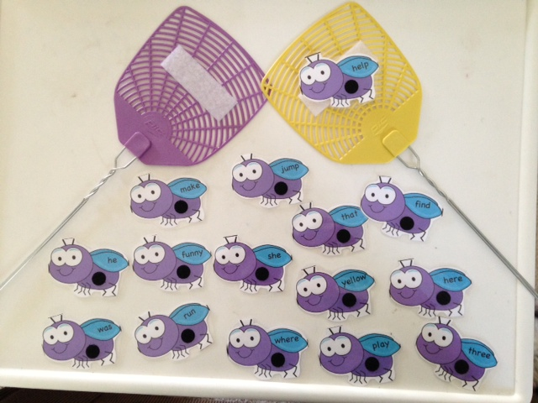

## Annex 2

## Hot Potato Game

How to play the game of Hot Potato

Object of the Game: Don’t get caught holding the hot potato when the music stops playing.

Need: Bean bag or ball for the hot potato, something to play music. Anything can be used for a hot potato - a doll, toy car or piece of fabric.

Set up the game: Sit children in a circle facing towards the center with one of them holding the “hot potato”.

How to Play and Rules: Start the music and have the children start to pass the hot potato around the circle. When the music stops the person holding the hot potato is out.  Continue the game until there is only one person left in the circle.  They are the winner.

Variation of Hot Potato: For children's parties the "potato" can be any item - it make the game even better if an object from the party theme is used.

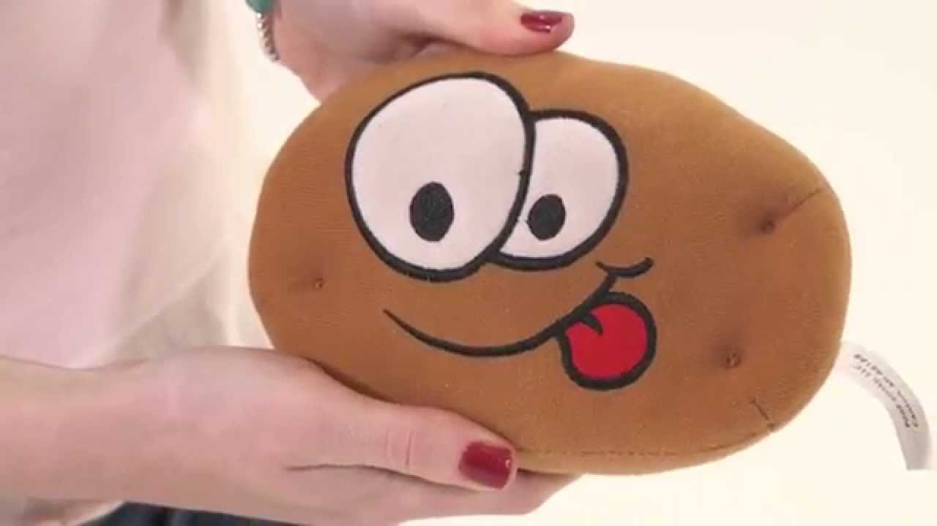

## Annex 3

## Learning names game

Learning names is a very important part of building community among learners! There are many, many activities for learning names. Remember that each name is like a vocabulary word and students need time to encounter and clarify them and the practice them a lot!! These are a few we have done:

1. Self- assessment: ask people to think about how many names they already know and how many they would like to learn.
2. Pair practice- check with a partner to see which names you know between the two of you.
3. Students are sitting or standing in a circle. Pass an object (a stone, a stick, a pen). The person holding the object says the name they would like to be called three times slowly. After 5 or 6 people, pass a second object. This time the person holding the object says nothing and everyone else in the class says their name 3 times slowly.
4. Pair practice- check with a partner to practice the names you know between the two of you.
5. Ball toss. Stand in a circle and toss a ball. Say your own name and the name of the person you are tossing it to. Once this has gotten started, start a second and/or third ball.
6. Partner quiz – quiz each other!

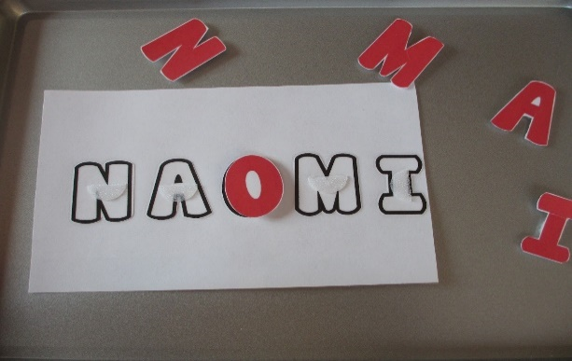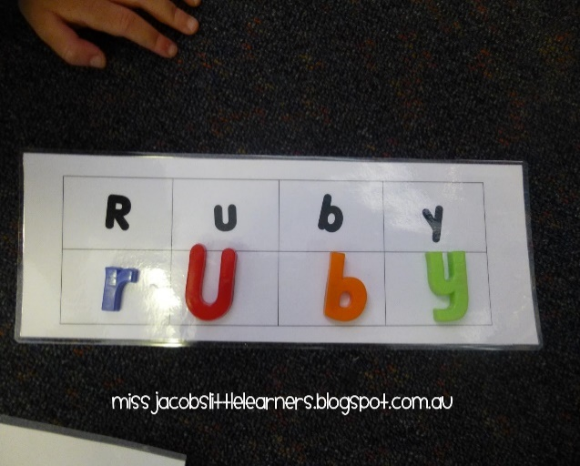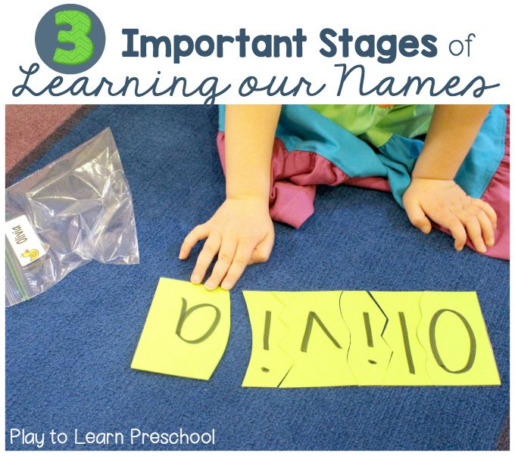

## Annex 4

## Four corners Game

**What it is**: Four corners is a classroom game (posted in honor of all my readers who are teachers!) that I remember playing in grade school as a reward for good behavior or at parties. It’s simple, there’s not really any skill involved, and it’s fun. The best type of classroom game there is.

**Best for**: A classroom full of students! I would say you need about 10 people at a minimum, to however many can fit comfortably in your room.

**What you need**: Just players and a room with four corners! Ooh, actually, if you were in a hexagon-shaped room, you could play *six*corners…but that’s beyond the point.

**How to play**: First assign each corner of your room a number one through four, like this:

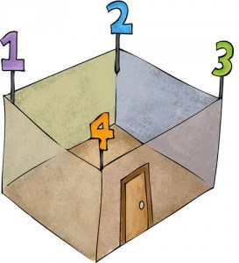

The numbers will stay the same and everyone will need to remember them.

Then select one player to be It, like Melanie. Melanie stands in the middle of the room, closes her eyes, and counts to ten (or another specified number). While she’s counting, all of the other players silently move to a corner of the room. Each player can pick whichever corner they want.

When Melanie is done counting, she keeps her eyes closed and then tries to guess which corner has the most people, based on the sounds she might have heard when she was counting. Say she heard a lot of rustling and banging over by the door in corner number 4. She would say out loud, “Four!” Then all of the players in corner 4 would be out and would go sit down at their desks. Then Melanie begins another round, counting to ten again while players move to whichever corner they want. Then Melanie picks a corner, the players in that corner are out, and a new round starts. Play continues until one player is left – the new It.

**Strategies**: You obviously want to be quiet when picking a corner. You don’t want Melanie to know that your corner is occupied! But, if you have time and if you move fast, maybe you could throw her off – make a noise over by corner 3 before hurrying silently back to corner 2. (The corner 3 people wouldn’t like it much, though.) When I’ve played, we’ve mostly tried to move as silently as possible and avoided too much “strategy.” There’s just something about this simple game that’s fun enough on its own: the countdown, hurrying to pick a corner, moving silently with everyone else, making eye contact and trying not to giggle, the suspense, the last-minute mind changes where you dart across the room. Ah, good times in Mrs. Pritchard’sthird grade class.

## Annex 5

## "Memory Game"

**Rules for playing**

1. Mix up the cards.
2. Lay them in rows, face down.
3. Turn over any two cards.
4. If the two cards match, keep them.
5. If they don't match, turn them back over.
6. Remember what was on each card and where it was.
7. 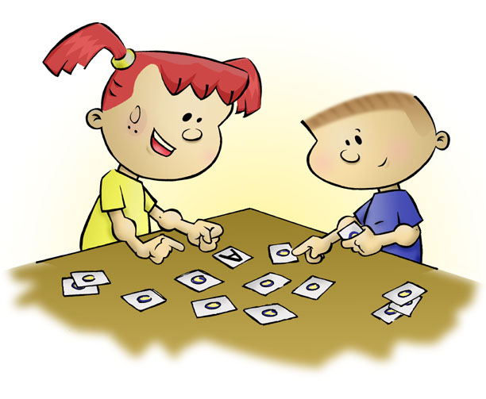Watch and remember during the other player's turn.
8. The game is over when all the cards have been matched.
9. The player with the most matches wins.

## Resources Unit 2

**Theme 1: Stand Up! Sit Down**

Theme 1: Commands

<https://www.youtube.com/watch?v=fuZktwZKYNE>

Video that teaches command through TPR.

<https://www.youtube.com/watch?v=UIGD9uFY-C4>

Video that teaches commands through simple phrase repetition.

**Theme 2: Things in the Classroom**

<https://en.islcollective.com/wuploads/preview_new/big_23270_school_supplies_pictionary_1.jpg>

Page with things found in the classroom. (Better.)

<https://s-media-cache-ak0.pinimg.com/736x/bd/37/c3/bd37c3b5b404b4e941fa0dad7d0133ae.jpg>

Page with things found in the classroom.

**Theme 3: School Supplies**

<https://www.youtube.com/watch?v=ahtIGvV-WeM>

Things in a classroom chant.

<https://www.youtube.com/watch?v=g7kK989HiRQ>

Things in a classroom: Talking Flashcards.

**Theme 4: Where is my Pencil?**

Other

<https://www.youtube.com/watch?v=orhZCfgTPDk>

For TEACHERS. Idea for teaching possessives. This method could be used for your, mine, his, her, their, etc.

<https://www.youtube.com/watch?v=WVA5VcGXLP8>

Simple video for possessive adjectives in the classroom.

**Game: Items on My Desk**

A student is asked to place three (or more) items on their desk. The teacher would do the same. The teacher would begin by modeling:

Teacher: On my desk is my pencil, my marker, and my eraser.

Maria, what is on your desk?

Maria: On my desk is my book, my crayon, and my scissors.

Juan, what is on your desk?

Other examples are: What is on his desk? What is in our locker? What is on our door? Etc.

* This game serves to teach possessives (my, your, our).
* This also reinforces classroom supplies.
* Use of repetition, modeling, and student engagement/interaction.

**Game: Around the World/Around the Classroom**

This activity works well in a room of about 15-20 students.

Basic set-up: The teacher would need to have a box of school supplies or a set of paper-sized flashcards with images of school supplies on them (or whatever the item being taught is.)

To begin, the teacher chooses a student to start, and that student goes to the desk/chair of the student next to him/her. When the two students are ready, the teacher pulls an item out of the box/shows a flashcard, and the first student to say the correct answer moves on to the next person. The person who is slower or gets the word wrong has to sit down in that seat.

The winner moves on to the next person and the same thing happens. When/if the student gets bested, he/she has to sit down where they lose. If the student makes it back to his/her seat and gets a final word correct there, he/she is declared the winner.

**Game: Flyswatter**

This game is simple. The class is divided into 2 groups, and they have to form lines. Photos of the items the students have been learning are taped on the whiteboard/blackboard or a wall. The person in the front of each line is given a flyswatter, and the entire team is asked to stand behind a certain line or a piece of tape. The teacher will call out an object and the students will race to the wall/board and ‘swat’ the item the teacher has called. The student who swats the right object earns a point for his/her team.

**Integrated Mini Project #1: What’s In Your Backpack?**

Make Printouts of a backpack vector image such as this one:

<http://content.mycutegraphics.com/graphics/school/black-white-backpack.png>

Each student will be given one of these and asked to color it.

Next, the students will be asked to flip the backpack over to the blank side and there, they can draw what is in their backpack.

When they are done, a student will present their backpack to the class.

(Has the potential to reinforce numbers, colors, school supplies as well as the preposition ‘in’.)

**Integrated Mini Project #2: Our Classroom**

Students will be given a blank sheet of paper and asked to create a drawing of the classroom. Instructions will be given that require them to draw items from a specific list of classroom items. (5-10 items) Students will present their classroom to the class and tell where the specific objects are located within the classroom.

**Integrated Mini Project #3: The Daily Routine**

For this project, students could be given graphic sequences or comic strips that show the following:

Students coming into the classroom.

Students walking to their desk.

Students sitting down.

Teacher greeting the class. (“Hello Class.”)

Class responding. (“Hello Teacher.”)

Teacher teaching class.

Class ending. (Teacher says “Class is finished. You may leave.”)

Student stand up.

Students leave class.

These items would be out of order, and the student would cut out the squares and be given a separate sheet of paper to paste them in order.

The option would also be given for students to be able to color these images before beginning to cut and paste.

This activity would incorporate fine motor skills with the cutting and pasting. Additionally, it would focus on classroom commands and sequencing.

## http://www.myfreephotoshop.com/wp-content/uploads/2016/03/611.jpgResources Unit 5

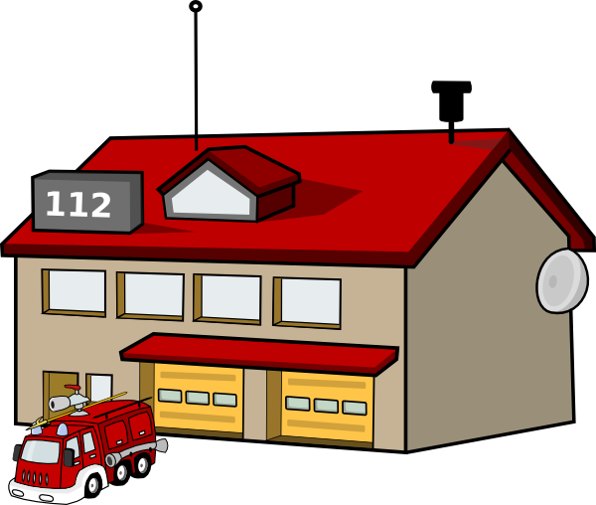

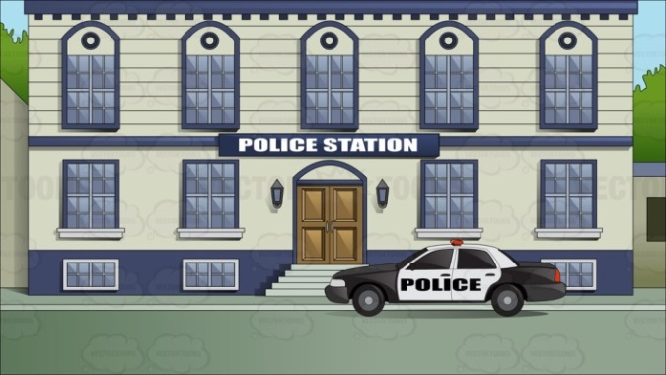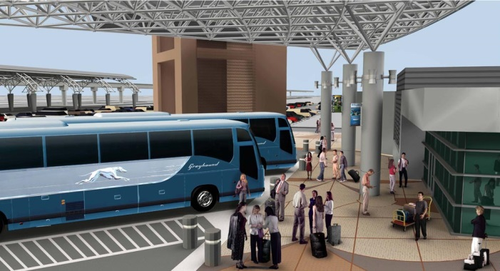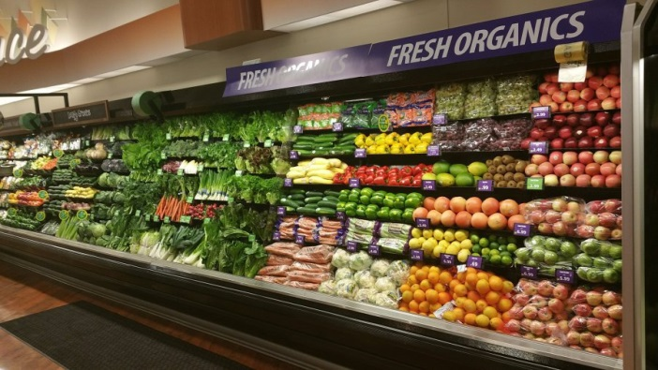

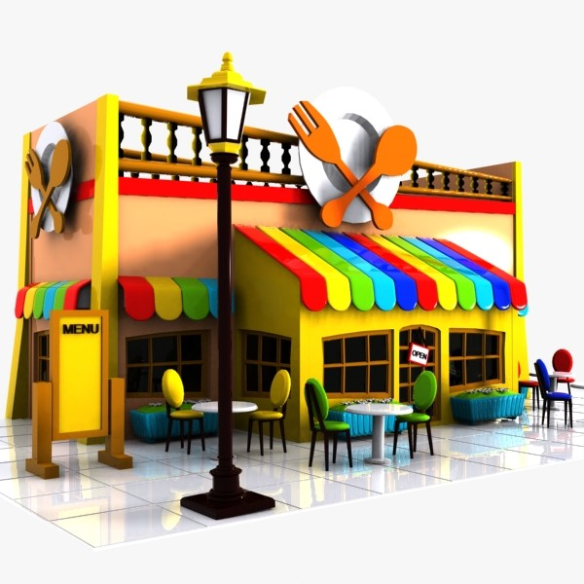

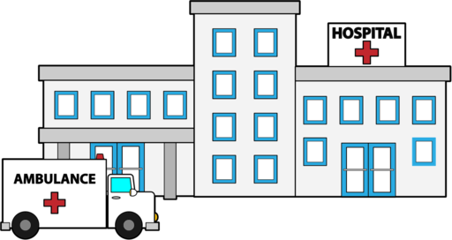

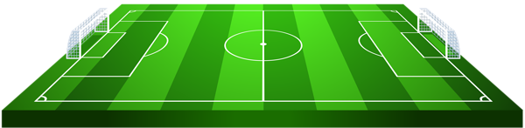

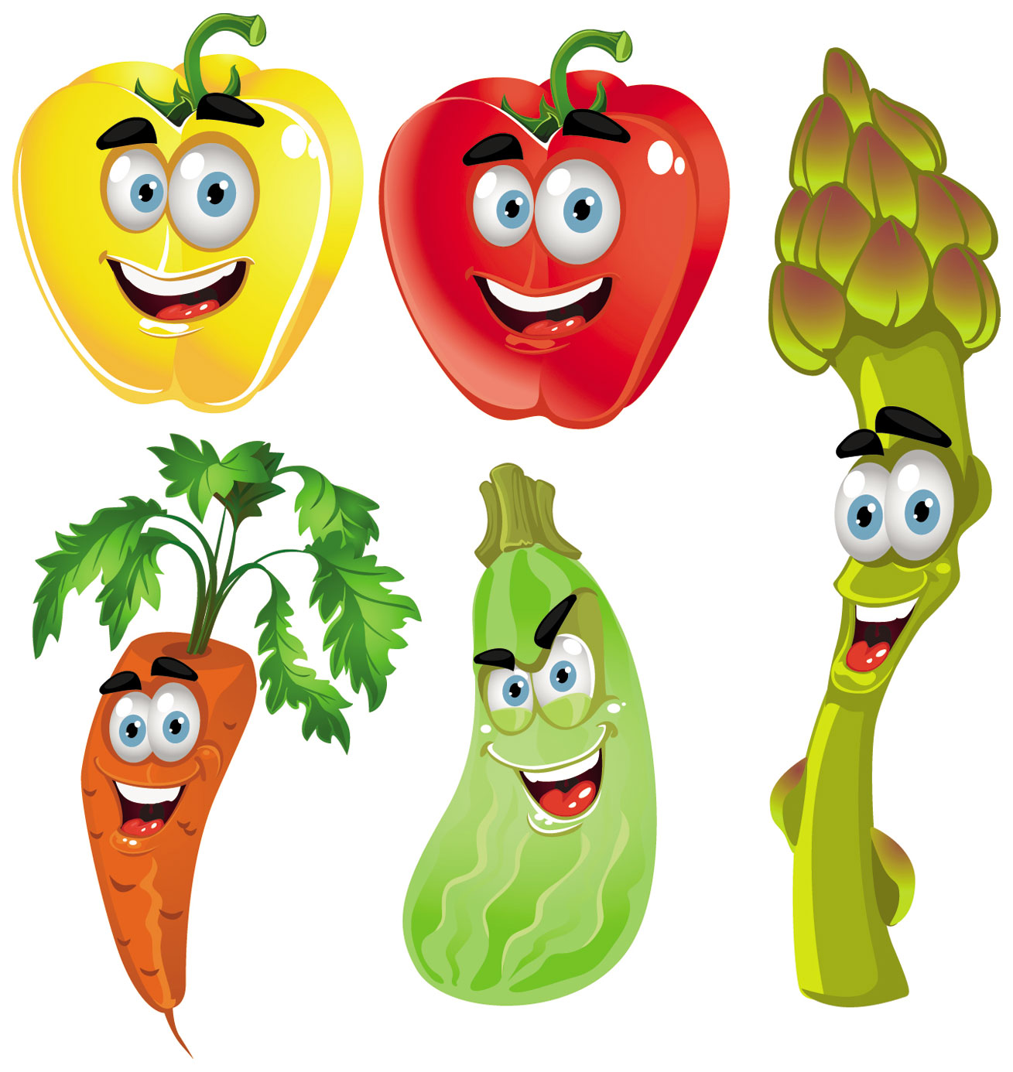

  

 

 

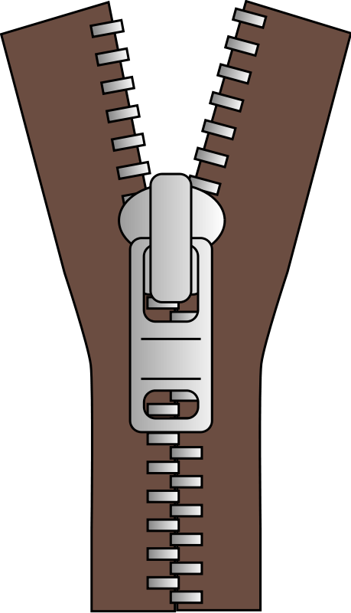  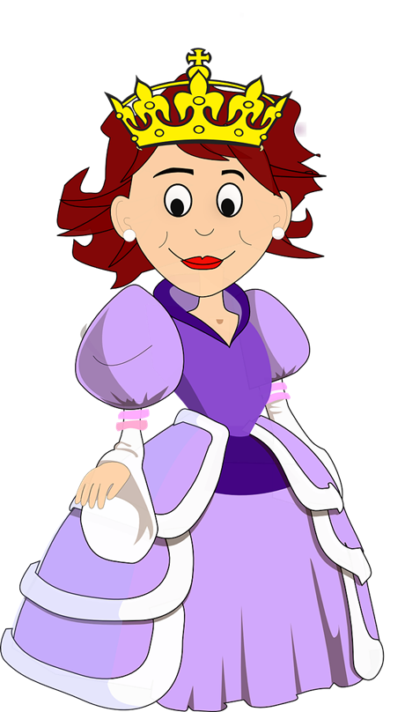

 





1

2

(Paste neighborhood name here)

(Paste location picture here)

(Paste location picture here)

Sing the following words to the music below:

<https://www.youtube.com/watch?v=7FXH36epPnY>

Up down behind x 2

In front of x 2

Left of, right of x2

In front of x2

Make the following gestures each time you sing one of the words:

Up (point up with two hands)

Down (point down with two hands)

Behind (point back with two thumbs)

In front of (hands held out flat in front)

Left of (hold hand out to the left)

Right of (hold hand out to the right)



Hello friend- nice to meet you! Want to see our neighborhoods?

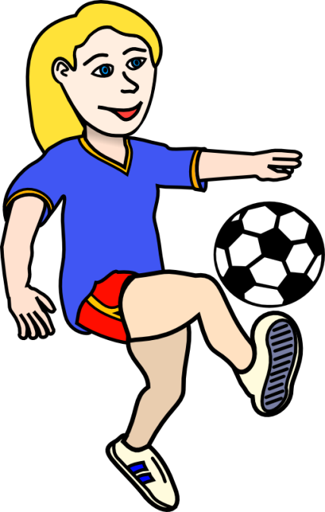

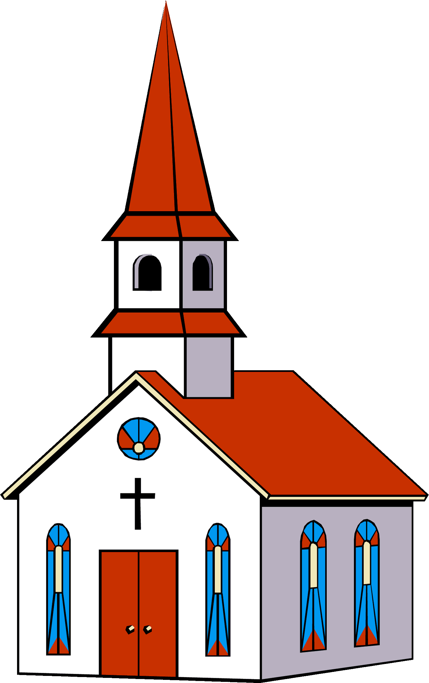

Hello! I live in Rainbowville. Here, the CHURCH is IN FRONT OF the soccer field.





Hello! I live in In Cloudy Town. In Cloudy Town the CHURCH is RIGHT OF the soccer field.



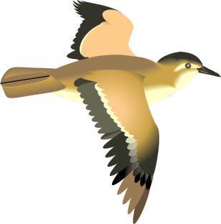

Good morning! I live in In Two Palms. In Two Palms the CHURCH is BEHIND the soccer field.





Hi! I live in Sun City. Here, the school is LEFT OF the soccer field.



(Paste location picture here)



My Neighborhood

 















Excuse me, where is the hospital?



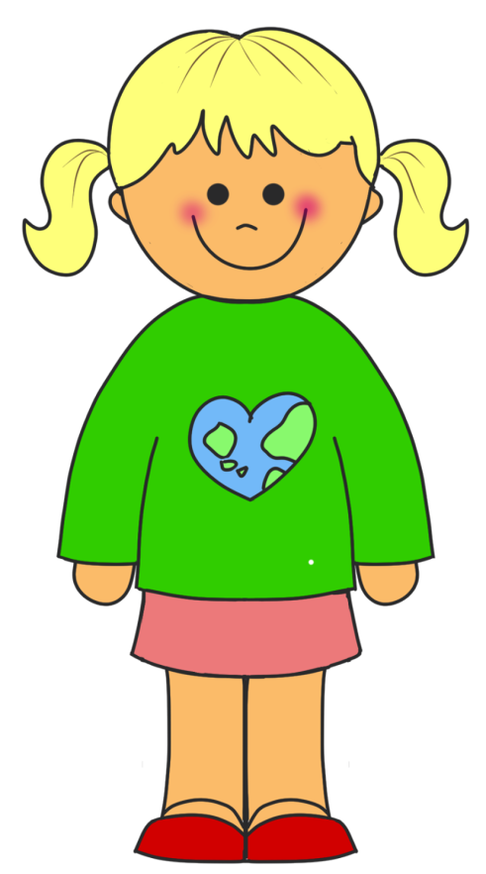



From the school entrance, **GO LEFT**









Then, **GO STRAIGHT** past the restaurant









At the police station, **GO RIGHT**.

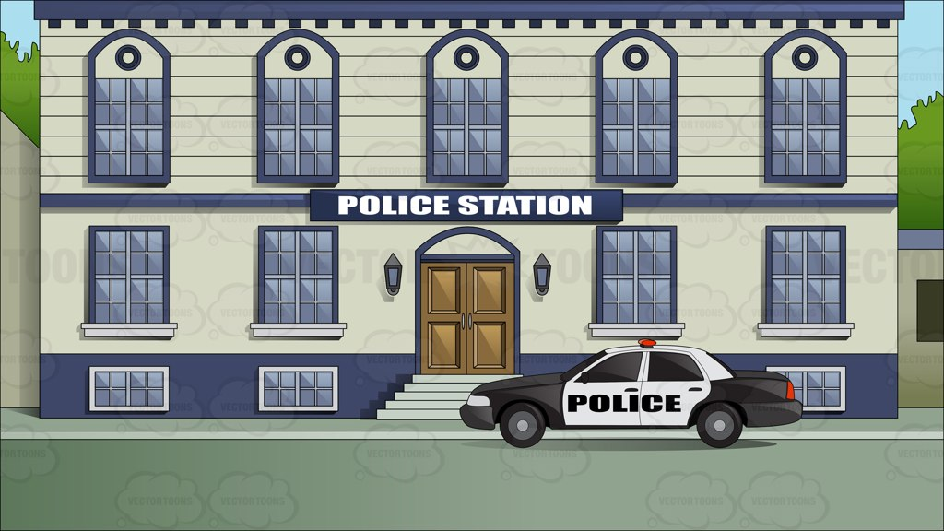







**STOP** when you see the big white building. That is the hospital!









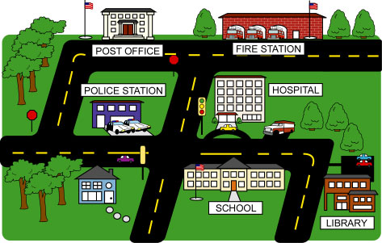





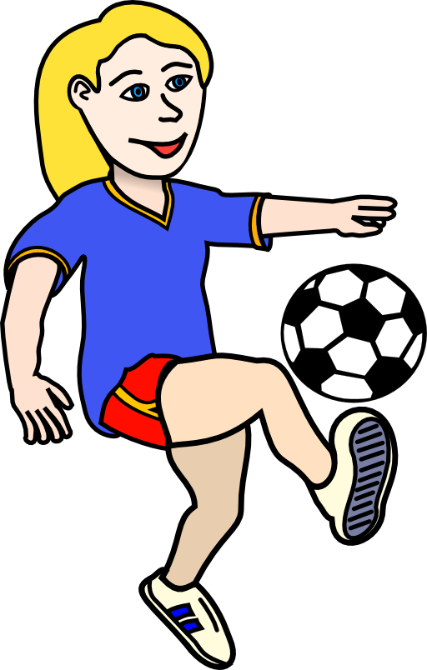





Bus Driver

Cashier

Chef

Teacher

Soccer Player

Doctor

Priest

Police Officer

Firefighter



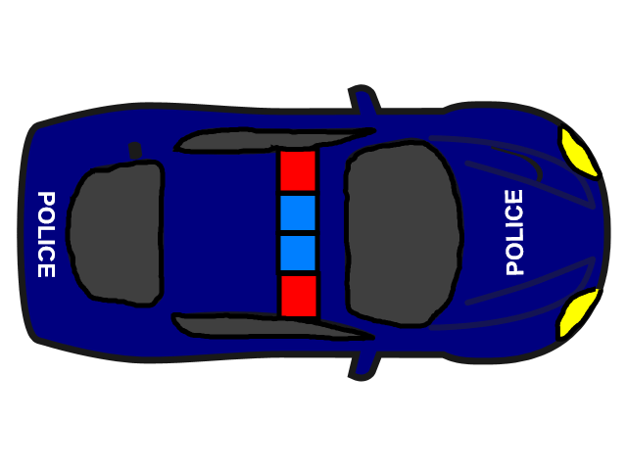



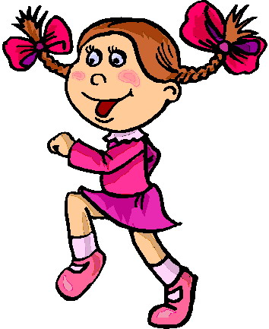

## Resources Unit 6

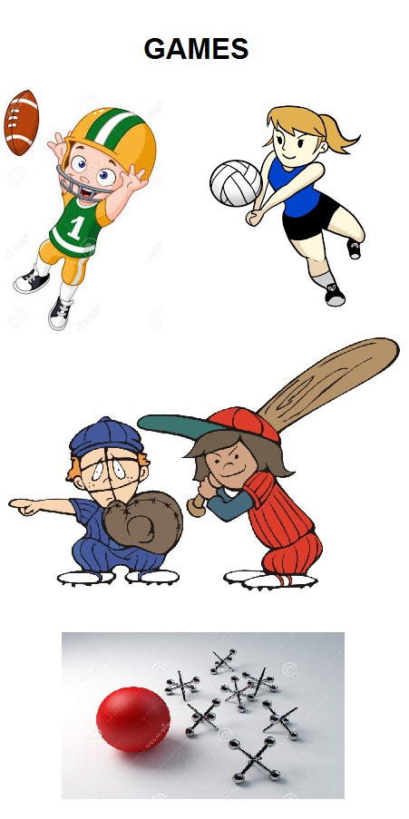

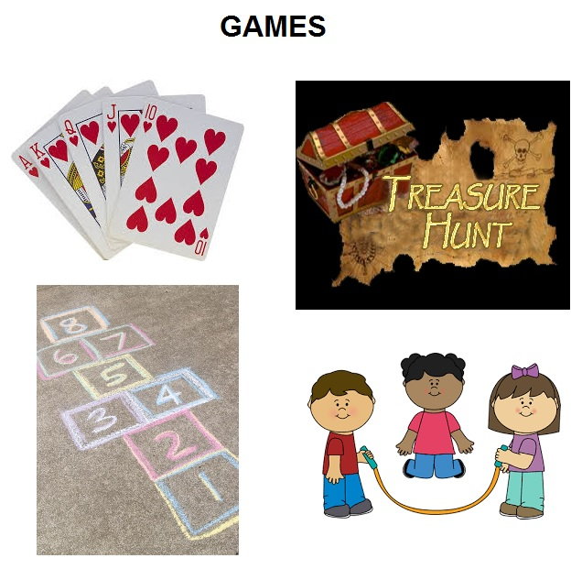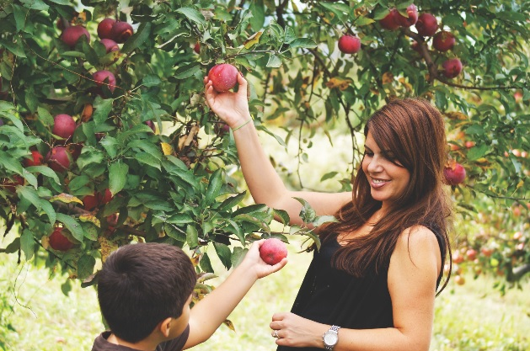

|  |  |  |  |
| --- | --- | --- | --- |
| **I see ___ dolls.** | **I see ___ dolls.** | **I see ___ dolls.** | **4**  **14**  **13**  **8**  **15**  **7** |
| **I see ___ dolls.** | **I see ___ dolls.** | **I see ___ dolls.** |

|  |  |  |  |
| --- | --- | --- | --- |
| **I see ___ dolls.** | **I see ___ dolls.** | **I see ___ dolls.** | **11**  **10**  **2**  **9**  **6**  **12** |
| **I see ___ dolls.** | **I see ___ dolls.** | **I see ___ dolls.** |

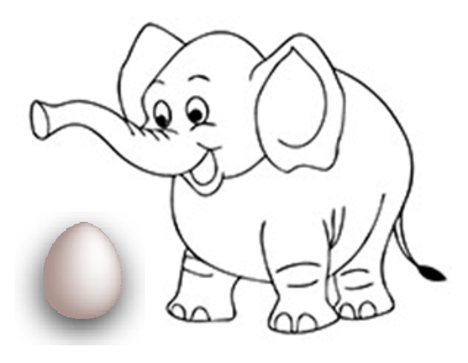

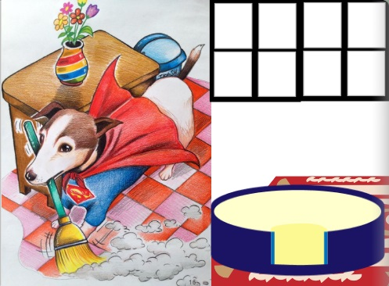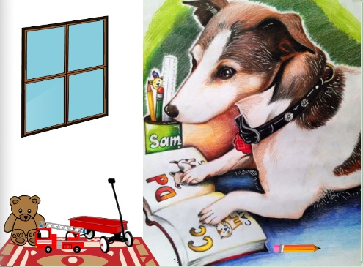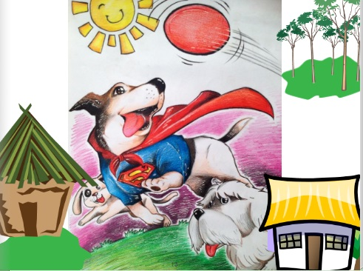

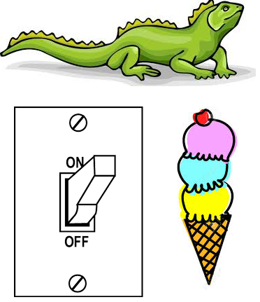

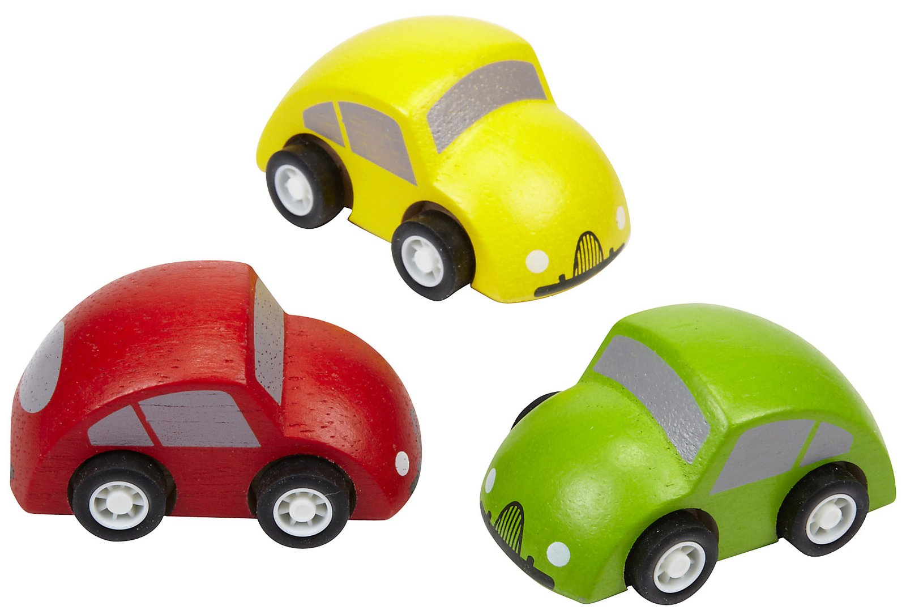

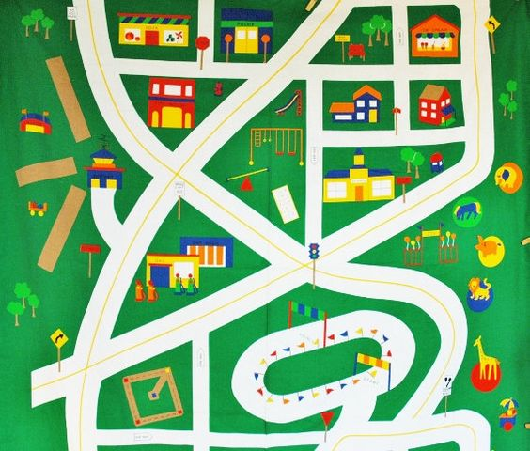





**AUTORIDADES**

Sonia Marta Mora Escalante

**Ministra de Educación Pública**

Alicia E. Vargas Porras

**Viceministra Académica**

Rosa Carranza Rojas

**Director Dirección de Desarrollo Curricular**

Anabelle Venegas Fernández

**Jefa, Departamento de Primero y Segundo Ciclos**

Rocío Torres Arias

**Jefa, Departamento de Evaluación de los Aprendizajes**

**Comisión redactora**

*Ana Isabel Campos Centeno*

*Yaudy Ramírez Vásquez*

**Asesoras Nacionales de Inglés Primero y Segundo Ciclos**

**Colaboradores**

Karen Campbell, Peace Corps volunteer  
Chelsea Geier, Peace Corps volunteer  
Colleen Hewitt, Peace Corps volunteer  
James Lucas, Peace Corps volunteer  
Evan Patton, Peace Corps volunteer  
Nira Penn, Peace Corps volunteer  
Darrell Potter, Peace Corps volunteer  
Jeremy Schmidt, Peace Corps volunteer  
Douglas Tyler, Peace Corps volunteer

**Diseño de Portada**

Christian Vargas Rojas, Dirección de Recursos Tecnológicos en Educación

|  |  |
| --- | --- |
| **Acronym** | **Meaning** |
| L1 | Listening goal one |
| R1 | Reading goal one |
| RPA.1 | Reading Phonemic Awareness goal one |
| SI. 1 | Spoken Interaction goal one |
| SP.1 | Spoken Production goal one |
| W1 | Writing goal one |
| IMP | Integrated Mini Project |